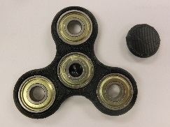SG Spinners!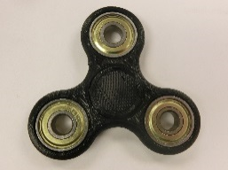
The Spring Grove Area High School rocketry team is selling custom fidget spinners that they are printing and building to raise funds for TARC Nationals and NASA SLI. The spinners can be made from many custom color combinations. Colors available include: black, SG blue, pink, gold, yellow, fluorescent yellow, purple, fluorescent green, green, white, magenta, orange, fluorescent orange, temperature sensitive and glow in the dark.
You can pick your frame color and finger hold colors for an additional charge. Custom bearings are also available that make them spin even faster.
Quantity Price
Stock color – whatever color is available ($4) _____ _____

Custom color – choose the color combination ($5) _____ ____

Frame color - first choice ___________________ backup _______________
Finger holds - first choice ___________________ backup _______________
(**if first choice is not available when you order, your SG spinner will be made out of the backup color)
Faster center bearing ($1) _____ ____
Extra frame ($1) switch out your bearings color ___________ _____ ____
Extra finger holds, 2 (.50) change yours color___________ _____ ____
Total ____
Paid yes no
Name ______________________ building ____________________ grade _____
Homeroom teacher _____________________________
LAST DAY TO ORDER this year May 19, 2017

