**Spring Grove Area School District**

**Project Triton SLI Rocketry 2016-17**

**FRR**

[](https://www.google.com/url?sa=i&rct=j&q=&esrc=s&source=images&cd=&cad=rja&uact=8&ved=0ahUKEwjrqIjkprDPAhUKSiYKHUQLAvcQjRwIBw&url=http://cetus.ucsd.edu/technologies_Software.html&bvm=bv.133700528,d.cWw&psig=AFQjCNGcdCwoI6jS8FzMtX8NFRp5utS20A&ust=1475091656065372)

**Project Triton**

**General Information**

1. School Information

    Name: Spring Grove Area High School

    Mailing Address:  Spring Grove Area High School

                 1490 Roth’s Church Road

                                    Spring Grove, PA 17362

    Name of Team:

2. Adult Educators:

Rosemary Cugliari

        Spring Grove Area High School Principal

        Phone number: (717) 225-4731 ext. 7060

        Email: Cugliarr@sgasd.org

Brian Hastings

        Physics teacher, Rocket Scientist Club Coach

        Phone number: (717) 225-4731 ext. 7220

        Email: Hastingsb@sgasd.org

Renee Bosak

        Biology teacher, Rocket Scientist Club Coach

        Phone number: (717) 225-4731 ext. 7242

        Email: EatonR@sgasd.org

3. Safety Officer:

Brian Hastings

        Level two NAR Representative

        Phone number: (717) 225-4731 ext. 7220

        NAR 96571 SR

4. We are not part of a USLI team, we are a SL team.

5. Key Managers:

Brian Hastings - Advisor and NAR representatives of students

Renee Bosak - Advisor and Supervisor of students

Mr. Sengia - Instructional Technology Specialist

Sarah Staley - Captain

6. For Launch Assistance, Mentoring, and Reviewing our team will be working with the local NRA representatives along with MDRA (Maryland-Delaware Rocketry Association) for all questions and launches

**Facilities and Equipment**

Description of Facilities/Personnel/Equipment/Supplies

* Spring Grove High School:
  + Hours: Monday through Friday 7:25 A.M. until 2:30 P.M. and after school upon instructor availability.
    - Room 135:
      * Gravograph LS100 30W laser
      * Structural Stress Analyzer 100
      * Computers with Microsoft Office and Solidworks
    - Room 130
      * AXYZ Automation INnc 2.2kW 18kRPM TypeB 12-2 CNC Router
      * Compound Dewalt miter saw
      * Framarbandsaw
      * 24” Planer
      * Paasche FABSF-6 spray booth
      * Belt sander
      * Drill press
      * Oliver table saw
      * Orbital sander
    - Room 131
      * Lab Volt 5400 CNC Mill
      * Lab Volt Automation 5500-B0 CNC Lathe
      * EMCO Concept Mill
      * General Model 480 Jointer
      * Jet Benchtop drum sander
      * Victor Metal Lathes
      * Tennsmith sheet metal cutter
      * Miller Spot Welder
      * Baldor Grinder/buffer
    - Room 220
      * Computers with Rocksim 9 and Logger Pro
      * Labquests
      * Drill press
      * Belt sander
      * Reciprocating saw
      * Circular saw
      * Cordless drill
    - Room 222
      * Storage and workspace
    - Room 221
      * Fume hoods
      * Laptop cart with 28 IBM Thinkpads
  + Launch site: MDRA Launch field requires an MDRA member for supervision whenever one is free to supervise
  + Materials/Supplies
    - There is an abundance of supplies in Room 220
    - All other needed supplies will be ordered at the appropriate time
* Description of Computer Equipment/WebEx required supplies
  + Conference rooms 50 and 51
    - Laptop computers
    - USB web camera
    - Cisco speakerphone
    - School network connection
  + WebEx/connectivity Instructor Contact Information:
    - Instructional Technology Specialist: Mr.Sengia
    - Email: Sengiaj@sgasd.org
    - Phone number: (717)-225-4731 ext.7060

The Spring Grove SLI Team will implement the Architectural and Transportation Barriers Compliance Board Electronic and Information Technology (EIT) Accessibility Standards (36 CFR Part 1194) Subpart B- Technical Standards 1194.21 (a-l), 1194.22 (a-p), and 1194.26 (a-d).<http://ecfr.gpoaccess.gov/cgi/t/text/textidx?c=ecfr&tpl=/ecfrbrowse/Title36/36cfr1194_main_02.tpl>

Facilities Available to All Students:

In room 220, Mr. Hastings’ room, we can work and plan most of our project.  It has numerous computers with Logger Pro and Rocksim 9. There is also a drill press, belt sander, and multiple Vernier LabQuests. We have original labquests and have a few new LabQuest 2’s. In the room there is also a Craftsman reciprocating saw, a circular saw and cordless drill.

*This room as mentioned above will be our main home for working on the rocket, its construction, and writing of the many papers we must write. Mr. Hastings, as our main mentor, is willing to stay after many late nights to help us work on the project.

**Table of Contents**

**General Information**

______________________________________________________________________________

School Information..........................................................................................................................2

Adult Educators...............................................................................................................................2

Safety Officer..................................................................................................................................2

Educators and Mentors Biographies................................................................................................7

Key Managers and Student Participants.....................................................................................7-10

Summary of FRR report…………………………………………………………………… .11-13

Changes Since CDR…….………………………………………………………………………14

**Facilities and Equipment**

______________________________________________________________________________

Facilities Available..........................................................................................................................3

Computer Equipment.......................................................................................................................4

EIT...................................................................................................................................................4

Technical Standards.........................................................................................................................4

**Vehicle Criteria**

______________________________________________________________________________

Design and Construction of Vehicle………………………………………………………….…..15-21

Recovery Subsystem………………………………………………………………………………21-23

Mission Performance Predictions…………………………………………………………………23-25

Full Scale Flight…………………………………………………………………………………………26

Launch concerns and operation procedures .................................................................26-28

Equipment Safety .............................................................................................29-

**Safety**

______________________________________________________________________________Safety Plan...............................................................................................................................39-44

NRA/TRA Personal Review…………………………………………………………………44-45

Student Briefings......................................................................................................................45-46

Methods for Including Necessary Caution Statements………………………………………46-46

Plan for Complying with Laws.................................................................................................46-48

Plan for motor handling and storage …………………………………………………………….48

Team Agreements……………………………………………………………………………48-49

**Payload Criteria**

______________________________________________________________________________

Payload Design ………………………………………………………………………..….…54-58

**Project Plan**

Technical challenges and solutions ……………………………………………………..…..59-60

Launch Operations Procedures …………………………………………………………….60-62

Testing ……………………………………………………………………………………….62-63

Budget Plan………………………………………………………………….……………..…63-65

Funding Plan…………………………………………………………………………………65

Schedule and Timeline……………………………………………………………………….65-66

Community Support…………………………………………………………………….……67

Sustainability of Rocket Project…………………………………………….…………….….67-68

**Educational Engagement**

______________________________________________________________________________

Educational Plans……………………………………………………………………….……69

**Team Members**

Mrs. Bosak: Biology Teacher and Assistant Coach

I have been a Biology teacher at Spring Grove High School since 2009. Since then, I have coached the Marching Band and Junior High Track and Field and have advised the Gay-Straight Alliance, Science Fair participants, the Envirothon team, and the SLI team. In addition, I have been a member of the York Jaycees, a local community service organization, since 2009. I finished my Master’s degree in Classroom Technology in 2013. In my spare time, I enjoy spending time with my friends and family, hiking, biking, reading, and training for 5K races and half-marathons. I am a NAR member and have a level 2 certification.

Brian Hastings: Instructor and Head Coach

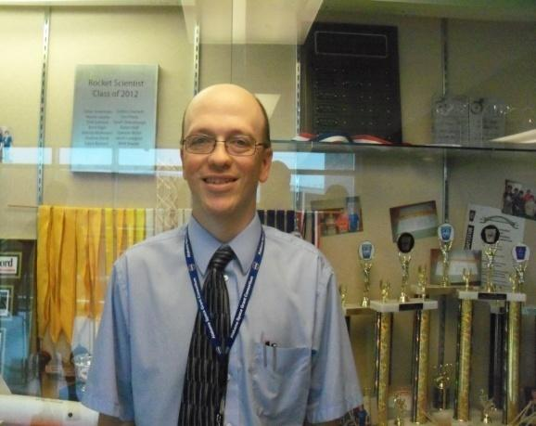 I have been a teacher at Spring Grove for 19 years, teaching Physics 1, Physics 1 Honors, and AP Physics 1 and 2. I have an Honors B.A. in secondary education Physics, a masters in science education and 60 graduate credits past my Master’s Degree. I have taught graduate courses to teachers and for the past 15 years have taught fast -paced high school physics for Johns Hopkins University’s Center for talented youth program. As a Rocket Scientists’ coach, I have started a Science Olympiad team, a Vex Robotics Team, Physics Olympics Team, and a Team America Rocketry Challenge Team. The Science Olympiad team has advanced to the state level each of the last ten years. We have been participating in TARC for 9 years and have advanced to Nationals each of the past 6 years, placing fourth overall at Nationals in 2012, and eighth at the Nationals in 2013. I am a NAR member and have a level 1 certification. Currently I am building a rocket for level 2 NAR certification.

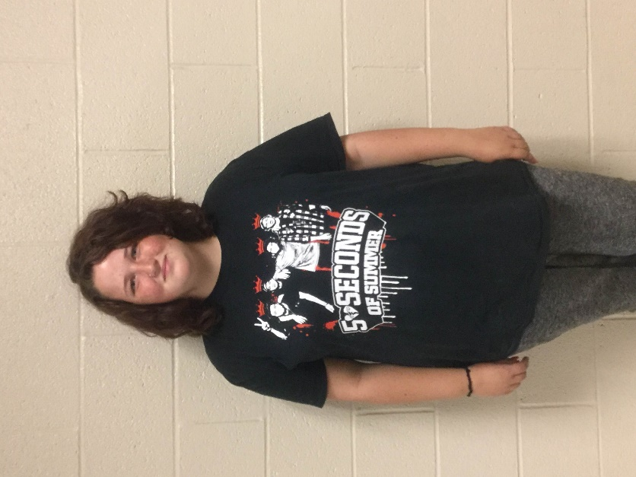Lindsay Mummert 15 Sophomore: Safety Specialist

I joined this club because this year I started to take an interest in science. I'm hoping this club will branch out my options for after college since I've decided to take a different path in life. I'm so honored to be in this club because it makes me feel good about myself since only 10 schools have it. I also feel like this is going to help with communication with others and making decisions. I’m also apart of GSA because I enjoy giving back to others and love helping others who are having a hard time in life.

Adam Winchell 16 Junior Technical Specialist

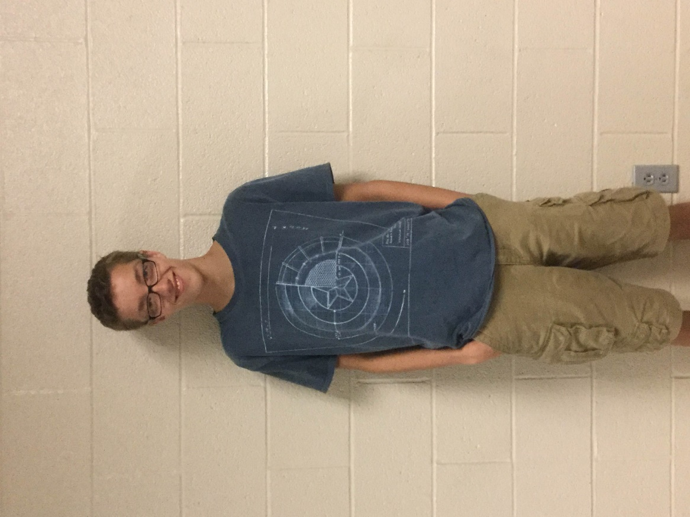

I've always been really interested in science since I was little. I was in Science Olympiad last year, but since we don't have a team this year, I wanted to find a new club to be part of. I heard of SLI, but wasn't sure what it was, but as soon as I went to the first meeting, I knew I was going to love it. I am going to go to college to be a science teacher, but am hoping to teach in Biology. Even though I have little experience with rockets, I am hoping to learn a lot and I’m really excited for this year of SLI.

Zach Ruth 17 Junior: Technical Design Specialist

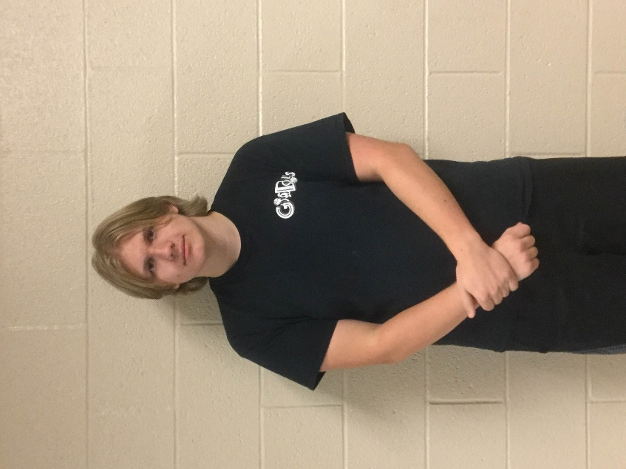I have always been interested in science. I was in Envirothon in 5th and 6th grade. I loved model rockets early on in my teenage years, and that led me to Team America Rocketry Challenge in my sophomore year. I have played violin since 5th grade, and I participate in the school plays and musicals. Last year, I joined International Thespian Society, which is an honorary theater achievement group.  I am a member of the Drama Club and vice president of the Game Club. I am excited to become an SL team member this year.

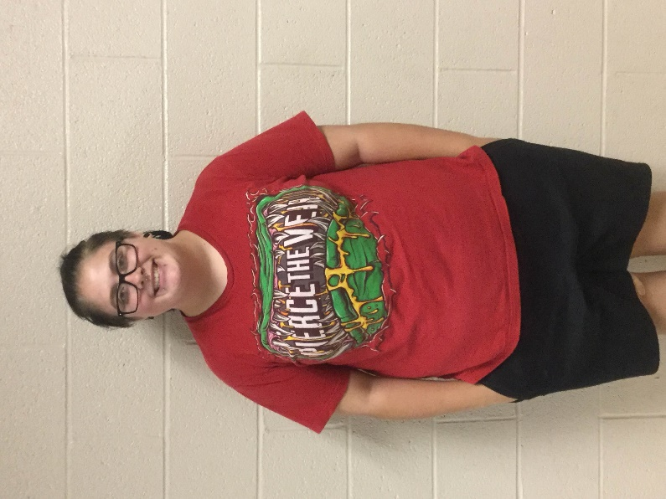Lacey Roller 16 Sophomore: Project Plan Specialist

I became a member in SL, because I thought it would be fun to branch out and expand my comfort zone. I will give this club my all, and make sure I don't let my team members down. This club is a huge part in my life now, because not all schools have this wonderful opportunity. I hope that this club will teach me how to become a brighter person, and I hope to step out of my comfort zone and show my team members and the other teams what I'm capable of. I’m also a member of GSA, and that is a huge part of my life that I wouldn't give up for anything.

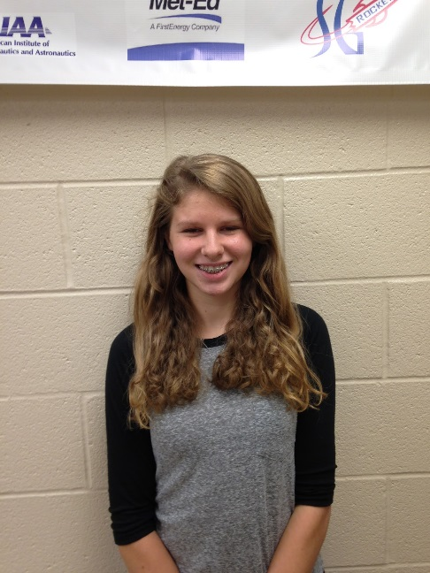Sarah Staley 16 Sophomore: Payload Specialist

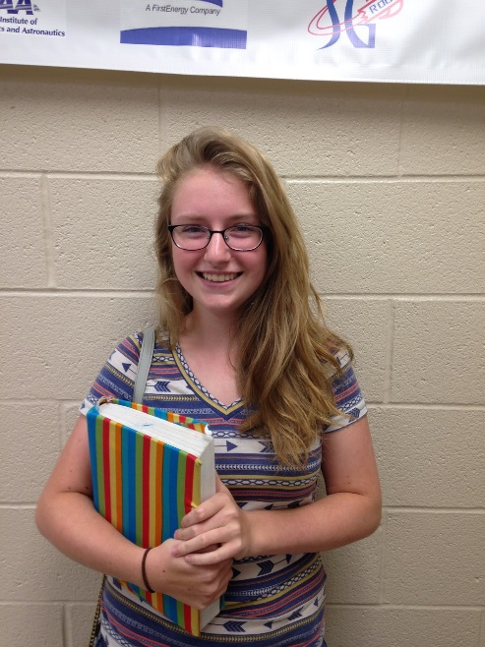I am a returning member of the 2015-2016 SLI team Darwin and I am very excited for another fun year in this program. Being a member of the Spring Grove SLI team has become a tradition for my family. It started with my sister in 2009-2013, then with my brother in 2013-2016 and now me. I am the historian of my class and a member of Spring Grove’s competition cheerleading squad, and I recently went to Germany through a program offered in our school. I like being around a diverse group of people and that are able to collaborate and work towards our team goals. I also hope to expand my knowledge of rocketry and have many successful launches. Fly high rockets!

Emily Edsall 17 Junior: Safety Specialist

This is my second year in Spring Grove's SLI team. I decided to join the team again to further expand my knowledge on the subject. I am also involved in my school TARC and foreign language clubs. For this year’s team, I hope I will be able to play a crucial part in our accomplishments.

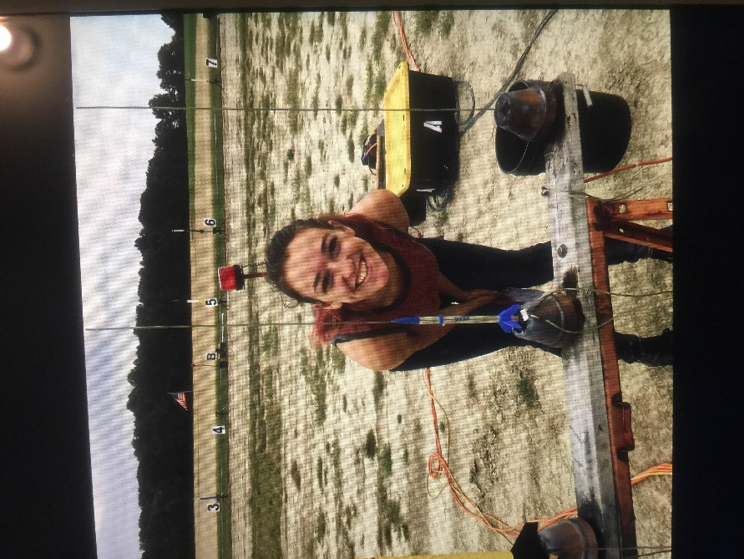

Melody Buckley 15 Sophomore: Educational Engagement Specialist

Hi I’m melody and I’m 15 years old and in 10th grade. I am in GSA and the manager of the football team. I was interested in SLI because rockets are pretty cool and awesome. NASA is an awesome space program, and I think it would be pretty nifty to work with them. I think it would also be a great to build rockets and launch them.

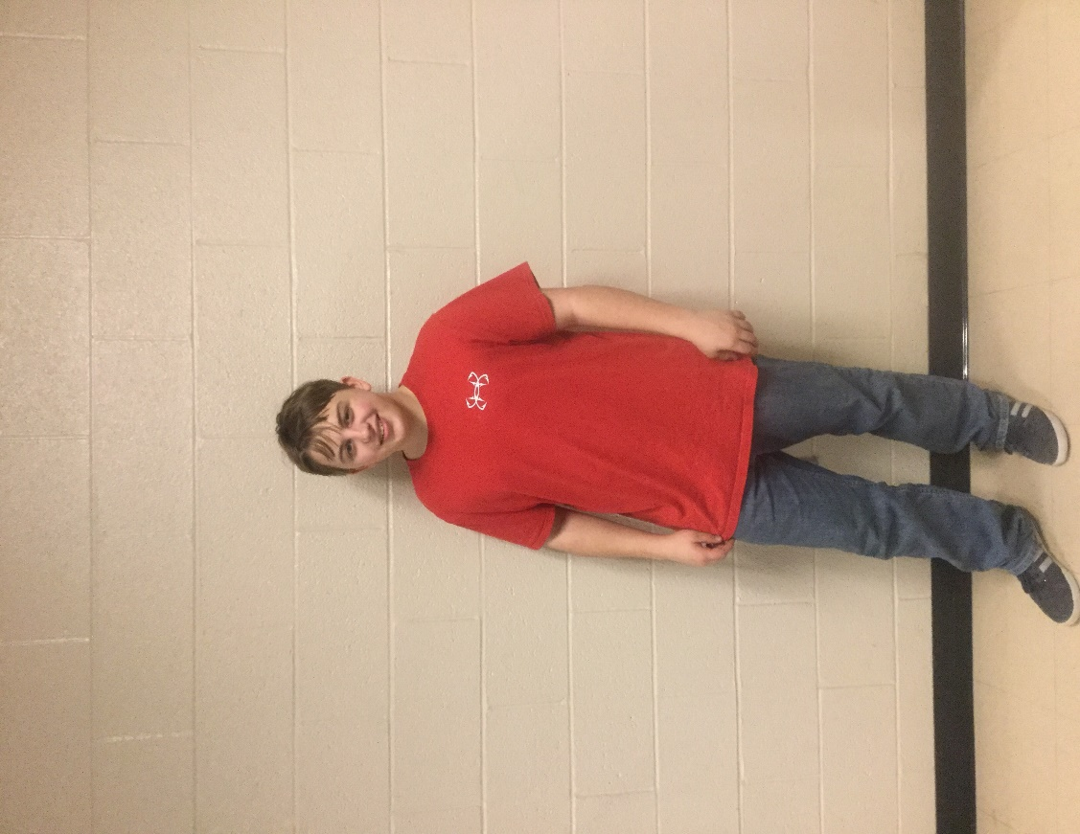

Josh Croson 16 Junior:

I joined SLI because I’m really interested in Mechanical Engineering. A friend recommended that I join SLI. I first helped with designing the fin can, and then joined the team. I don't have a lot of experience with rockets, but I am actively learning all about it. I am really excited about this year.

**I)Summary of FRR Report:**

**Team summary:**

* Our team name is Triton
* Mailing address: Spring Grove Area High School 1490 Roth’s Church Road Spring Grove, PA 17362
* Brian Hastings, 96571, level 3 certification

**Launched Vehicle Summary:**

* The rocket is 105.18 inches in Length and 23.84 lbs
* The motor is a AreoTech K1000
* Recovery system drogue parachute Elliptical 15in and Main Iris Ultra 72in
* Rail size 1515in/144in

**Milestone review Flysheet:**

|  |  |  |  |  |  |  |  |  |  |  |  |
| --- | --- | --- | --- | --- | --- | --- | --- | --- | --- | --- | --- |
| **Milestone Review Flysheet** | | | | | | | | | | |  |
|  |
| **\*Please see Milestone Review Flysheet Instructions.\*** | | | | | | | | | | |  |
| **Institution** | Spring Grove Area High School | | | | |  | **Milestone** | Flight Readiness Review | | |  |
|  |  |  |  |  |  |  |  |  |  |  |  |
| **Vehicle Properties** | | | | |  | **Motor Properties** | | | | |  |
| Total Length (in) | | 105.18 in | | |  | Motor Manufacturer(s) | | AeroTech | | |  |
| Diameter (in) | | 4.00 in | | |  | Motor Designation(s) | | K1000 | | |  |
| Gross Lift Off Weight (lb) | | 23.84 lbs | | |  | Max/Average Thrust (lb) | | 224.81 lbs | | |  |
| Airframe Material | | Fiberglass | | |  | Total Impulse (lbf-sec) | | 564.61 lbf-sec | | |  |
| Fin Material | | Ultem | | |  | Mass (before, after burn) | | 5.74 lbs / 3.14 lbs | | |  |
| Drag | | 150.63 N | | |  | Liftoff Thrust (lb) | | 224.81 lbs | | |  |
|  |  |  |  |  |  |  |  |  |  |  |  |
| **Stability Analysis** | | | | |  | **Ascent Analysis** | | | | |  |
| Center of Pressure (in from nose) | | | 83.06 in | |  | Maximum Velocity (ft/s) | | | 674.74 ft/s |  |  |
| Center of Gravity (in from nose) | | | 54.78 in | |  | Maximum Mach Number | | | 0 |  |  |
| Static Stability Margin | | | 7.07 | |  | Maximum Acceleration (ft/s^2) | | | 45.23 ft/s^2 |  |  |
| Thrust-to-Weight Ratio | | | 9.43 | |  | Target Apogee (1st Stage if Multiple Stages) | | | 5280 ft |  |  |
| Rail Size (in)/ Length (in) | | | 1515 / 144 in | |  | Stable Velocity (ft/s) | | | 43.99 ft/s |  |  |
| Rail Exit Velocity (ft/s) | | | 95.2 ft/s | |  | Distance to Stable Velocity (ft) | | | 2.13 ft |  |  |
|  |  |  |  |  |  |  |  |  |  |  |  |
| **Recovery System Properties** | | | | |  | **Recovery System Properties** | | | | |  |
| **Drogue Parachute** | | | | |  | **Main Parachute** | | | | |  |
| Manufacturer/Model | | Elliptical | | |  | Manufacturer/Model | | Iris Ultra | | |  |
| Size | | 15 in | | |  | Size | | 72 in | | |  |
| Altitude at Deployment (ft) | | | Apogee | |  | Altitude at Deployment (ft) | | | 600 ft | |  |
| Velocity at Deployment (ft/s) | | | 33.5 ft/s | |  | Velocity at Deployment (ft/s) | | | 136.08 ft/s | |  |
| Terminal Velocity (ft/s) | | | 141.48 ft/s | |  | Terminal Velocity (ft/s) | | | 21.13 ft/s | |  |
| Recovery Harness Material | | | Tubular Kevlar | |  | Recovery Harness Material | | | Tubular Kevlar | |  |
| Harness Size/Thickness (in) | | | 1.00 in | |  | Harness Size/Thickness (in) | | | 1.00 in | |  |
| Recovery Harness Length (ft) | | | 50.00 ft | |  | Recovery Harness Length (ft) | | | 50.00 ft | |  |
| Harness/Airframe Interfaces | | Forged steel eye bolt on the front of the motor casing, and U- Bolts on the E-bay  and nosecose. Chute held on with tubular kevlar and quick links. | | |  | Harness/Airframe Interfaces | | Forged steel eye bolt on the front of the motor casing, and U- Bolts on the E-bay  and nosecose. Chute held on with tubular kevlar and quick links. | | |  |
|  |  |
|  |  |
| Kinetic Energy of Each Section (ft-lbs) | Section 1 | Section 2 | Section 3 | Section 4 |  | Kinetic Energy of Each Section (ft-lbs) | Section 1 | Section 2 | Section 3 | Section 4 |  |
| 3502.90 | 2101.74 |  |  |  | 31.25 | 46.91 | 46.88 |  |  |
|  |  |
|  |  |  |  |  |  |  | | | | |  |
| **Recovery Electronics** | | | | |  | **Recovery Electronics** | | | | |  |
| Altimeter(s)/Timer(s) (Make/Model) | | PerfectFlite Stratologger Altimeter CF | | |  | Rocket Locators (Make/Model) | | PR-100 Reciever                                       AT-2B Transmitters | | |  |
|  |  |
| Redundancy Plan | | We will have a pair of altimeters, a pair of transmitters, and two ejection charges for each parachute. | | |  | Transmitting Frequencies | | 223.530  222.470 | | |  |
|  |  |
|  | Black Powder Mass Drogue Chute (grams) | | 1.80 g | | |  |
|  |  |
| Pad Stay Time (Launch Configuration) | | 3 hours | | |  | Black Powder Mass Main Chute (grams) | | 3.00 g | | |  |
|  |  |
|  |  |  |  |  |  |  |  |  |  |  |  |
| **Milestone Review Flysheet** | | | | | | | | | | |  |
|  |
| **\*Please see Milestone Review Flysheet Instructions.\*** | | | | | | | | | | |  |
| **Institution** | Spring Grove Area High School | | | | |  | **Milestone** | Flight Readiness Review | | |  |
|  |  |  |  |  |  |  |  |  |  |  |  |
| **Autonomous Ground Support Equipment (AGSE)** | | | | | | | | | | |  |
| Capture Mechanism | Overview | | | | | | | | | |  |
| n/a | | | | | | | | | |  |
|  |
|  |
| Container Mechanism | Overview | | | | | | | | | |  |
| n/a | | | | | | | | | |  |
|  |
|  |
| Launch Rail Mechanism | Overview | | | | | | | | | |  |
| n/a | | | | | | | | | |  |
|  |
|  |
| Igniter Installation Mechanism | Overview | | | | | | | | | |  |
| n/a | | | | | | | | | |  |
|  |
|  |
| CG Location of Launch Pad (in inches) When Rail is Horizontal (Use Base of Rail as the Reference Point) | | | | | | | | n/a | | |  |
| Moment Analysis | | n/a | | | | | | | | |  |
|  |
|  |  |  |  |  |  |  |  |  |  |  |  |
| **Payload** | | | | | | | | | | |  |
| Payload 1 | Overview | | | | | | | | | |  |
| We are testing the effects that a rocket launch will have on a colloid solution. We will see if this solution acts as a solid, or a liquid under the extreme pressures acting on it from the launch. | | | | | | | | | |  |
|  |
|  |
| Payload 2 | Overview | | | | | | | | | |  |
| n/a | | | | | | | | | |  |
|  |
|  |
|  |  |  |  |  |  |  |  |  |  |  |  |
| **Test Plans, Status, and Results** | | | | | | | | | | |  |
| Ejection Charge Tests | We tested the different amounts of black powder and found out that 1.8 grams for the Drogue chute and 3.0 g for the main worked great. | | | | | | | | | |  |
|  |
|  |
| Sub-scale Test Flights | The flight of the sub scale rocket had a predicted height of 2403 ft. The actual height was 2303, which was a 4.2% difference.  It made a safe accent and a safe landing as well. | | | | | | | | | |  |
|  |
|  |
|  |
| Full-scale Test Flights | Not yet performed | | | | | | | | | |  |
|  |
|  |
|  |
| **Milestone Review Flysheet** | | | | | | | | | | |  |
|  |
| **\*Please see Milestone Review Flysheet Instructions.\*** | | | | | | | | | | |  |
| **Institution** | Spring Grove Area High School | | | | |  | **Milestone** | Flight Readiness Review | | |  |
|  |  |  |  |  |  |  |  |  |  |  |  |
| **Additional Comments** | | | | | | | | | | |  |
| Section 1                               Section 2                               Section 3                                                                                                                                                                            Main         Front Half                                Back Half                               n/a                                                                                                                                                                                    Main         Front Half                                Back Half                           Nosecone and Payload | | | | | | | | | | |  |

**Payload summary:**

* Payload title: Oobleck vs G-force

We are testing to see how Ooblecks reacts to G-Forces during the ascent of the rocket, by using a solenoid and two test tubes, we can see whether the colloid flows into the bottom test tube or solidifies staying in the upper test tube.

**II) Changes made since CDR:**

* Changed 50’ of 1” tubular nylon as shock cord to 50’ of ½” tubular Kevlar in both halves of the rocket to accommodate the K711 motor
* Requested a motor change to the CTI K711 from the CTI K510 to increase the thrust to weight ratio
* Submitted pictures and a description of the shock cord attachment point on the end of the 54mm 6XL grain CTI motor casing as requested. Currently attempting to get approval from CTI to use the attachment.
* Due to the delay in getting approval from CTI about the shock cord attachment, we would like to formally request that we use an Aerotech 75mm 2 grain K1000 motor instead of the K711, because we still have not heard from CTI as to the shock cord attachment at the front of the motor. It is a concern that we may not get approval in time for our March 11 practice launch. The K1000 motor was flight tested in our rocket on Feb 11, 2017 and flew to a height of 5455ft on a rocket that is at least 4oz lighter than the final configuration.
* A key switch was installed on the bulkhead of the payload compartment to arm the payload on the field prior to launch.

**III.) Vehicle Criteria**

**Design and Verification of Launch Vehicle**

Design and Construction of Vehicle

Section 1

Our mission is to launch a rocket to an altitude of one mile while testing the effects of G-forces on a Non-Newtonian fluid. In order for our mission to be successful, our rocket must reach an altitude of one mile, and safely return.

Design and Construction changes since CDR:

We have switched from a K510, to a K1000 motor to increase the thrust weight to ratio. We have also changed the Nylon shock cord to a Kevlar shock cord because the Kevlar is heat resistant, stronger, and less bulky. We switched our drogue chute from a 24in to a 15in to decrease the descent time in order to decrease the drift distance.

Structural Elements:

The Launch Lugs guide the rocket along the launch rail. The Body Tube Sections are the main structure of the rocket. The Nose Cone reduces the drag on the rocket and allows it to fly straight. The Fin Can provides stability for the rocket and reduces drag. The Parachutes slow the rocket to a reasonable speed during descent. The Shock Cords limit the separation of the sections. The Motor Retainer holds the motor in place.

Electrical Elements:

The Key Switches allow the rockets to be armed and disarmed. The altimeter tracks the altitude and speed of the rocket as well as well as controls the parachute ejections. The ejection wells hold the black powder until it is ignited by altimeter.

Construction process:

First, we cut body tubes to length. Second, we worked on Electronics bay. Third, we did the electrical assembly and wiring. Then, we attached shock cords and parachutes. Also, we prepared the payload. Finally, we prepared the rocket motor.

Flight Reliability:

The rockets have proven design and are expected to reach the desired altitude.

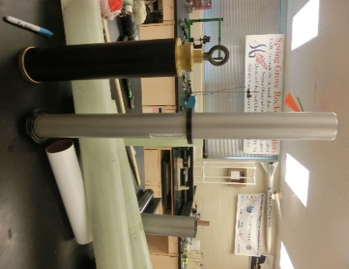

Motor Casing of the(Aerotech K1000 left, CTI K711 right with centering rings)

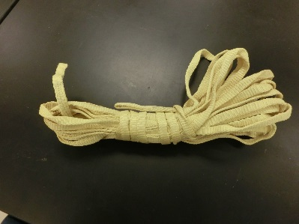

Shock Cords(Kevlar)

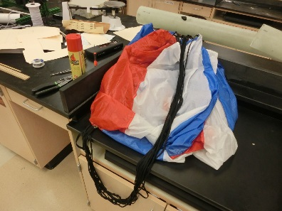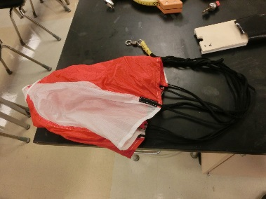

Parachuthe(Left main, right drogue)

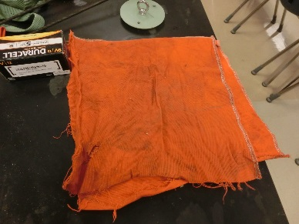

Heat Sheild for Parachute

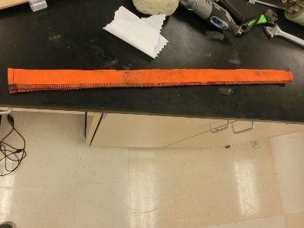

Heat Sheild(on shock cord)

EBAY

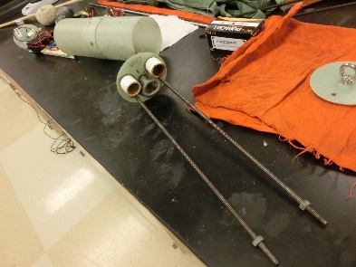

All-thread Rods

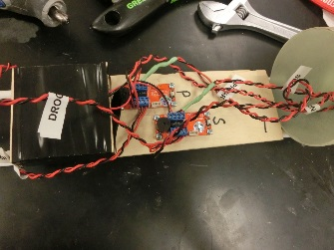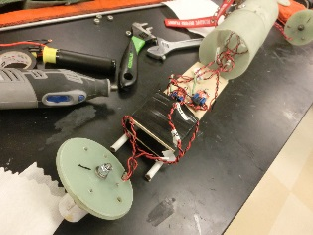

Wiring of the Electronic Bay

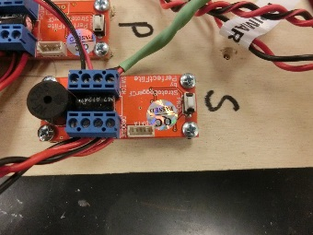

Altimeters(Primary and Secondary)

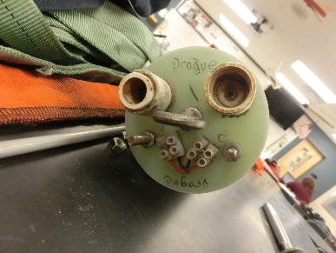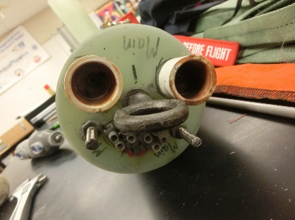

Ejection Wells(Drouge left, main right)

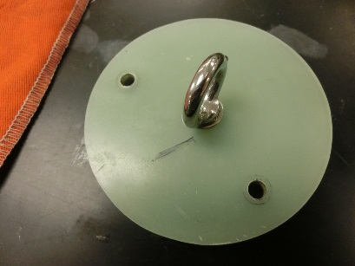

End cap of the Payload

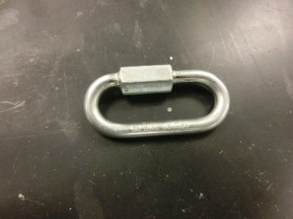

Quick Links

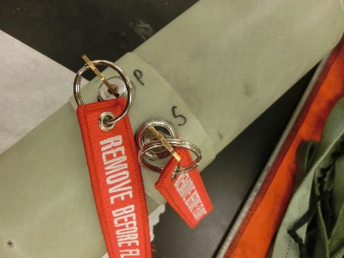

Key Switches

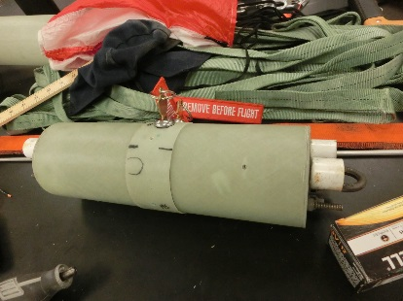

Electronic Bay

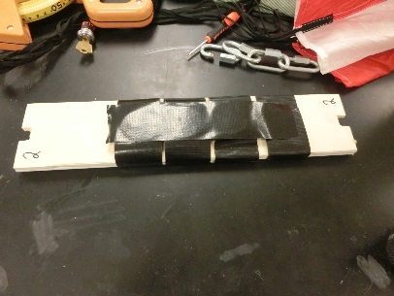

Simulated Payload

STRUCTURAL PARTS

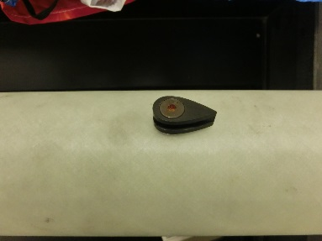

Launch Lug

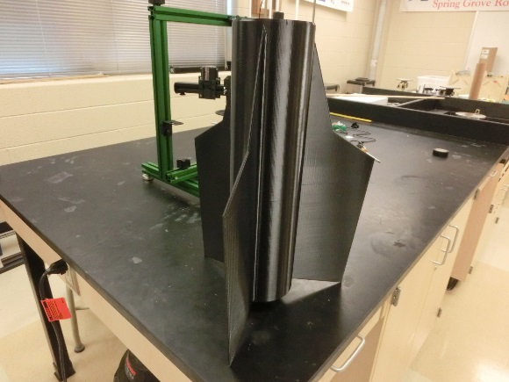

3-D Printed Fin can

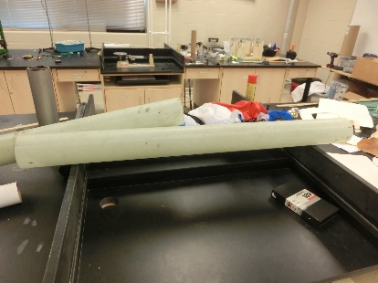

Front Body Tube

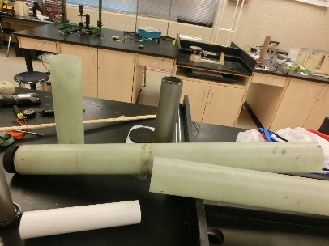

Back Body Tube

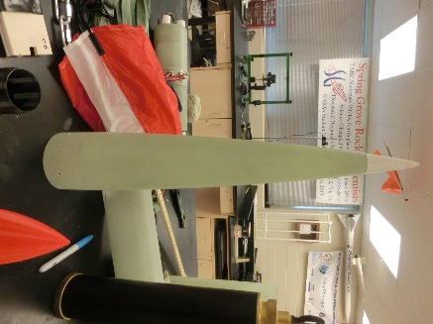

Nose Cone

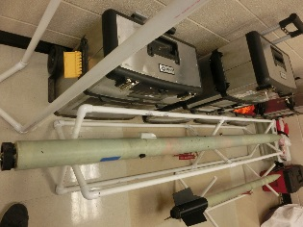

Full Rocket without Fin Can

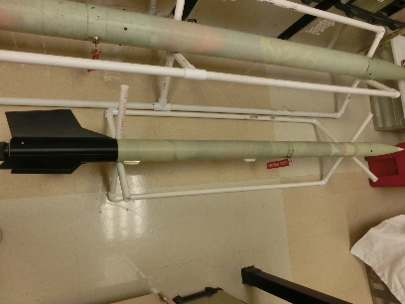

Sub Scale Rocket

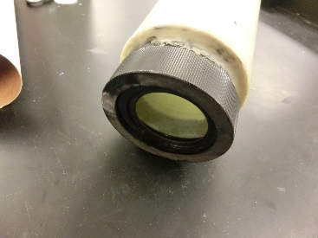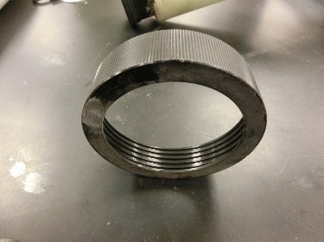

Motor Retainer

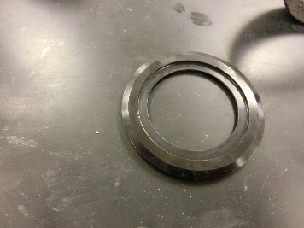

Motor Adapter 75mm to 54mm

**Subscale Flight Results**

Section 6

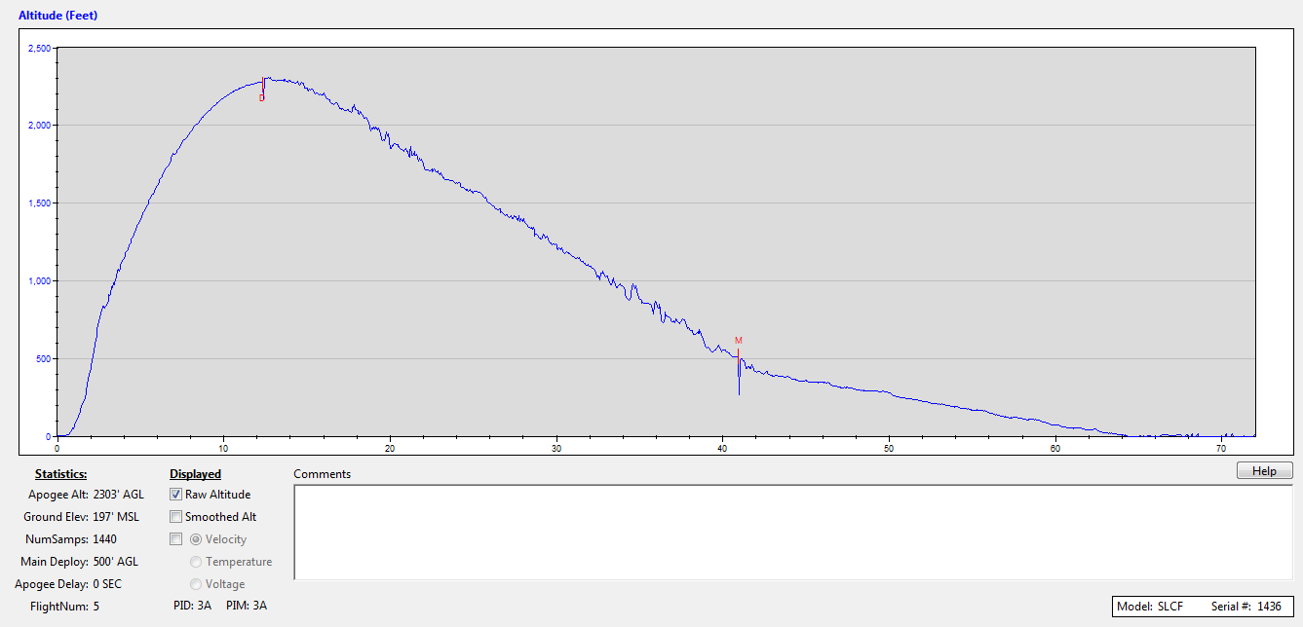

Section 7

The length of the rocket, the diameter of the tube, and the size of the nose cone were all scaled by a factor of three. The parachute size and the width of the tube wall, however, were not evenly scaled. The reason these were not scaled is because gravity doesn't scale nicely. To get the results we are looking for, we need to have the parachute at the sizes chosen.

Section 8

On the day of the subscale launch, it was around 45°, overcast, and wind of about 10 miles per hour.

https://lh5.googleusercontent.com/mgPKSKPuawGRh0sW3TDabsDg_6-dYIvFMNgLGv_PCMbAi_AkL8al32u3IX6Vy0v2ZW9byTXG3CRHQKkMXF8RDEZiV40xBjzwGYTiLHaAjSrdFLVixOFY9XQ-9daERbjMlbTH9Iii

Section 9

The flight of the sub scale rocket had a predicted height of 2403 ft. The actual height was 2303, and had a 4.2% difference. Other than the height difference, the rockets behaved the same, and made a safe decent.

Section 10

The subscale flight has shown that the design of the rocket is correct, and showed that the recovery system worked successfully. The subscale performed well, and proved the design. It did not affect the overall design of the full scale rocket.

Recovery Subsystem

● Describe and defend the robustness of the as-built and as-tested recovery system.

1. Our rocket is held together by shear pins, connecting the back body tube to the electronics bay, and connecting the nose cone and payload to the front body tube. It is also held together by pop rivets at the connection between the front body tube and the electronics bay, and as well as the connection between the nose cone and the payload. Within the rocket, the sections are held together by shock cord, which is attached to bulkheads via quick links in the payload, the electronics bay, and an eyebolt on the motor casing. These objects are robust enough to withstand the force of the shock cord pulling on them after ejection.

2. The electronics bay contains two altimeters, two 9-Volt batteries, and on the outside there are two key switches. These key switches provide power to the altimeters via the 9-Volt batteries.

3. Within the recovery subsystem, redundancy exists to ensure to safety of our rocket and of nearby humans and/or property. Two 9-Volt batteries, two altimeters, and two sets of black powder charges are present in the recovery subsystem to make sure that if something goes wrong with the primary set, a secondary is in place to eject the parachutes if the primary does not eject.

4. The main parachute is a 72 inch Iris Ultra from Fruity Chutes, which will slow our rocket to a descent velocity of 16.71 ft/s before landing. The drogue parachute is a 15 inch Elliptical from Fruity Chutes, which will slow our rocket to a velocity of 132.25 ft/s by 600 ft

5. View of main rocket components

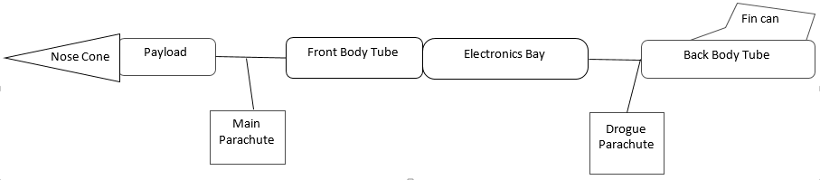

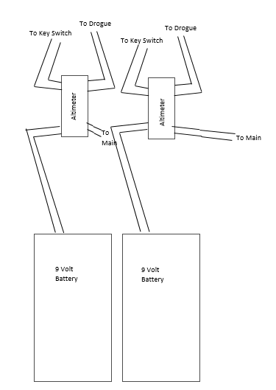View of components inside electronics bay

6. The trackers we will be using is an AT-2B Communication Specialists Inc. tracker, and the operating frequencies are 222.470 and 223.530. The wattage of these trackers are 50 milliwatts, and have a range of about 5 miles.

7. Nothing additional on the rocket generates an electromagnetic field, and no features on the rocket will be affected by an electromagnetic field. The Perfectflite Altimeter is only affected by air pressure, and the payload is not expected to be affected by an electromagnetic field.

Mission Performance

Mission Performance Criteria:

Our mission is to launch a rocket to an altitude of one mile while testing the effects of G-forces on a Non-Newtonian fluid. In order for our mission to be successful, our rocket must reach an altitude of one mile, and safely return.

Flight Profile Simulation:

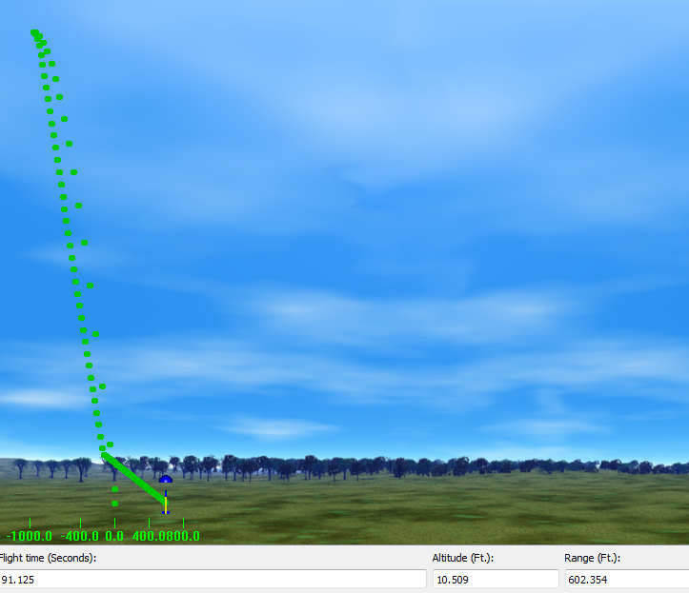

Altitude Predictions:

The predicted result of the full scale flight was that the rocket would apogee at about 5520 feet.

Component Weights:

|  |  |
| --- | --- |
| **Item** | **Weight** |
| Nose Cone | 71.96 oz |
| Body Tube | 59.20 oz |
| Shock Cord | 29.20 oz |
| Electronics Bay | 41.10 oz |
| Main Chute | 12.80 oz |
| Drogue Chute | 2.30 oz |
| Fin Can | 28.20 oz |
| Payload | 16.30 oz |

Motor Thrust Curve of the K1000:

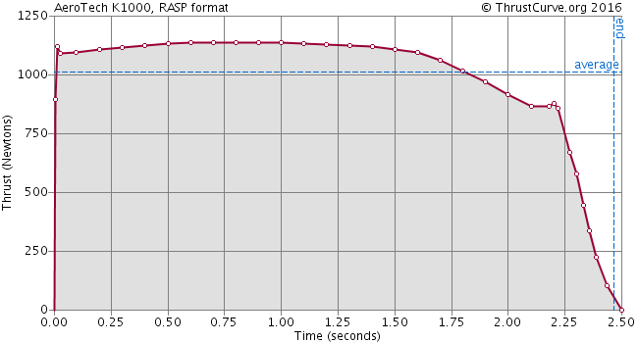

Drag Assessment:

The main parachute will create a drag force of 727.12 Newtons

The drogue parachute will create a drag force of 95.04 Newtons

Scale Modeling Results:

* Flight conditions were 45 degrees Fahrenheit , overcast, and wind of about 10 mph
* Predicted altitude of 2,403 ft
* Actual altitude was 2,303 ft
* 4.2% difference
* Very stable flight, dual deployment worked as planned

Predicted vs. Actual Results:

The predicted result of the full scale flight was that the rocket would apogee at about 5520 feet. The actual result of the full scale flight was that the rocket would apogee at BLANK feet.

Kinetic Energy (and how it will be controlled):

We will be controlling the kinetic energy by the use of a 72 inch FruityChutes parachute and a 15 inch FruityChutes parachute.

Wind Drifts:

|  |  |
| --- | --- |
| Total flight time 88.9 s | Total flight time 79.0 s |

|  |  |
| --- | --- |
| Drouge at 600ft | Drouge at 550ft |

|  |  |  |  |
| --- | --- | --- | --- |
| Wind Speed (mph) | Drift Distance (ft) | Drift Distance (ft) |  |
| 0.0 | 0.00 | 0.00 |  |
| 5.0 | 652 | 579 |  |
| 10.0 | 1305 | 1159 |  |
| 15.0 | 1957 | 1738 |  |
| 20.0 | 2607 | 2314 |  |

Full Scale Launch:

Launch Conditions:

about 40o F, about 10-15 mph wind, partly cloudy,

Simulation using weather:



Predicted vs. Actual Flight Data:

The predicted result of the full scale flight was that the rocket would apogee at about 5520 feet. The actual result of the full scale flight was that the rocket would apogee at BLANK feet.

Error:

No sources of error

Drag Coefficient of Full-scale:

The drag coefficient before the drogue chute deploys is 0.72.

The drag coefficient after the drogue chute deploys is 1.10.

The drag coefficient after the main chute deploys is 2.20.

**IV) Safety**

**Launch concerns and operation procedures**

*Final Assembly and Launch Procedure*  
         To ensure that the rocket was completed properly, the team captains and our safety officer will check over the project. They will be looking to make sure all the parts are secure and where they need to be. They will check for any errors or problems that may endanger our project to be a success. For launch, the motor will be placed in the rocket at the launch site. The rocket will be looked over once again and then will be placed on the launch pad. After this, everyone will clear to a safe distance and the rocket will be launched.

*Recovery Preparation*         The shock cord will be cut to the proper length, at least one rocket length long or longer, and then attached to each side of the electronics bay and their respective bulkheads. We will place a heat shield on the shock cord to prevent the drogue parachute from melting. Then the parachutes will be connected onto the shock cord and folded so that the fit into the tube. In the electronics bay we will check over the wiring to make sure none are touching so they don't short. We will be using a USB data transfer kit to set the altimeters to send ejection charges at apogee with the drogue chute and at 650 feet with the main chute. The redundant altimeter will be set for ejection of drogue at apogee with a 2 second apogee delay and a main chute deployment at 550 feet.

*Motor Preparation*  
         The motor is being built by our Level III NAR representative, Robert DeHate. He will assemble the motor with caution. He will follow all instructions so that the motor is built and will perform properly.

*Setup on launcher*  
         The rocket will be set up on the launch pad and we will make sure the launch lugs are smooth moving up the rail. The keys in the electronics bay will be turned and removed to activate the altimeters that will control when ejection charges deploy.

*Igniter installation*  
          We will be using the igniter provided with the Cesaroni Motor. It will be inserted into the motor so that it can ignite the motor causing the rocket to lift off.

*Preliminary checklist*

* Test altimeters in Payload
* Payload sections need to be airtight
* Check wiring in ebay section
* Check altimeters in ebay
* Fold drogue parachute properly
* Fold main parachute properly
* Observe and monitor the building of motor by our mentor
* Put payload in top body tube then pack drogue parachute
* Pack main chute in bottom section of body tube
* Connect both body tubes with ebay section
* Put shear pins in ebay holding rocket together
* Test key switches
* Take rocket to pad with igniter
* Place rocket on pad and arm altimeter, then remove key switches

*Troubleshooting*  
         If problems occur on the launch pad then our safety officer will wait the necessary time before approaching the rocket. He will check the fuse and the clips to check for any problems. If the altimeters do not set off the first ejection charges on the first altimeter, there was an internal electronic error and hopefully the redundant altimeter will set off the second ejection charges deploying the chutes properly.

*Post-flight inspection*

         We will locate the rocket’s final resting place. We will then inspect that all aspects of the rocket are still attached and in the place they should be. We will check that the shock cord is still attached to either side of the electronics bay and has not been compromised, and that the parachutes are still attached. We will then carry the rocket back to our home base where we can use a USB data transfer kit to get readings from all of the altimeters in the ebay and payload.

**SLI Team Triton, 2016-2017**

**Before launch Checklist:**

1. Test altimeters in Payload: ____________________
2. Payload sections need to be airtight: ____________________
3. Check wiring in ebay section: ____________________
4. Check altimeters in ebay: ____________________
5. Fold drove parachute properly: ____________________
6. Fold main parachute properly: ____________________
7. Observe and monitor the building of motor buy our mentor:____________________
8. Put Payload in top body tube then pack rogue parachute: ____________________
9. Pack main chute in bottom section of body tube: ____________________
10. Connect both body tubes with ebay section: ____________________
11. Put shear pins in ebay holding the rocket together: ____________________
12. Test key switches: ____________________
13. Take rocket to pad with igniter: ____________________
14. Place rocket on pad and arm altimeter, then remove key switches: ____________________

**Equipment Safety**

Framar Band Saw

Before operating the bandsaw, remove all jewelry, confine long hair, and remove or roll up long sleeves or any article of clothing that could become caught in the blade or the band saw. Also, obtain an instructor’s permission to use the machine and ensure that safety glasses are covering your eyes. When cutting, make sure adjustment knobs are tight; the upper blade guard should be around one eighth of an inch above the material being cut. Do not force any material through the blade, attempt to cut a radius smaller than the blade will allow, and do not back out of long cuts. Keep fingers on either side of the cut line, never on the line. If necessary, use a push stick or scrap block to guide the material through. Do not allow bystanders to stand to the right of the machine, because if the blade breaks, an injury may occur. Never leave the machine until the blade has come to a complete stop. If an injury should occur during the usage of the band saw, stop the machine, step on the brake to stop the blade quickly, inform an instructor of the injury, and then have the rest of the students in the classroom sit outside in the hallway to avoid being in the way of instructors and medical personnel helping the student.

Router

Before operating the router, remove all jewelry, confine long hair, and remove or roll up long sleeves or any article of clothing that could become caught in the router or router bit. Also, obtain an instructor’s permission to use the machine and ensure that safety glasses are covering your eyes. Ensure that the power switch is in the off position before plugging in the router. Then, check to make sure that the bit is firmly secured in the chuck and that the piece being worked on is firmly secured. Also make sure that the intended path of the router is free of obstructions. Hold the router with both hands and apply constant pressure. Never force the router or bit into the work. When changing bits or making adjustments turn off the router and unplug it from its power source. If an injury should occur during usage of the router, turn off the machine, inform an instructor of the injury, and then have the rest of the students in the classroom sit outside in the hallway to avoid being in the way of instructors and medical personnel helping the student.

Delta Radial Arm Saw

Before operating the saw, remove all jewelry, confine long hair, and remove or roll up long sleeves or any article of clothing that could become caught in the blade. Also, obtain an instructor’s permission to use the radial arm saw and ensure that your eyes are covered by safety glasses. Make all needed adjustments, such as adjusting the blade guard and kickback fingers, while the power is off. Test to see if leaf guards are working properly and that the blade does not extend past the edge of the table. Always firmly hold materials against the fence and pull the blade completely through the material and return blade behind the fence before removing the material and starting another cut. If too much of the table is cut away, then the instructor must be notified so that the table can be replaced. Wait for the blade to stop before leaving the machine. If an should injury occur during usage of the saw, turn off the machine, inform an instructor of the injury, and then have the rest of the students in the classroom sit outside in the hallway to avoid being in the way of instructors and medical personnel helping the student.

Planer-Surface Sander

Before operating the sander, remove all jewelry, confine long hair, and remove or roll up long sleeves or any article of clothing that could become caught in the machine. Also, obtain an instructor’s permission to use the sander and ensure that safety glasses are covering your eyes. Turn on the sawdust collection

system. Check all material for loose knots, nails, staples, or any other loose, foreign objects. Never force a material through the planer; after insertion the machine will automatically feed it through. The operator should wait on the other side of the machine to receive the material. Select a proper machine depth and speed for the material being used. Never attempt to plane more than an eighth of an inch of material in one pass. Do not look into the machine at surface level or try to clean debris while the machine is turned on. Always stand to the side, because the possibility of kickback always exists. If injury occurs during usage of the sander, turn off the machine, inform an instructor of the injury, and then have the rest of the students in the classroom sit outside in the hallway to avoid being in the way of instructors and medical personnel helping the student.

Dewalt Compound Miter Saw

Before operating the saw, remove all jewelry, confine long hair, and remove or roll up long sleeves or any article of clothing that could become caught in the blade. Also, obtain an instructor’s permission to use the saw and ensure that safety glasses are covering your eyes. Make all changes to the saw and saw blade while the power is off and the plug is disconnected from its power supply. Hold the material firmly against the fence and the table. Allow the motor to reach its full speed before attempting to cut through the material. Make sure that all guards are functioning properly. If injury occurs during usage of the Miter Saw, turn off the machine, inform an instructor of the injury, and then have the rest of the students in the classroom sit outside in the hallway to avoid being in the way of instructors and medical personnel helping the student.

Jointer

Before operating the jointer, remove all jewelry, confine long hair, and remove or roll up long sleeves or any article of clothing that may become caught in the blade. Also, obtain an instructor’s permission to use the jointer and ensure that safety glasses are covering your eyes. Turn on the sawdust collection system. Make all changes or adjustments to the jointer while the power is off. Use a push stick or scrap block if your hands run the risk of coming within two inches of the blade. Do not attempt to take off more than one eighth of an inch at a time. The minimum length of material that can be cut with the jointer is double the size of the blades. If injury occurs during usage of the jointer, turn off the machine, inform an instructor of the injury, and then have the rest of the students in the classroom sit outside in the hallway to avoid being in the way of instructors and medical personnel helping the student.

Hand Sanders

Before operating the hand sanders, remove all jewelry, confine long hair, and remove or roll up long sleeves or any article of clothing that could become caught in the machine. Also, obtain an instructor’s

17

permission to use the hand sanders and ensure that safety glasses are covering your eyes. Replace the sandpaper while the sander is off and unplugged. Only use sand paper that is in good condition and properly installed. Place the material that you intend on sanding on a flat surface and sand slowly over a large area. Wait for the sander to stop oscillating before placing it on a secure resting surface. Never carry any corded tool by the power cord. If injury occurs during usage of the hand sanders, turn off the machine, inform an instructor of the injury, and then have the rest of the students in the classroom sit outside in the hallway to avoid being in the way of instructors and medical personnel helping the student.

Electric Drills

Before operating the drill, remove all jewelry, confine long hair, and remove or roll up long sleeves or any article of clothing that could become caught in the bit. Also, obtain instructor permission before using the drills and ensure that safety glasses are covering your eyes. Replace the bit while the power is off, installing the bit properly and making sure the chuck is tightened and the chuck key is taken out. Never drill without first marking the hole with an awl. Ensure the material is clamped securely and drill with even pressure. Never carry any corded tool by the power cord. If injury occurs during usage of the electric drills, turn off the drill, inform an instructor of the injury, and then have the rest of the students in the classroom sit outside in the hallway to avoid being in the way of instructors and medical personnel helping the student.

Powermatic Drill Press

Before operating the drill press, remove all jewelry, confine long hair, and remove or roll up long sleeves or any article of clothing that could become caught in the bit or machine. Also, obtain instructor permission and ensure that safety glasses are covering your eyes. Replace the bit while the power is off, installing the bit properly and making sure the chuck is tightened and the chuck key is taken out. Firmly secure the material that you are drilling with vises or clamps. Adjust the table to avoid drilling into it and pick the correct size bit that is properly sharpened. If the drill becomes stuck turn off the machine and inform an instructor. Select the proper speed for the material. If an injury occurs during usage of the drill press, turn off the machine, inform an instructor of the injury, and then have the rest of the students in the classroom sit outside in the hallway to avoid being in the way of instructors and medical personnel helping the student.

CNC Router

Before operating the router, remove all jewelry, confine long hair, and remove or roll up long sleeves or any article of clothing that could become caught in the bit or machine. Also, obtain an instructor’s permission to use the router and ensure that safety glasses are covering your eyes. Turn on the sawdust

collection system. Make all adjustments while machine is off. Materials must be firmly secured before the project is run through the router. A person needs to be with the machine during the entire operation. Check to make sure that the spindle rotation, speed, and depth of cut are all correct before starting the machine. Only clean the machine while it is off and make sure that all setup tools are cleared from the table. If an injury occurs during usage, turn off the machine, inform an instructor of the injury, and then have the rest of the students in the classroom sit outside in the hallway to avoid being in the way of instructors and medical personnel helping the student.

Oliver Table Saw

Before operating the table saw, remove all jewelry, confine long hair, and remove or roll up long sleeves or any article of clothing that could become caught in blade. Also, obtain an instructor’s permission to use the table saw and ensure that safety glasses are covering your eyes. Turn on the sawdust collection system. Make all adjustments to the blade or guide while machine is off. Gullets of the blade must clear the top of the material. Never use the miter gauge and the fence at the same time. The miter gauge it for cross cutting and the fence is for ripping. Use extra caution while using a dado cutting head. Always use a push stick when your hand could come close to the blade and have another person at the other end of the table to catch the material that was just cut. Do not leave the table until the blade stops. If an injury occurs during usage of the table saw, turn off the machine, inform an instructor of the injury, and then have the rest of the students in the classroom sit outside in the hallway to avoid being in the way of instructors and medical personnel helping the student.

Powermatic Belt Sander

Before operating the belt sander, remove all jewelry, confine long hair, and remove or roll up long sleeves or any article of clothing that could become caught in machine. Also, obtain an instructor’s permission before using the machine and ensure that safety glasses are covering your eyes. Make all adjustments while the machine is off. Check that there is adequate tension in the belt and that it is not torn before turning on the machine. Keep the material on the table at all times. Keep fingers away from the sand paper. If an injury occurs during the usage of the sander, turn off the machine, inform an instructor of the injury. The instructor will then have any students in the room go out into the hallway. This will ensure that the students do not interfere with the injured person, instructors, or medical personnel that will be helping the student.

Powermatic Disc Sander

Before operating the disc sander, remove all jewelry, confine long hair, and remove or roll up long sleeves or any article of clothing that could become caught in the machine. Also, obtain an instructor’s permission before using the sander and ensure that safety glasses are covering your eyes. Make all adjustments while machine is off. Check that the disc was properly installed and that it is not torn. Keep the material on the table at all times. Keep fingers away from the sand paper. If an injury should occur during usage, turn off the machine, inform an instructor of the injury, and then have the rest of the students in the classroom sit outside in the hallway to avoid being in the way of instructors and medical personnel helping the student.

Powermatic Drum Sander

Before operating the drum sander, remove all jewelry, confine long hair, and remove or roll up long sleeves or any article of clothing that could become caught in the machine. Also, obtain an instructor’s permission before using the sander and ensure that safety glasses are covering your eyes. Make all adjustments while machine is off. Use the proper drum for the radius that is being sanded. Keep the material that you are sanding on the table at all times. Keep fingers away from the sand paper. If an injury occurs during usage, turn off the machine, inform an instructor of the injury, and then have the rest of the students in the classroom sit outside in the hallway to avoid being in the way of instructors and medical personnel helping the student.

Craftsman Reciprocating Saw

Before operating the reciprocating saw, remove all jewelry, confine long hair, and remove or roll up long sleeves or any article of clothing that could become caught in the blade. Also, obtain an instructor’s permission before using the saw and ensure that safety glasses are covering your eyes. Make all changes with the power off and the plug disconnected from its power supply. Firmly secure all material to a workbench or table. Allow the motor to reach its full speed before cutting through the material. Hold the saw with both hands while you are using it. If an injury occurs during usage, turn off the machine, inform an instructor of the injury, and then have the rest of the students in the room sit outside in the hallway to avoid being in the way of instructors and medical personnel helping the student.

Craftsman Circular Saw

Before operating the circular saw, remove all jewelry, confine long hair, and remove or roll up long sleeves or any article of clothing that could become caught in the blade. Also, obtain an instructor’s permission before using the saw and ensure that safety glasses are covering your eyes. Make all changes with the power off and the plug disconnected from its power supply. Firmly secure all material to a workbench or table. Before cutting, ensure that the cut line is not above the table. At least one person must be holding the material being cut off, as long as that piece is large enough for a person to hold it. Allow the motor to reach its full speed before cutting through the material. Hold the saw with both hands while using it. If an injury occurs during usage, turn off the machine, inform an instructor of the injury, and then have the rest of the students in the classroom sit outside in the hallway to avoid being in the way of instructors and medical personnel helping the student.

CNC Lathe (EMCO Concept Mill 55, Lab Volt 5400 CNC Mill, a Lab volt Automation 5500-B0)

Before operating the lathe, remove all jewelry, confine long hair, and remove or roll up long sleeves along with any article of clothing that could become caught in the bit. Also, obtain an instructor’s permission before using the lathe and ensure that safety glasses are covering your eyes. Make all adjustments while machine is off. The material that you intend on cutting must be firmly secured before the project is run through the lathe. A person needs to be with the machine during the entire operation. Check to make sure that the spindle rotation, speed, and depth of cut are all correct before starting the machine. Only clean the machine while it is off .If an injury occurs during the usage of the lathe, turn off the machine, inform an instructor of the injury, and then have the rest of the students in the classroom sit outside in the hallway to avoid being in the way of instructors and medical personnel helping the student.

Victor metal lathes

Before operating the lathes, remove all jewelry, confine long hair, and remove or roll up long sleeves or any article of clothing that could become caught in the work. Also, obtain an instructor’s permission before using the lathe and ensure that safety glasses are covering your eyes. Make all changes with the power off. Center the material so that it will not spin off-center. Firmly secure all of the material to a machine. Use the proper speed for the task at hand. Use the correct, sharpened tools. If an injury occurs during usage, turn off the machine, inform an instructor of the injury, and then have the rest of the students in the classroom sit outside in the hallway to avoid being in the way of instructors and medical personnel helping the student.

Paasche FABSF-6 spray booth

Before using the spray booth, turn on the ventilation system and wear proper protection. Use the correct spray for the material and do not inhale toxic fumes. If an injury occurs during usage, inform an instructor of the injury, and then have the rest of the students in the classroom sit outside in the hallway to avoid being in the way of instructors and medical personnel helping the student.

Miller Spot Welder

Before operating the welder, put on proper clothing, welding mask, gloves, and apron. Obtain an instructor’s permission before using the welder. Do not look at the welding torch unless you are wearing a welding mask. Ensure that the proper solder is being used and that the materials are secured. If an injury occurs during usage, turn off the machine, inform an instructor of the injury, and then have the rest of the students in the classroom sit outside in the hallway to avoid being in the way of instructors and medical personnel helping the student.

Baldor grinder/buffers

Before using the grinder and buffers, put on safety glasses, check that the spark shield is intact, and obtain an instructor’s permission to use it. Keep hands away from the spinning wheel. Adjust the tool rest to the proper height and always use it. If an injury occurs during its usage, turn off the machine, inform an instructor of the injury, and then have the rest of the students in the classroom sit outside the hallway to avoid being in the way of instructors and medical personnel helping the student.

Tennsmith Sheet metal cutter

Before operating the sheet metal cutter, remove all jewelry, confine long hair, and remove or roll up long sleeves or any article of clothing that could become caught in the cutter. Also, obtain an instructor’s permission before using the cutter and ensure that safety glasses are covering your eyes. Do not attempt to cut any material thicker than what the machine is rated for. Make sure that the material and blade are free from debris. If an injury occurs during usage, inform instructor of the injury, and then have the rest of the students in the classroom sit outside in the hallway to avoid being in the way of instructors and medical personnel helping the student.

Gravograph LS100 30 watt laser/engraver/cutter

Before operating the laser, ensure that the laser is focused, the vent fan is on, and the right speed and power are selected for the material you intended on cutting or engraving. Obtain an instructor’s permission before using the laser. Never look directly into the laser. Stay at the laser throughout the entire process. If the machine cuts an area that you didn’t want cut or malfunctions, turn off the machine and alert an instructor immediately. If an injury occurs during usage of the laser, turn off the machine, inform an instructor of the injury, and then have the rest of the students in the classroom sit outside in the hallway to avoid being in the way of instructors and medical personnel helping the student.

**Safety Plan**

Before any work is done on the rocket, a second mandatory safety meeting will take place to re-inform students of the NAR safety code.  When handling potentially hazardous materials, students will be required to read the Materials Safety Data Sheet (MSDS) on the hazardous material.  This will be done before they can work with the material.  Team members are to handle the material according to the Materials Safety Data Sheet, including, but not limited to, the handling and storage of the material.

The SL rocket will be constructed in the Spring Grove Area High School.  Students will have quick access to the following safety materials: Sellstrom SM Z87+FF Safety Goggles, Splash Aprons, Emergency Eye Wash Stations, Emergency Body Wash Stations, Cantflame Fire Blankets, BFPE type ABC Dry Chemical Fire Extinguishers regularly serviced by Dale E. Ness Inc., and Simplex Fire Alarms.  In all rooms where rockets will be assembled and prepared, there are fire detection and suppression systems present. There are also sprinklers in all rooms. We also plan on using nitrile gloves and respirators as the MSDS sheets suggest.  These will be used for the handling of potentially hazardous materials.

We have appointed a construction safety officer who is required to certify that all materials and building procedures are in conformance with the NAR High Power Rocketry Safety codes.  This construction safety officer has also been appointed as our range safety officer.  He will also certify that the launch facility, rocket engine components, and environmental conditions are within safety regulation requirements.  Our Safety Officer will be Mr. Hastings.  Mr. Hastings will be responsible for the safety and handling of the rocket motors.  He is also responsible for the safety of all of the Spring Grove SL participants while he is handling a motor.  In addition, he will oversee the construction of the project and will ensure that the Safety Plan is being followed throughout the entire project.  Mr. Hastings is NAR Level 3 certified.  Therefore, he will also be responsible for the ordering and storage of our rocket motors. He will oversee and make sure there is an emphasis on safety during construction, assembly, and launching of the rocket.  Our student safety officer is Melody Buckley.  She will ensure that all SL members follow all safety rules and guidelines.

We will incorporate safety as an integral part of the design. The rocket will also be safely inspected and checked throughout the construction. The safety officer will emphasize safety throughout the entire construction. In addition to the safety plan, we will be following the NAR High Power Safety Code guidelines as outlined below:

*Probability is rated on a scale of 1 to 10, where 1 represents a low probability that the risk will present a problem and a 10 represents a very high probability that the risk will present a problem.  Risks that are rated at ten or close to ten will be dealt with as soon as possible and handled according to the mitigation and/ the best way to handle the problem.

|  |  |  |  |
| --- | --- | --- | --- |
| **Risks** | **Probability of Risk *(1-10)** | **Impact on Project Progress** | **Mitigations** |

|  |  |  |  |
| --- | --- | --- | --- |
| We may fail to get valuable data from the rocket. | 2 | We will need to redesign, rebuild, or reload the payload. This would delay the progress of construction. | The team shall ensure that the payload is properly handled and deal with any design flaws. |
| The rocket parachute does not deploy and rocket returns unsafely to the ground. | 3 | We lose a rocket and must build another one, losing work time and time to launch. | The team will carefully insert the parachute and make sure there is enough heat shields the ground material to prevent flame up. |
| Injury could occur while using coping saw. | 2 | A leave of absence of a team member could occur due to minor or severe injury and possibly delay the rocket-building progress. | The team will be aware of limbs and fingers when using this tool. |
| Injury could occur during Exacto knife usage. | 5 | A small injury could occur, possibly delaying the rocket-building progress. | The team will carry the knife in cautious matter, cut away from oneself, and be aware fingers when using this tool. |
| Accidental combustion of rocket materials | 3 | In addition, possible injury and a delay of rocket-building progress could occur. | The team will keep 25 feet away from electrical outlets, open flame, and the indoor magazine. |
| Allergic reactions to chemicals involved in rocket production | 2 | Minor or severe chemical burns of team members and possible delay of rocket progress could occur. | The team will make all students aware of each other’s allergies and stay away from possible allergens. |
| Electrocution during electrical outlet usage | 1 | Minor or severe injury could occur. | The team will only use electrical outlets if hands are dry and static free. The team will keep fingers away from prongs. |

|  |  |  |  |
| --- | --- | --- | --- |
| Adhesion to materials or self | 4 | Minor injury and very minor delay of rocket progress could occur. | The team will exercise proper caution when  handling adhesive material and will not use too much of the material. |
| Injury during laser engraver usage | 2 | Possible combustion of rocket materials could lead to reordering of materials and delay progress. | The team will make sure the laser is on the proper power, speed, and focus settings, and ensure that the exhaust fan is on. |
| Injury during drill press usage | 2 | Severe injury and delay of progress could occur. | The team will keep clothing, hair, and body parts away from the drill bit and use safety glasses. |
| Tripping and falling hazards | 3 | Minor or severe injury, delay of rocket progress could occur. | The team will make sure the walking path is clear and keep clutter off of floor. |
| Abrasions and bruises caused by belt sander | 2 | Minor injury and delay of progress. | The team will keep hands and clothing away from the sandpaper. |
| Burning caused by soldering iron usage | 2 | Minor injury and delay of progress. | The team will use soldering iron in a proper manner and use safety gear. |
| Premature ignition of rocket motors | 2 | Possible minor or severe injury, the need to reorder rocket motors, and delay of rocket progress. | Ensure that only the proper level certified personal handle the rocket motors and installations as well as reloads. |
| Team estrangement because of lack of cooperation | 1 | Delay of rocket progress. | The team will talk calmly and will not fight with one another. The team will respect each other and themselves. |

|  |  |  |  |
| --- | --- | --- | --- |
| Going over-budget | 5 | Delay of rocket progress due to the need for more time to fundraise | The team will carefully use all materials, order only the parts needed, keep track of materials, and use the budget wisely. The team will be diligent in fundraising endeavors. |
| Misuse or mishandling of hazardous materials | 2 | Minor or severe injury, leave of absence for team member affected, and delay of progress | The team will follow all safety code regulations, laws, and instructions. |
| Unforeseen rocket design complications | 4 | Delay of rocket design and rocket building progress | The team will design a stable rocket based on the locations of the center of pressure and center of gravity. The team will also have a NAR representative check rocket design. |
| Unforeseen payload design complications | 3 | Delay of payload design and production. | The team will design a payload that will be effective for the size body tube that is used and double-check that the components of the payload are properly made. |
| Complications during transportation of participants and materials to SL or practice launch sites | 3 | Delay of rocket progress due to rocket repairs or cancellation of practice flights because of extensive damage. | The team will make sure that the launch date is known in advance and that all specifications are planned out well in advance.  The team will pack the rocket well and make sure it is secure during transportation. |

|  |  |  |  |
| --- | --- | --- | --- |
| Accidental partial or complete destruction of building site | 2 | Damage to work environment, additional expenditures for repairs, possible progress delay. | The team will ensure that safety guidelines from NAR and the MSDS are being followed. |
| Team communication failure | 3 | Rocket/payload may be built incorrectly or too many of one part may be made, causing a slight to major delay of progress or loss of material. | Every team member will have access to other members’ email addresses and have the ability to talk during the school day. |
| Shortage of rocket building materials | 2 | Major delay due to the need to order new material and wait for it to ship. | The team will double- check all materials before ordering and enforce a checklist while parts are being used. |
| Commitment complications among team members | 2 | Loss of time or team member if the complication is too great. | The team will make sure all team members make this their first priority and plan accordingly. |
| Inhalation of dangerous fumes | 2 | Minor to severe injury, time lost taking student to ER, delay of progress. | The team will wear proper safety gear, exercise proper use of fume hoods, and be aware of surroundings. |
| Accidental ingestion of rocket materials | 1 | Minor to severe injury, delay of progress, possible loss of material. | Only experienced students should work with dangerous materials under proper supervision. |
| Motor ignition delay | 3 | Launch delay, loss of motor if it does not ignite, minor to severe injury if motor ignites while personnel are approaching rocket. | The team will only use commercially available and Range Safety Officer-approved igniters. |
| Rocket catches fire on the launch pad | 2 | Possible loss of rocket, minor to severe injuries if | The team will bring a fire extinguisher suitable for |

|  |  |  |  |
| --- | --- | --- | --- |
|  |  | fire is not properly extinguished. | the needs of the fire and according to the MSDS of the motors being used. |
| Cancellation of launch due to poor conditions | 4 | Delay of testing. | The team will plan multiple days to launch, be flexible in scheduling practice launches, and practice patience. |
| Motor ignition failure | 3 | Delay of launch testing and rocket progress. | The team will ensure that commercially available igniters and motors are used and follow the NAR High Power Safety Code, which outlines what to do during motor ignition failure. |

**Procedures for NAR/TRA Personnel to Perform:**

Brian Hastings is our Level III NAR mentor as well as our safety officer. He will be certifying that the rocket motors that we are using are certified and safe for launch. He will also be ensuring that the engine reload kits are certified and safe for us to use. Mr. Hastings will also be overseeing the construction of the rocket to ensure that the rocket will only be constructed out of lightweight materials such as paper, wood, rubber, plastic, fiberglass, or, if necessary, ductile metal. He will visit occasionally to inform team members about better construction methods and how to build safely.

Mr. Hastings will verify that the rocket engines and engine reload kits are not broken upon delivery. He will also store the engines and reload kits in a locked Type 4 magazine that meets the requirements of NFPA 1127. He will verify that no sources of fire or heat are within 15 feet of the locker and 25 feet of the rocket motors when they are being used. Mr. Hastings will keep an inventory of the engines and reload kits and an adult supervisor will also ensure the completion of the above steps by the safety officer.

Mr. Hastings will be responsible for controlling the inventory of all engines and rocket motor reload kits. When ready for use, he will also update the inventory of the rocket motors and reload kits to ensure that there are no missing supplies. Engines and reload kits that are not used for flight, but have been checked out for use, will be returned to Mr. Hastings and accounted for in the inventory. Engines and  reload kits will be documented with the launch location for that particular motor or reload kit, the date and time it was used in a flight, and the number of the flight. Mr. Hastings will also be ensuring that safety equipment for hazardous materials and handling procedures for hazardous materials are being followed based on the Materials Safety Data Sheets for those materials.

**Plan for Briefing Students:**

Students will be required to participate in an introductory meeting, including reading of the NAR High Power Rocketry Safety Code to all members of the team. Team members shall also be required to attend more meetings covering the safety codes of the NFPA and FFA. During the meetings, NAR High Power Rocketry Safety Code shall be reviewed again. Examples from past experience will be used to put the discussions in perspective. Materials will be shown to all team members and they will be told of the hazards of the materials before they are able to use them.

Meetings will be held prior to launches as well. In these meetings, safety codes will be reviewed, team members will be made aware of the hazardous equipment, and team members will be informed of how to avoid other accidents. Team members will be informed on what safety equipment to use while using hazardous materials.

**Methods for Including Necessary Caution Statements:**

In order to ensure that cautionary statements are included in plans, procedures, and other working documents, we plan to post warning signs on the entrances of the room in which the indoor magazine will be placed. Cautionary statements will be placed on the entrance of room 220 to ensure that participants are aware that hazardous materials are being stored in the vicinity as well. To ensure hazardous adhesives and accelerants are handled with care, warnings will be posted on the door of the cabinet where they are stored to notify users of the risks involved with these materials. We plan on posting the Materials Safety Data Sheet for the motors being used outside of the room in which it will be stored for team members to read before entering the room. In the planned documents we also plan to include detailed plans of our safety plan and any other plans to keep everyone safe such as securing the launch site and reading all postings' on machines and launch fields. During construction and assembly of rocket team members will be required to use Personal Protective Equipment. Team members will be required to wear Sellstrom SM Z87+FF Safety Goggles during construction. The will also be informed at safety meetings on how to use emergency eyewash and ABC Dry Chemical Fire Extinguishers. When handling hazardous materials team members will use nitrile gloves.

**Plan for Complying with Laws:**

In order to comply with federal, state, and local laws regarding unmanned rocket launches and

motor handling, the Spring Grove SL team shall launch its rocket so that it stays in a suborbital trajectory.  The team shall also launch the rocket so that it does not cross into the territory of a foreign country, and the rocket shall be unmanned.  The rocket shall be launched in a manner that does not create a hazard for any persons, property, or other aircraft.  The team rocket shall also be subject to any additional operating limitations necessary to ensure that air traffic is not adversely affected, and to ensure that public safety is not jeopardized.

To ensure further compliance with FAA regulations, the team shall also avoid launching the rocket at any altitude where clouds or other obscuring phenomena of more than five-tenths coverage prevail.  This shall include not launching the rocket at any altitude where the horizontal visibility is less than five miles and not launching the rocket into any cloud.  The rocket shall not be launched between sunset and sunrise without prior authorization from the FAA and will not be launched within 9.26 kilometers of any airport boundary without prior authorization from the FAA.  The team shall not launch the rocket in controlled airspace.

The Class 2 rocket shall not be launched unless the team observes that there are appropriate separation distances between the launch site and any person or property that is not associated with the operations. The separation should not be less than one-quarter the maximum expected altitude or 457 meters (1,500 ft.), unless a person of at least eighteen years old is present and is charged with ensuring the safety of the operation, and has final approval from authority for initiating high-power rocket flight and unless reasonable precautions are provided to report and control a fire caused by rocket activities.

The Spring Grove SL team shall give the FAA and ATC facility nearest to the place of intended operation the following information no less than 24 hours before and no more than three days before beginning the operation:

a) The name and address of the event launch coordinator, whose duties include coordination of the required launch data estimates and coordinating the launch event;

b) Date and time the activity will begin;

c) Radius of the affected area on the ground in nautical miles;

d) Location of the center of the affected area in latitude and longitudinal coordinates;

e) Highest affected altitude;

f) Duration of the activity;

g) Any other pertinent information requested by the ATC facility.

The Spring Grove SL team shall also research state and local laws regarding rocketry in order to ensure compliance with all laws associated with rocketry in the vicinity of the rocket launch site. The team shall also be in compliance with all rules and regulations regarding rocket launch sites, rocket motor storage, and rocket launch safety described in NFPA 1127.

**Plan for Motor Handling and Storage:**

Rocket motors will be purchased through our NAR level III certified representative, Brian Hastings. All motors will be stored within a Type 4 magazine and access will be granted solely to our NAR representative. Mr. Hastings will be responsible for the safe transportation and construction of the rocket motor reloads. Any use of the motor will be under his supervision at all times.

**Team Agreements: All team members read and signed a copy of the agreement below.**

Spring Grove SL Team Agreements:

As a team member:

1. I agree to comply with all applicable local, federal and state laws.

2. I agree to use of airspace laws of Federal Aviation Regulations 14 CFR, Subchapter F, Part 101, and Subpart C.

3. I agree to handle and use low explosives according to the Code of Federal Regulation 27 Part 55: Commerce in Explosives.

4. I also agree to follow all fire safety regulations according to NFPA 1127 “Code for High Power Rocket Motors.”

5. I will follow the NAR High Power Rocketry Safety Code.

6. I agree to read the Material Safety Data Sheet and follow all of its instructions. I will be aware of the hazards that are involved with the materials that we are using in our project. This includes, but is not limited to, the rocket motor.

7. I will use safety equipment in accordance to its safety regulations during the construction of the rocket.

8. I will obey all instructions given by the project manager and supervisors.

9. I agree to work with my team members in a constructive manner in order to make a safe environment for all team members to work together.

10. I am committed to working on this team until the completion of our project.

11. As a team member, I promise to show up to 75 percent or more of all meetings and do my work when I am assigned and do my work to the best of your own ability.

As a team:

A. We agree that there will be range safety inspections for each of our rockets before they are flown. Upon inspection, we will comply with the determination of the safety inspection.

B. We agree that The Range Safety Officer has the final say on all rocket safety issues. Therefore, The Range Safety Officer has the right to deny the launch of any of our rockets for safety reasons.

C. We agree that if our team that does not comply with the safety requirements we will not be able to launch our rocket.

I agree to the Spring Grove SL Team Agreements above. I understand that any violation of these rules will result in consequences including getting taken off the team.

Name: ___________________ Signature: _____________________ Date: _____________

**Safety and Environment (Vehicle and Payload)**

**Safety and Environment (Vehicle and Payload)**

Potential failures in our proposed rocket

* The potential failures can include adhesion failure, a motor that may be incapable of carrying the rocket through the extreme atmospheric pressure, breaking of bulkheads, and breaking of centering rings. The body of the rocket may not be able to withstand the high pressures and forces it will endure in its ascent to the clouds.
* A way to ease these failures is to use a durable epoxy which will be tough enough to withstand the incredible pressures and join the components without shattering the covalent bond. We intend to use fiberglass tubing so the structural surround sound is at optimum capacity. Few problems may arise surrounding the payload such as payload being too big for the given hole, an improperly attached shock cord. To avoid these errors before they occur we will triple check the exterior diameter of the body tube and the interior diameter to ensure they fit together like peas in a pod to ensure room for said components. When building the rocket we will take into account the size of the payload and other apparatuses in order to ensure that there is plenty of space for the rocket to properly fit together.
* Launch operations may fail due to a motor delay, the ejection charge not being set off and having an ejection charge that is not powerful enough to break apart the rocket and provide a safe decent. In order to avoid these failures we will rule over our NAR representative with an iron fist to ensure they properly build and rebuild the motor with zero faults. We will ensure we use proper amounts of black powder during ejection so nothing explodes. We have used proper research on hazard and safety regulations have been met and we ensure all procedures are followed to a tee.

**Environmental Factors**

* It is incredibly important to us that the environment is protected at all costs. Our project is environmentally friendly. Our rocket may only affect the environment t if we do not recover the rocket. The burning black powder produces low amount of potentially toxic gas however the level released is so low that it will not cause major harm to the environment. Animals who consume the potentially hazardous parts could be affected however we ensure that our rocket lands within a 2500 foot radius and we scour the lands in search for all pieces of our rocket.
* The environment may affect our launch as well. Winds could cause our rocket to travel far from the launch pad. The humidity may cause the rocket to not travel as high. Rain will hurt the electronics if they get wet and any wet landing surface such as a creek, pond, or lake may cause damage to the payload data and electronics.

|  |  |  |  |
| --- | --- | --- | --- |
| **Risks** | **Probability of Risk *(1-10)** | **Impact on Project Progress** | **Mitigations** |

|  |  |  |  |
| --- | --- | --- | --- |
| We may fail to get valuable data from the rocket. | 2 | We will need to redesign, rebuild, or reload the payload. This would delay the progress of construction. | The team shall ensure that the payload is properly handled and deal with any design flaws. |
| The rocket parachute does not deploy and rocket returns unsafely to the ground. | 3 | We lose a rocket and must build another one, losing work time and time to launch. | The team will carefully insert the parachute and make sure there is enough heat shields the ground material to prevent flame up. |
| Injury could occur while using coping saw. | 2 | A leave of absence of a team member could occur due to minor or severe injury and possibly delay the rocket-building progress. | The team will be aware of limbs and fingers when using this tool. |

|  |  |  |  |
| --- | --- | --- | --- |
| Injury could occur during Exacto knife usage. | 5 | A small injury could occur, possibly delaying the rocket-building progress. | The team will carry the knife in cautious matter, cut away from oneself, and be aware fingers when using this tool. |
| Accidental combustion of rocket materials | 3 | In addition, possible injury and a delay of rocket-building progress could occur. | The team will keep 25 feet away from electrical outlets, open flame, and the indoor magazine. |
| Allergic reactions to chemicals involved in rocket production | 2 | Minor or severe chemical burns of team members and possible delay of rocket progress could occur. | The team will make all students aware of each other’s allergies and stay away from possible allergens. |
| Electrocution during electrical outlet usage | 1 | Minor or severe injury could occur. | The team will only use electrical outlets if hands are dry and static free. The team will keep fingers away from prongs. |

|  |  |  |  |
| --- | --- | --- | --- |
| Adhesion to materials or self | 4 | Minor injury and very minor delay of rocket progress could occur. | The team will exercise proper caution when  handling adhesive material and will not use too much of the material. |
| Injury during laser engraver usage | 2 | Possible combustion of rocket materials could lead to reordering of materials and delay progress. | The team will make sure the laser is on the proper power, speed, and focus settings, and ensure that the exhaust fan is on. |
| Injury during drill press usage | 2 | Severe injury and delay of progress could occur. | The team will keep clothing, hair, and body parts away from the drill bit and use safety glasses. |
| Tripping and falling hazards | 3 | Minor or severe injury, delay of rocket progress could occur. | The team will make sure the walking path is clear and keep clutter off of floor. |
| Abrasions and bruises caused by belt sander | 2 | Minor injury and delay of progress. | The team will keep hands and clothing away from the sandpaper. |
| Burning caused by soldering iron usage | 2 | Minor injury and delay of progress. | The team will use soldering iron in a proper manner and use safety gear. |
| Premature ignition of rocket motors | 2 | Possible minor or severe injury, the need to reorder rocket motors, and delay of rocket progress. | Ensure that only the proper level certified personal handle the rocket motors and installations as well as reloads. |
| Team estrangement because of lack of cooperation | 1 | Delay of rocket progress. | The team will talk calmly and will not fight with one another. The team will respect each other and themselves. |

|  |  |  |  |
| --- | --- | --- | --- |
| Going over-budget | 5 | Delay of rocket progress due to the need for more time to fundraise | The team will carefully use all materials, order only the parts needed, keep track of materials, and use the budget wisely. The team will be diligent in fundraising endeavors. |
| Misuse or mishandling of hazardous materials | 2 | Minor or severe injury, leave of absence for team member affected, and delay of progress | The team will follow all safety code regulations, laws, and instructions. |
| Unforeseen rocket design complications | 4 | Delay of rocket design and rocket building progress | The team will design a stable rocket based on the locations of the center of pressure and center of gravity. The team will also have a NAR representative check rocket design. |
| Unforeseen payload design complications | 3 | Delay of payload design and production. | The team will design a payload that will be effective for the size body tube that is used and double-check that the components of the payload are properly made. |
| Complications during transportation of participants and materials to SL or practice launch sites | 3 | Delay of rocket progress due to rocket repairs or cancellation of practice flights because of extensive damage. | The team will make sure that the launch date is known in advance and that all specifications are planned out well in advance.  The team will pack the rocket well and make sure it is secure during transportation. |

|  |  |  |  |
| --- | --- | --- | --- |
| Accidental partial or complete destruction of building site | 2 | Damage to work environment, additional expenditures for repairs, possible progress delay. | The team will ensure that safety guidelines from NAR and the MSDS are being followed. |
| Team communication failure | 3 | Rocket/payload may be built incorrectly or too many of one part may be made, causing a slight to major delay of progress or loss of material. | Every team member will have access to other members’ email addresses and have the ability to talk during the school day. |
| Shortage of rocket building materials | 2 | Major delay due to the need to order new material and wait for it to ship. | The team will double- check all materials before ordering and enforce a checklist while parts are being used. |
| Commitment complications among team members | 2 | Loss of time or team member if the complication is too great. | The team will make sure all team members make this their first priority and plan accordingly. |

|  |  |  |  |
| --- | --- | --- | --- |
| Inhalation of dangerous fumes | 2 | Minor to severe injury, time lost taking student to ER, delay of progress. | The team will wear proper safety gear, exercise proper use of fume hoods, and be aware of surroundings. |
| Accidental ingestion of rocket materials | 1 | Minor to severe injury, delay of progress, possible loss of material. | Only experienced students should work with dangerous materials under proper supervision. |
| Motor ignition delay | 3 | Launch delay, loss of motor if it does not ignite, minor to severe injury if motor ignites while personnel are approaching rocket. | The team will only use commercially available and Range Safety Officer-approved igniters. |
| Rocket catches fire on the launch pad | 2 | Possible loss of rocket, minor to severe injuries if fire is not properly extinguished. the needs of the fire and according to the MSDS of the motors being used. | The team will bring a fire extinguisher suitable for |

|  |  |  |  |
| --- | --- | --- | --- |
| Cancellation of launch due to poor conditions | 4 | Delay of testing. | The team will plan multiple days to launch, be flexible in scheduling practice launches, and practice patience. |
| Motor ignition failure | 3 | Delay of launch testing and rocket progress. | The team will ensure that commercially available igniters and motors are used and follow the NAR High Power Safety Code, which outlines what to do during motor ignition failure. |
| Parachute deployment failure | 1 | Possible loss of rocket and broken tail fin | The team will tie the parachute protector to the shock cord instead of the parachute itself to avoid the cords from getting tangled and keeping the parachute from deploying. |

|  |  |  |  |
| --- | --- | --- | --- |
|  |  |  |  |

**V) Payload Design**

How does the material oobleck react to G-force?

Oobleck is a colloid that when pressure in applied to the substance it turns into a solid. When no applied forces are acting on the colloid is turns into a liquid. Are payload is testing if G-forces from the rocket causes the colloid to solidify or remain a liquid. We will test this by using a two test tubes and a solenoid. The test tubes will be placed vertically of each other with a metal clamp pinching a flexible tube connecting the two test tubes. The colloid will be placed in the top test tube. The payload circuit consists of a NI-MH battery, rotary arming switch, G-switch, latching relay, a timer, two test tubes and a solenoid.

Before the launch:

* The payload circuit will be armed with an arming switch.

During the launch:

* When the rocket starts moving the G switch will close.
* When the G switch closes it allows power from the 12v battery to flow to the latching relay.
* The latching relay energizes and stays latched on.
* That allows power to flow from the battery through the latching relay to the timer relay.
* When the timer relay is energized it will allow power to flow to the battery to the solenoid.
* The solenoid is then energized, which will open up the path between the two tubes (open up the metal clamp).
* The timing relay has a timing circuit that can be set form 0 to 20 seconds to allow the solenoid to be powered for a fixed period of time.
* That time has to match the vertical ascent time of the rocket or less.
* When the timer relay times out power is cut to the solenoid.
* The solenoid will then de-energizes closing the path between the upper and lower tubes.

Note: The arming switch is also the safety switch, because it will not allow the circuit to be energized until it is manually set.

An alternative design will include one altimeter, one DC 12 volt battery, two solenoid valves, if room two cameras, a NE555 timer and two test tubes. When the rocket comes off the launch pad, the altimeter will close staring the timer and opening the solenoid valve for how many seconds we adjust it to. The oobleck in the top test tube will either drain to the bottom or stay in the top tube. The solenoid valve will then close when the timer stops and the data will be collected when retrieved. If room cameras in the rocket will add to the data collected in this experiment by visually showing what happens to the colloid when G-forces are applied.

The fist payload design is the best choice because it’s the easiest to design and it’s robust.

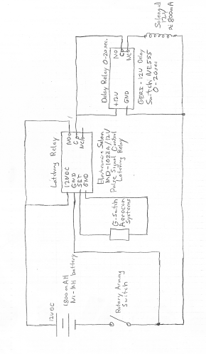The experiment will be housed in separate compartment, similar to the ebay housing, in the nose cone and extended out to the rockets body. The compartment housing our experiment will be about 14 inches and will be glued to the nose cone. Sheer pins will be used to hold the experiment housing to the body tube and will break during ejection allowing the nose cone to split form the body tube. The parts inside will mounted on one of the fiberglass caps. This cap will have a U-bolt screwed on the outside of the cap, which will be connected with a quick link to the main parachute. A wooden piece (the sled) will be secured perpendicular to the inner part of the disk/cap allowing the solenoid valves to be removable. Because the payload is housed in a separate compartment it had no risk of interfering with any other components of the rocket.

Electronics Circuit

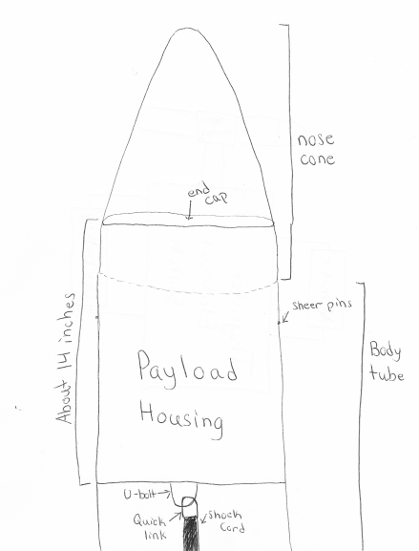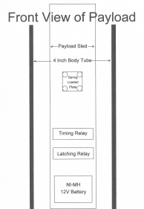

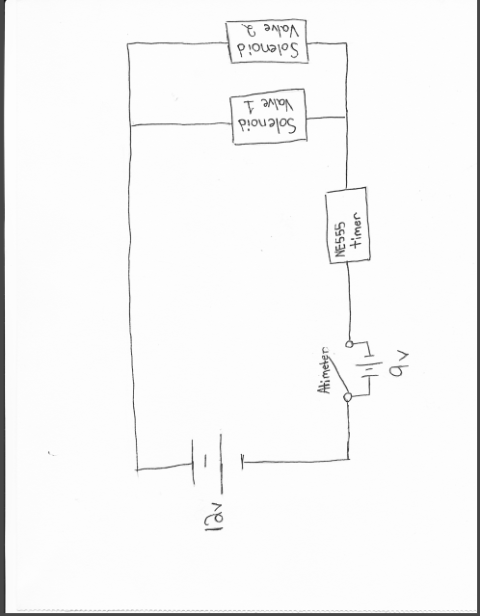

Alternative Payload Electronics System

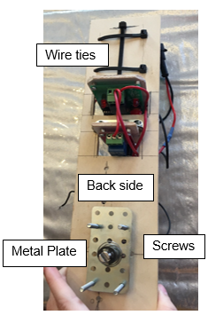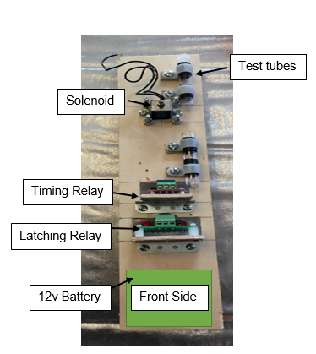

In our rocket recovery system design, will have 2 parachutes connected to shock cord. Each shock cord will have one end connected to the electronics bay. Our shock cord in the bottom half of our rocket will house our drogue parachute which will connected in the middle of the shock cord. The ends will be connected to the bottom of the electronics bay and the bulkhead on the outside of our payload housed above our motor. Our shock cord in the front half of our rocket will have the main parachute connected in the middle of the shock cord. The ends will be connected to both the top of electronics bay and to the bulkhead on our nosecone with quick links.

Our altimeters in the electronic bay will trigger 2 separate ejection charges with one on each end of our electronics bay. One altimeter will be our main altimeter which will fire an ejection charge at apogee to eject our drogue parachute, as well as fire our ejection charge at 600ft to eject our main parachute. The second altimeter is a redundant altimeter that will fire after 3 seconds to ensure that we have separation of our vehicle parts. The first ejection charge fired from the main altimeter will eject the back half of the rocket off away from the electronic bay. The second ejection charge fired from the main altimeter as well and will eject our nose cone out from the rest of our rocket pulling out the main parachute thus deploying our main parachute.

**Vehicle Requirements**

The Spring Grove Area High School Rocket design for the launch vehicle is designed and intended to reach an altitude of 5,280 feet above ground level and not exceed that limit. During the flight, the vehicle is designed and made to remain under mach 1 for the entire flight going up and returning safely back to Earth. This rocket is designed to contain a recovery system and proper components to make the rocket recoverable and reusable. The rocket is also designed to only contain four independent sections all tethered together which is exactly the legal limit. The launch vehicle shall be constructed before reaching a launch site, so that the rocket is capable of being prepared for flight within two hours from the time the FAA flight waiver opens. The rocket is going to contain the proper components needed to keep the rocket in launch-ready configuration for one hour without losing any functionality of any onboard components that are critical to the safety and success of the launch. The launch vehicle shall also contain components which would make it compatible with either an eight foot 1010 or a 1515 rail. The vehicle will also be capable of being launched with a standard 12 volt DC current firing system. It won’t need external circuitry or special ground support equipment to initiate its launch. The vehicle will make use of a commercially available solid fuel motor propulsion system which uses an ammonium perchlorate composite propellant approved by the NAR, TRA, and the CAR. The vehicle shall contain no more ballast than 10% of the unballasted vehicle mass. The final rocket design will be flown and recovered in full scale prior to the FRR. The successful flight of the full-scale rocket shall be documented on the flight certification form by a Level 2 or 3 NAR/TRA observer, and then documented in the FRR. After successful completion of the full-scale flight, the rocket and its components will not be altered without the concurrence of the NASA Range Safety Officer (RSO). All of our launch vehicles won’t, in any way employ forward canards, forward firing motors, titanium sponges, hybrid motors, or a cluster of motors. The launch vehicle of Spring Grove Area High School has been designed to deploy two separate recovery systems. The first of those two recovery systems is designed to deploy at apogee and consists of a small, drogue parachute. The secondary recovery system, that deploys at a much lower altitude consist of a larger, main chute. This deployment is necessary to reduce the speed of the falling rocket to a safer landing speed. All sections of the vehicle shall have a kinetic energy less than 75 foot pounds of force. The vehicle has also been designed to land within 2500feet of the launch pad, assuming a 15 miles per hour wind, ensuring the safety of those outside of the 2500foot radius of the launch pad. The recovery system circuits have also been designed to be completely separate from the payload’s electrical circuits. The recovery system of the rocket has also been designed to include commercially available altimeters. The altimeter contained within the recovery system has also been designed by the manufacture to be armed from the outside of the rocket airframe with an arming switch. The altimeter shall have a power supply reserved for the use of the altimeter only. The arming switch for the altimeter will also be capable of being locked in the ON position for the entire duration of the launch. The arming switch for the altimeter must be less than six feet above the base of the rocket. The main parachute compartment and the drogue parachute compartment shall also contain removable shear pins. During flight a functional electronic transmitting device is intended to be placed inside the rocket. It will be used to track all of the components of the rocket. The recovery system electronics have also been incorporated into the rocket design in a way that no other onboard electronic devices adversely affect the recovery system. The recovery system will use low-current, commercially available electric matches to ignite all onboard ejection charges. The electronic ignition system for ejection charges won’t use a flashbulb. In addition, a rear ejection parachute design will not be used.

**Technical Challenges and Solutions**

|  |  |
| --- | --- |
| Challenge | Solution |

|  |  |
| --- | --- |
| Keeping the oobleck mixed. | Mix the two parts cornstarch and one part water to make the the colloid within an hour or less before the rocket is taken out to the payload. This will keep the colloid mixture from separating and losing its properties. |
| The motor selection will determine the length of the of time the rocket accelerates effecting the time of our experiment | We can use RockSims to get an estimation on the time of our rockets acceleration, so we can then set the timer for our experiment. |
| Determine the optimum dimeter of our test tubes. | If the test tubes are too big and the colloid might solidify under the G-forces, causing the colloid to drop to the bottom test tube. If the test tube is too small then the colloid might stay in a solidified state casing not change during the rockets accent. We can solve this by trial and err or by placing a small ring in the top test tube so when the solenoid valve opens the colloid either turns into a liquid and flows through the hole, or the colloid stays in the top tube do to a solid state of matter. |
| Getting all electronics to work together at the same time. | In order to insure that all electronics work together at the same time the electronics will be test prior to flight. We also have two of each electronics (solenoid valve and camera) in the nose cone, if in the event that one of the electronics fails to work we have a back up to collect the data. |
| Creating a rocket that won’t go over 5280 feet. | Design the rocket to fly one mile high or slightly over under perfect conditions. This is accounted for the highly probable that the rocket will weigh 25 percent more than calculated values. Therefore in experimental launches you will have consider all factors like air resistance (that will cause drag) and modify as needed. |

**VI) Launch Operations Procedures**

*Final Assembly and Launch Procedure*

To ensure that the rocket was completed properly, the team captains and our safety officer will check over the project. They will be looking to make sure all the parts are secure and where they need to be. They will check for any errors or problems that may endanger our project to be a success. For launch, the motor will be placed in the rocket at the launch site. The rocket will be looked over once again and then will be placed on the launch pad. After this, everyone will clear to a safe distance and the rocket will be launched.

*Recovery Preparation*

The shock cord will be cut to the proper length, 50 feet, and then attached to each side of the electronics bay and their respective bulkheads. We will place a heat shield on the shock cord to prevent the drogue parachute from melting. Then the parachutes will be connected onto the shock cord and folded so that the fit into the tube. In the electronics bay we will check over the wiring to make sure none are touching so they don't short. We will be using a USB data transfer kit to set the altimeters to send ejection charges at apogee with the drogue chute and at 600 feet with the main chute. The redundant altimeter will be set for ejection of drogue at apogee with a 2 second apogee delay and a main chute deployment at 500 feet.

*Motor Preparation*

The motor is being built by our Level III NAR representative, Brian Hastings. His NAR number is 96571. He will assemble the motor with caution. He will follow all instructions so that the motor is built and will perform properly.

*Setup on launcher*

The rocket will be set up on the launch pad and we will make sure the launch lugs are smooth moving up the rail. The keys in the electronics bay will be turned and removed to activate the altimeters that will control when ejection charges deploy.

*Igniter installation*

We will be using the igniter that was purchased with the Aerotech motor. It will be inserted into the motor so that it can ignite the motor causing the rocket to lift off. The wires will then be connected to the launch pad clips.

*Preliminary checklist*

• Test connections in payload

• Payload section needs to be airtight

• Check wiring in ebay section

• Check altimeters in ebay

• Fold drogue parachute properly

• Fold main parachute properly

• Observe and monitor the building of motor by our mentor

• Put payload in top body tube attached to the nose cone, then pack main parachute

• Pack drogue chute in bottom section of body tube

• Connect both body tubes with ebay section. On the top use 4 plastic pot rivets, on the back two shear pins.

• Test key switches

• Take rocket to pad with igniter

• Place rocket on pad and arm altimeters by removing key switches

*Troubleshooting*

If problems occur on the launch pad then our safety officer will wait the necessary time before approaching the rocket. He will check the fuse and the clips to check for any problems. If the altimeters do not set off the first ejection charges on the first altimeter, there was an internal electronic error and hopefully the redundant altimeter will set off the second ejection charges deploying the chutes properly.

*Post-flight inspection*

We will locate the rocket’s final resting place. We have an RF tracking device that can locate the rocket. We will then inspect that all aspects of the rocket are still attached and in the place they should be. We will check that the shock cord is still attached to either side of the electronics bay and has not been compromised, and that the parachutes are still attached. We will then carry the rocket back to our home base where we can use a USB data transfer kit to get readings from all of the altimeters in the ebay and payload.

**VII) Project Plan**

Testing

Subscale

* Our subscale launch was successful, it was stable, the rocket went up straight, and the parachutes deployed when it was required. The full- scale was built to the specifications of the subscale so there was no changes from the subscale launch. The mass for the subscale was not changed because we were looking at the altitude and we were just looking at the design of the rocket and same goes for the motor, also the parachute. All we were looking for was the safe recovery.

Ground test for full scale

* We saw that the length of the back shock cord was a bit short and the charge was a little too energetic. As a result, the charge was reduced and the shock cord lengthened. It was also retested successfully. The new configuration was used on all 5 full scale launches to date successfully.

Flight testing full scale

* For the 1st full-scale launch we used a CTI K510 twice and we didn’t use a payload or mass to represent the payload. The height was 5900ft and the trust to weight ratio was too close to the 5.0 minimum. The overall launch was successful and we need to work on the trust to weight ratio and the height was also a problem. This launch showed us that we need to the work on the trust to weight ratio, we need to work on the mass of the rocket and the impulse of the motor. We must change the mass of the rocket so we can get to are required height.
* For the 2nd full-scale launch we tested three different motors, the Aerotech K1000 and K560 and also the CTI K711. The CTI K711 is the one we proposed to use but we are waiting on CTI approval of the shock cord attachment to the front of the motor casing as requested. If the CTI K711 doesn’t work out our backup is the Aerotech K1000. With these three launches we used a simulated payload weight that was 16 oz. We did three launches of the rockets, which were all successful. We just need to test out the actual payload and see if any changes need to be made. The next full scale launches are planned for March 11 and 12.

Requirements Compliance

The verification plan for all of the parts one through five can be seen in the form of a checklist that will be printed out and tacked to every launch to ensure that we have all of our requirements met before me launch. For our specific rocket we will be testing it multiple times as to verify the requirement. The associated plan needed for verification is to launch our rocket a number of times to ensure safety, flight readiness, and its ability to meet the requirements set by the NASA Student Launch Initiative guidebook this timeline can be seen in the part entitled “Budget and Timeline”. Our current status on testing the rocket can be seen in our timeline and the launches we plan to attend, further results can be seen in the section entitled “Testing”.

Our set of team derived requirements to meet can be seen in the checklist written out. These will be our minimal requirements for mission success. Our before flight checklist will be handled with great care and will be inspected by multiple people, both from the team and the team’s advisors, to ensure that nothing was missed and everything is flight ready. Our plan can be seen as the checklist below and a status can be seen in the parts entitled “Testing” and “Safety and Environment”.

Budgeting and Timeline:

**Budget:**

|  |  |
| --- | --- |
| ***Item*** | ***Cost (In dollars)*** |
| Travel to Huntsville | 3500 |
| Food for all trips | 4860 |
| Practice trips to Maryland x4 | 3360 |
| Lodging in Huntsville | 4038 |
| Nose Cone (full scale) x 2 | 138 |
| Nose Cone (sub scale) x 2 | 118 |
| Body Tubes (full scale) | 1000 |
| Body Tubes (sub scale) | 380 |
| E-bay (full scale) | 70 |
| E-bay (sub scale) | 74 |
| Rocket Stand | 45 |
| RocketPoxy | 84.96 |
| Shock Cord (full scale) | 180 |
| Shock Cord (sub scale) | 119.5 |
| Large Parachute (full scale) | 530 |
| Large Parachute (sub scale) | 178 |
| Small Parachute (full scale) | 132 |
| Small Parachute (sub scale) | 120 |
| Centering Rings | 96 |
| Bulkheads | 96 |
| Reload (full scale) | 1027 |
| Reload (sub scale) | 327.8 |
| Couplers (full scale) | 52 |
| Couplers (sub scale) | 20 |
| Motor Mount Tube x2 | 19.9 |
| Engine Retainers | 130 |
| U-bolts | 15.84 |
| Quick Links | 14.88 |
| Altimeters | 295.46 |
| Batteries for E-bay | 25.46 |
| Wires | 30.78 |
| All-threads | 6.4 |
| Key switches | 106.68 |
| 3D Printer filament | 84.88 |
| Camera | 199.98 |
| Battery Holder | 5.6 |
| Solenoid Valve x2 | 8.55 |
| Delay timer x2 | 15.78 |
| Latching relay x2 | 12.79 |
| Cordless soldering iron | 53.4 |
| Forged eyebolt x8 | 5.49 |
| 1/4 Quick links x50 | 34 |
| Battery pack for payload x2 | 9.92 |
| Power relay x2 | 6.84 |
| Patches x400 | 400 |
| Jackets x10 | 554 |
| Polos x20 | 456 |
|  |  |
| ***Total*** | ***23038.89*** |

**Funding Plan:**

In order to receive the necessary funds to successfully complete this project, our team intends to cover the costs through a combination of fundraisers, donations and sponsors/grants, all of which will be completed and then sent to our financial advisor for approval. Past, current, and future fundraisers include the sale of “Nuts About Granola” (information is located at www.nutsaboutgranola.com), cotton candy at school sporting events, Bonus Books (information is located at [www.bonusbook.com](http://www.bonusbook.com)), and 3D printed figurines as well as Fall and Spring Paint Night events. We have received a grant from TE Connectivity for $7,500, a grant from Pennsylvania Space Grant Consortium for $2,500, a grant from the National Association of rocketry (NAR) Cannon Award for $500 for establishing rocketry course, a grant from the Engineering Society of York for $1,000, a grant from the Hanover Rotary for $1,000, a grant from M&T Bank for $1,250, and a grant from the Spring Grove Educational Fund for $1,000. We also received a donation from Rutter’s for $250 and another donation for $100. We are also expecting a donation from a previous sponsor, Aquaphoenix. All funds raised or donated will be used towards the purchase of supplies and travel to practice launches and Huntsville, AL in April.

**Timeline:**

**September 2016:**

* September 17, 2016 – travel to Centreville, MD for a launch to introduce our new team members on how we do our launches.
* September 30, 2016 – travel to Greenbelt, MD to tour the NASA Goddard.
* Begin fundraising - we will be selling:
  + Cotton candy at home football games
  + 3D printed “rocktopi”

**October 2016:**

* Work collaboratively on the Preliminary Design Review.
* Begin building the sub-scale rocket.
* October 16, 2016 – travel to Centreville, MD for a practice launch
* October 25, 2016 - We will be touring TE Connectivity since they donated a lot of money to our team
* Continue fundraising - we will be selling:
  + Cotton candy at home football games.
  + 3D printed “rocktopi”
  + Paint night – October 24, 2016

**November 2016:**

* November 19 & 20, 2016 – travel to Centreville, MD for a sub-scale launch.
* Begin building the full-scale rocket.
* Continue fundraising - we will be selling:
  + 3D printed “rocktopi”
  + Bonus Books
* PDR presentation – November 29,, 2016

**December 2016:**

* Work collaboratively on our Critical Design Review.
* Continue building the full-scale rocket.
* Continue fundraising - we will be selling:
  + 3D printed “rocktopi”
  + Bonus Books

**January 2017:**

* Work collaboratively on our Critical Design Review.
* Continue building the full-scale rocket.
* January 14 & 15, 2017 – travel to Price, MD for a full-scale launch.
* Continue fundraising - we will be selling:
  + 3D printed “rocktopi”
  + Nuts About Granola
* CDR presentation

**February 2017:**

* February 11 & 12, 2017 – travel to Price, MD for a full-scale launch.
* Continue fundraising - we will be selling:
  + 3D printed “rocktopi”
  + Nuts About Granola
  + Avon

**March 2017:**

* March 11 & 12, 2017 – travel to Price, MD for a full-scale launch.
* Continue fundraising - we will be selling:
  + 3D printed “rocktopi”
  + Nuts About Granola
  + Paint Night event – March 9, 2017
* Work on our Flight Readiness Review
* FRR presentation

**April 2017:**

* Travel to Huntsville, Alabama
* Work on Post Launch Assessment Review

**Community Support:**

To publicize our project, our team will be contacting local television stations like FOX43

of the FOX Corporation and WGAL 8 in the Susquehanna Valley like we have done in previous years as well as contacting local radio stations like 107.7 and 105.7. Lastly we will contact local newspapers to spread the word of the Spring Grove Rockets. We will be sending each of these kinds of organizations information about us and asking if they were willing to spread awareness about our club. We will also be using our own SL website to notify the public about the project and to post updates. We plan on making presentations to both our middle school and intermediate school about our project and the clubs offered at our high school to help get the kids more into and aware of the great possibilities that SLI provides. We also intend to create posters to put around our school and local businesses to promote and encourage sponsorship and donations.

**Sustainability Plan:**

We intend to keep our SL club together now and into the future through a combination of many plans and elements. We intend to maintain all of our current relationships by send them regular reports, maintain an active dialogue with them and taking their feedback into account. Our current relationships are with several certified NAR members, Advanced Application Design and the Engineering Society of York. Now in keeping a steady stream of new members coming into the club we will primarily recruit new members from our TARC teams who have had past experience in rocketry but we are willing to accept anyone who wants to join and is willing to put in the work. We will be using a combination of announcements, posters, and our website to get the word to potential club members. We intend to engage the students of Spring Grove Area School District in our club and mission through a series of assemblies and workshops. Lastly we intend to keep a steady stream of funding coming in through fundraisers, donations and sponsors/ grants. This will all ensure that our club is maintained well into the future. We also plan to:

1. Avoid safety hazards is to have team members and supervisors read the all operation manuals for the tools and products that will be handled during the completion of our project before proceeding with any of such devices or products, while following the enclosed safety plan.
2. Address if a team member is comfortable with using a tool at any time or not. ∙ Raise enough funds for our project we will be holding public outreach programs for funding and support we will be contacting local businesses for grants such as our local power company’s (MetEd’s)
3. Stay on budget, we will keep track of all funds being used and track whether the prices of materials are within the projected coast by researching for the best pricing of the materials. If going over budget is inevitable, due to rising prices of materials, we will raise more funds from companies using our progress on the project to incite sponsorship from more companies and businesses.
4. In order to make it to Huntsville, we want to work with people, local businesses, and corporate sponsors in and around the Spring Grove area. We plan on spreading awareness of our rocketry programs at Spring Grove to every adult and student in the area, to accomplish this we would like to create hands-on learning experiences for kids in our community to explore and learn more about the rocketry field.
5. We will also be holding public outreach and funding programs at school and local events to help with awareness of our project to get the attention of adults of our community.
6. We hope to have small groups work together and build small scale rockets, each group will have an SL member directing the group to help teach the students to build the small rocket. If feasible, we may launch the said rockets (if they are deemed safe to fly). We want to provide fun hands-on experience for our students so more students will be interested in joining TARC and potentially even SL in the future.
7. In order to spread public awareness, we are planning to contact television stations, such as FOX and our local news channels, to see if they are interested in making a short segment on the SL program of Spring Grove High School. We will also contact local radio stations such as 107.7 and 105.7 to see if they are interested in speaking on behalf of our program here at Spring Grove.

**Educational Engagement**

As a team, we work hard and continuously to get our team down the Alabama each year. We have the support of the Spring Grove Area community, staff, and students to make it possible for us to make this trip an accomplishment. We put our sweat and blood into every last detail of our project. We push ourselves to the limit when it comes time to construct our rocket. We cannot continue this program without the younger students in our district.

In order for our SLI team to be carried on through the years to come, we must begin with educating the children in younger grades so as we graduate, they have the opportunity and knowledge to carry on the program. We need to educate the younger children because without them, we will not be able to carry a rocket down to Huntsville, Alabama in the following years. We are hoping to encourage the younger students of Spring Grove Middle, Intermediate, and Elementary schools to join SLI in high school through presentations and workshops that show just how fantastic and fun SLI is. These presentations will detail what SLI means and what responsibility comes with such an active program..

The current students in the SLI program will run the presentations and programs, which will not only show the younger students that anybody of any intellectual level can join our club, but also to give the SLI members a chance to share their experiences with the younger students. The SLI members will also have the opportunity to show the younger generations what SLI has done for them. SLI is not merely slapping together a rocket and throwing it into the air; it is about teamwork, hard work, and perseverance. SLI gives the students a chance to make friends and surround themselves with a community of people who will help them to succeed.

SLI is working harder this year more than ever to get our younger students involved. We rely on them to carry us into the future of rocketry and the NASA based program.