Spring Grove Area School District
Biology Team SLI Rocketry 2015-16 Proposal
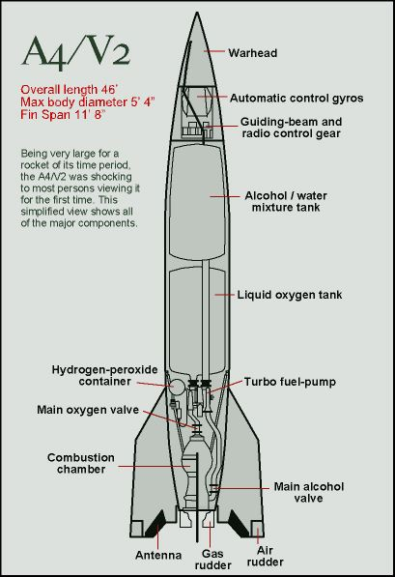

Team Darwin

General Information
1. School Information

Name: Spring Grove Area High School
Mailing Address: Spring Grove Area High School
1490 Roth’s Church Road
Spring Grove, PA 17362
Name of Team:

2. Adult Educators:
- Rosemary Cugliari
Spring Grove Area High School Principal
Phone number: (717) 225-4731 ext. 7060
Email: Cugliarr@sgasd.org

- Brian Hastings
Physics teacher, Rocket Scientist Club Coach
Phone number: (717) 225-4731 ext. 7220
Email: Hastingsb@sgasd.org

- Renee Bosak
Biology teacher, Rocket Scientist Club Coach
Phone number: (717) 225-4731 ext. 7242
Email: EatonR@sgasd.org

3. Safety Officer:
- Brian Hastings
Level two NAR Representative
Phone number: (717) 225-4731 ext. 7220
NAR 96571 SR

4. We are not part of a USLI team, we are a SL team.

5. Key Managers:

- Brian Hastings - Advisor and NAR representatives of students
- Renee Eaton - Advisor and Supervisor of students
- Mr. Sengia - Instructional Technology Specialist
- Josh Staley - Co-Captain and Student Safety Officer
- Adam - Co-Captain (Rocket Design Leader)

6. For Launch Assistance, Mentoring, and Reviewing our team will be working with the local NRA representatives along with MDRA (Maryland-Delaware Rocketry Association) for all questions and launches

Table of Contents

General Information
______________________________________________________________________________
School Information..........................................................................................................................2
Adult Educators...............................................................................................................................2
Safety Officer..................................................................................................................................2
Educators and Mentors Biographies................................................................................................6
Key Managers and Student Participants.....................................................................................6-10

Facilities and Equipment
______________________________________________________________________________
Facilities Available...................................................................................................................11-12
Computer Equipment.....................................................................................................................12
EIT.................................................................................................................................................12
Technical Standards.......................................................................................................................12

Safety
______________________________________________________________________________
Equipment Safety in Spring Grove Area High School.............................................................13-20
Safety Plan................................................................................................................................20-26
NRA/TRA Personal Review………………………………………………...……….…..…...26-27
Student Briefings...........................................................................................................................27
Methods for Including Necessary Caution Statement...................................................................27
Plan for Complying with Laws.................................................................................................27-28
Plan for Motor Handling and Storage............................................................................................29
Team Agreement…………………………………………………………...…………...…….….30

Technical Design
______________________________________________________________________________
Proposed Rocket (A-G)……………………… …………...…………………………………31-36

Educational Engagement
______________________________________________________________________________
Educational Plans……………………………………………………………………….……37-38
Educational Workshop………………………………………………………………….……37-38

Project Plan
______________________________________________________________________________
Schedule and Timeline……………………………………………………………………….39-42
Budget Plan……………………………………………………………………………..…….42-43
Funding Plan………………………………………………………………………………….….43
Community Support…………………………………………………………………….……43-44
Sustainability of Rocket Project…………………………………………….…………….….44-45

Team Members
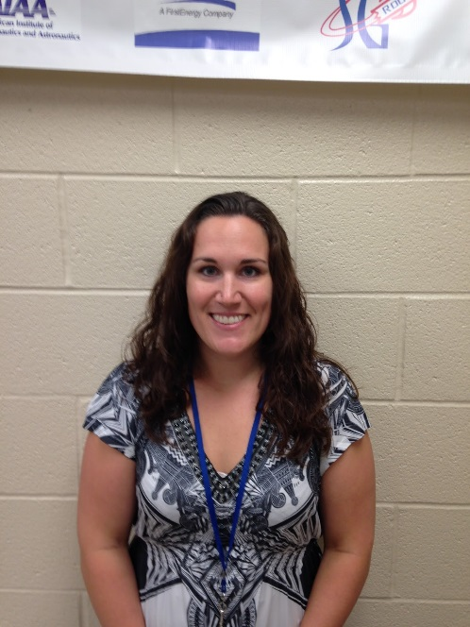
Mrs. Bosak: Biology Teacher and Assistant Coach
I have been a Biology teacher at Spring Grove High School since 2009. Since then, I have coached the Marching Band and Junior High Track and Field and have advised the Gay-Straight Alliance, Science Fair participants, the Envirothon team, and the SLI team. In addition, I have been a member of the York Jaycees, a local community service organization, since 2009. I finished my Master’s degree in Classroom Technology in 2013. In my spare time, I enjoy spending time with my friends and family, hiking, biking, reading, and training for 5K races and half-marathons. I am a NAR member and have a level 2 certification.

Brian Hastings: Instructor and Head Coach
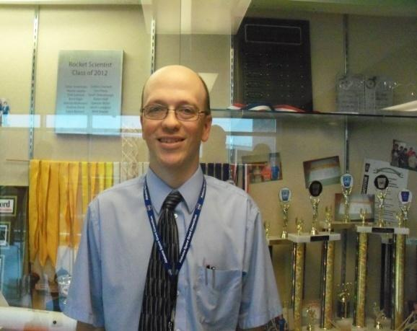
I have been a teacher at Spring Grove for 19 years, teaching Physics 1, Physics 1 Honors, and AP Physics 1 and 2. I have an Honors B.A. in secondary education Physics, a masters in science education and 60 graduate credits past my Master’s Degree. I have taught graduate courses to teachers and for the past 15 years have taught fast -paced high school physics for Johns Hopkins University’s Center for talented youth program. As a Rocket Scientists’ coach, I have started a Science Olympiad team, a Vex Robotics Team, Physics Olympics Team, and a Team America Rocketry Challenge Team. The Science Olympiad team has advanced to the state level each of the last ten years. We have been participating in TARC for 9 years and have advanced to Nationals each of the past 6 years, placing fourth overall at Nationals in 2012, and eighth at the Nationals in 2013. I am a NAR member and have a level 1 certification. Currently I am building a rocket for level 2 NAR certification.

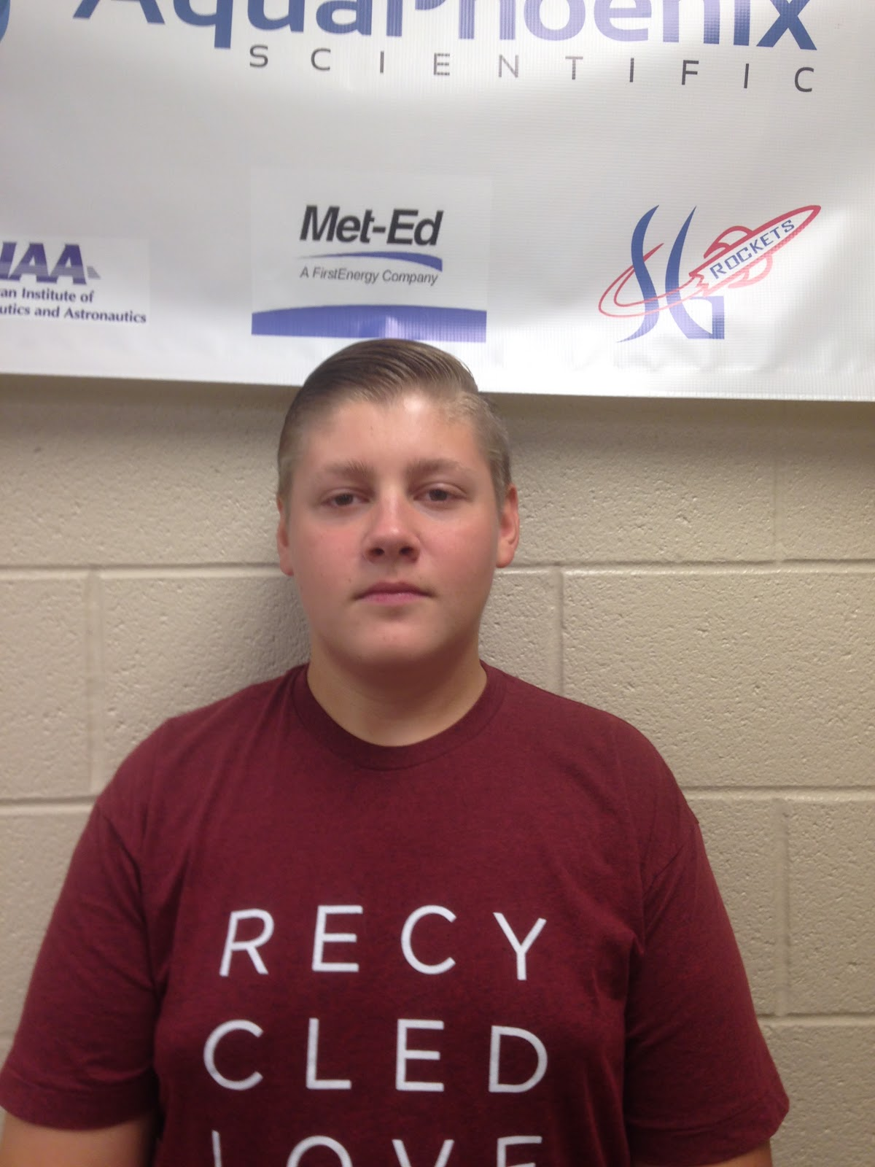
Adam Cavanaugh 17 Senior: Co-Captain and Rocket Design Leader
Ever since my sophomore year, after my first physics class, I have been more interested in sciences than any other subject. I became a “rocket scientist” last year, my junior year, when I really got involved in our rocketry teams and our science Olympiad team at Spring Grove. My sophomore year intrigued by the rocketry teams at our school but didn’t join. My junior year our TARC team placed 8th in the national competition. I also helped with the Spring Grove SL team, but was not a member. It was a learning experience last year and this year is my chance to apply it all. Outside of school I am an involved youth member at my church and I am a boy scout. I also enjoy golfing and being out in nature. This year I am very much looking forward to being a member of the SL team and the other opportunities that come with this large task.

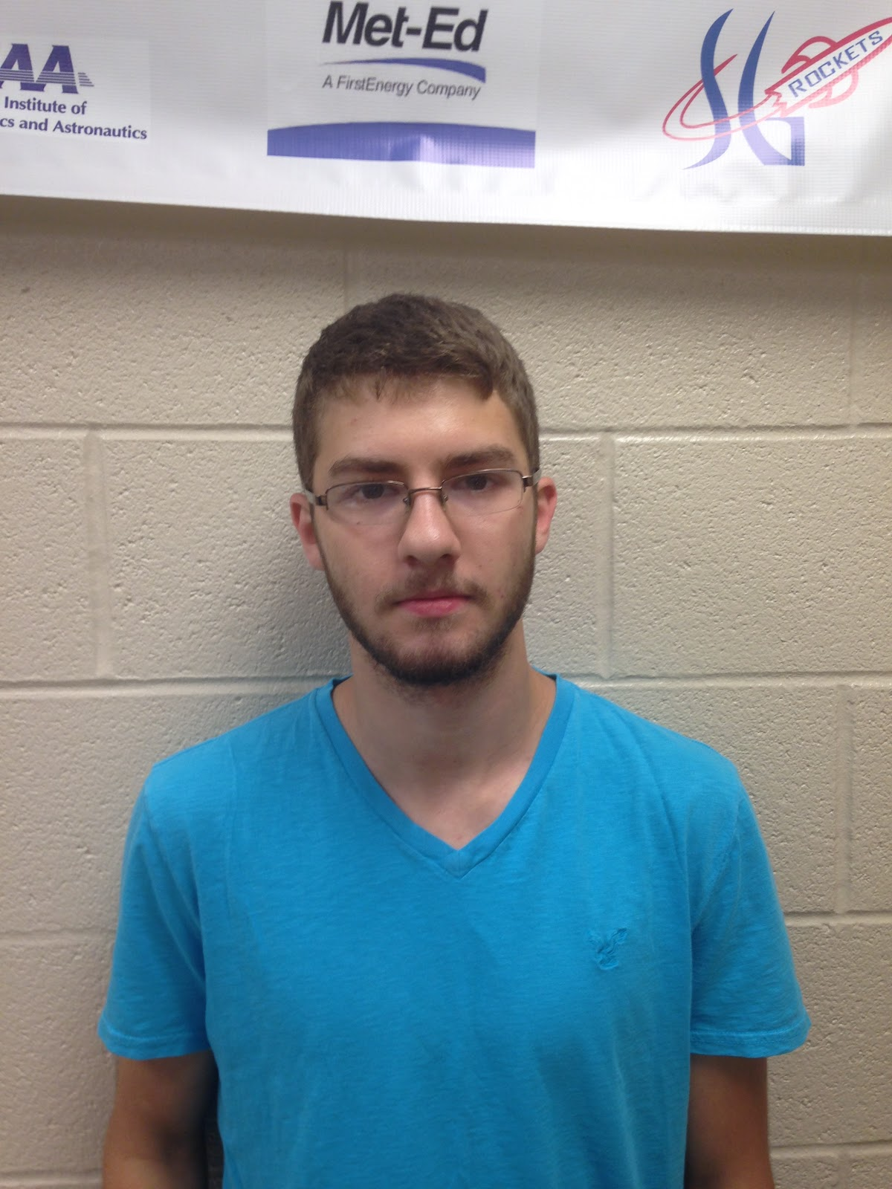
Josh Staley 18 Senior: Co-Captain and Student Safety Officer
I became interested in science when I joined the Envirothon team in 7th grade. I began taking part in Science Olympiad the following year and have made it to the State competition each year since joining the team. I started learning about rockets in my freshmen year when I took part in Team America Rocket Challenge. I have now had 2.5 years of experience in high powered rocketry and look forward to a successful year in the SL program.

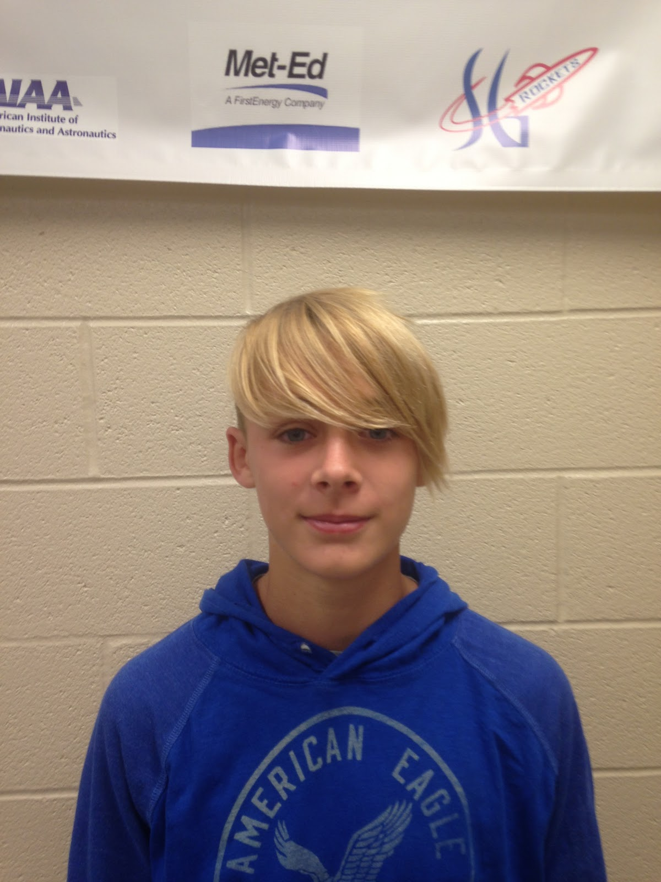
Quinn Black 14 Freshman: Mass reduction specialist
My name is Quinn Black this is my first year in high school, SL, and TARC. Last year in 8th grade I would walk to the high school and watch the TARC teams build rockets and launch rockets. My brother was involved in TARC and SL so he would teach me things about the rockets and how they worked. Mr. Hastings would let me stay, last year I learned some about Rocketry. But this year I am ready to help build one I joined the rocket team because I am interested in the mechanics and design of the rocket. Outside of school I play soccer for the high school and I also like to be outside.

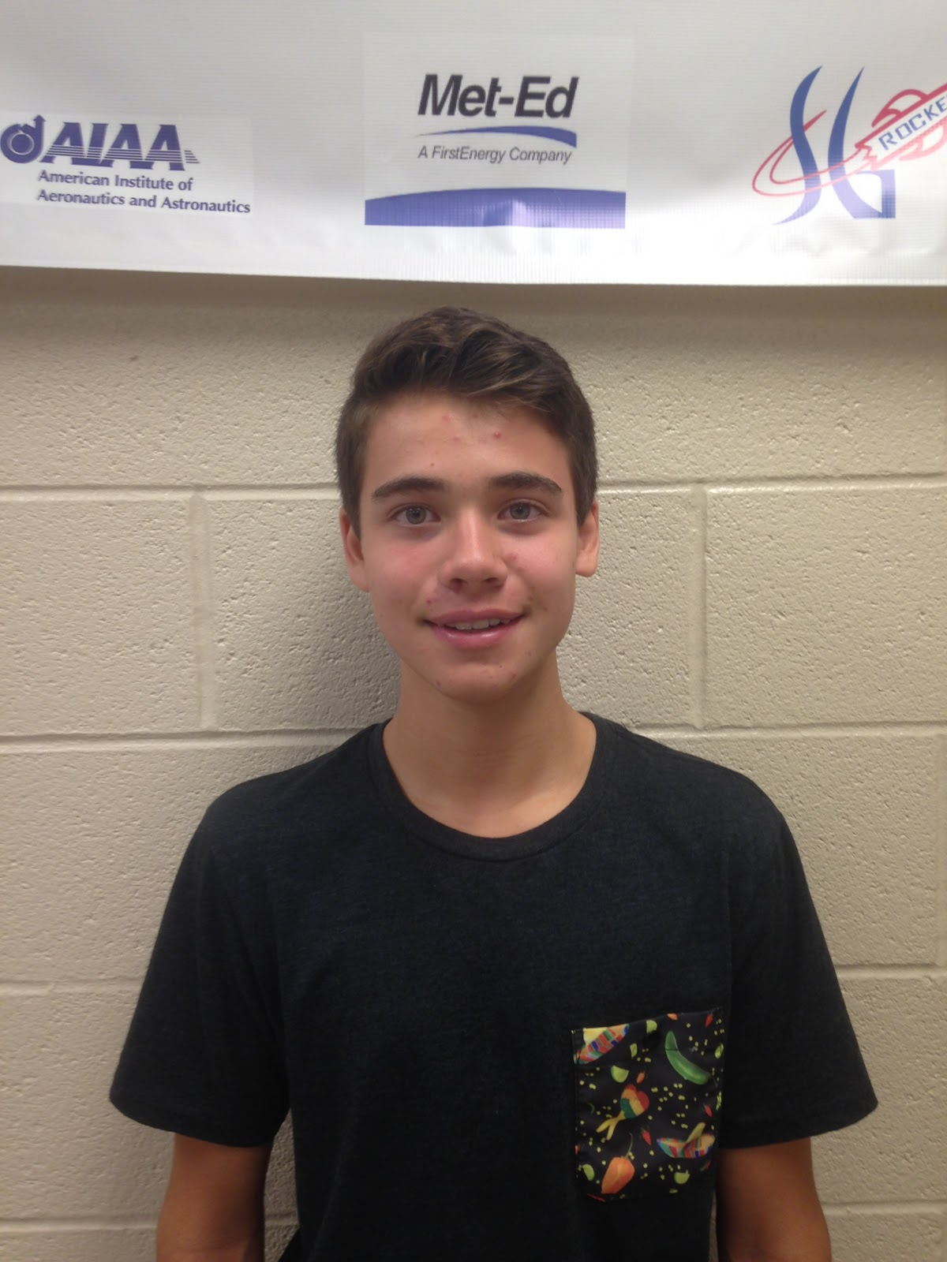
Carson Buffalow 16 Sophomore: Electronics Bay
When I was in middle school, I was introduced to science Olympiad. I took great interest in this and enjoyed the science field as a whole. Now as a sophomore, I have found SL. I enjoy rockets and working as part of a team so I figured I would enjoy being a part of the Spring Grove team. I like to do graphic design and play lacrosse and am very creative and like to design things so I thought this would be the club for me. I am hoping to use this as an outlet to help me pursue my possible career in engineering and have a lot of fun doing it.

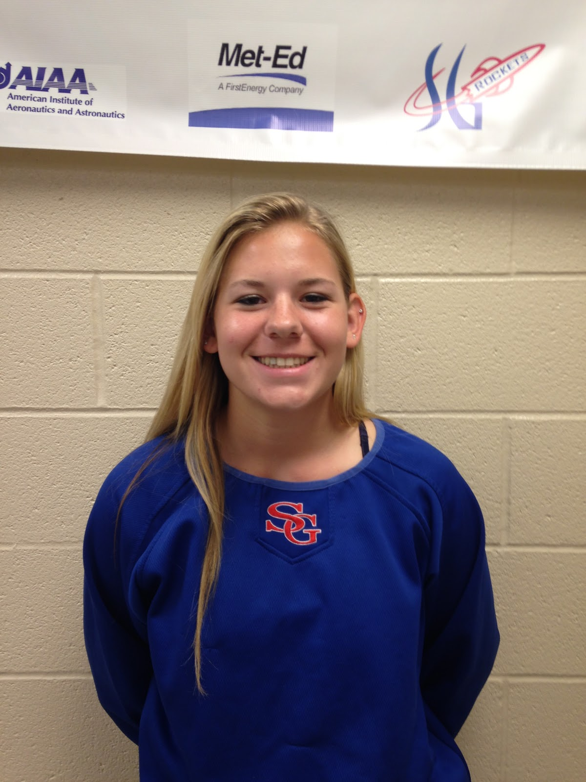
Hannah Sheffer 17 Senior: Budget and Funding Plan
As a student I have always been interested in Math and Science for as long as I can remember. I like being able to solve no matter the difficulty. Being my first year in SLI, I think it will be a new and exciting challenge for me. In addition to SLI I am a member of National Honor Society, a player on Spring Grove's Varsity Field Hockey Team, and President of German National Honor Society. Being a part of SLI will help me to gain more experience in the Math and Science field. I am looking forward to being a member of SLI. After high school I plan to go to college to further my career in Math and Science.

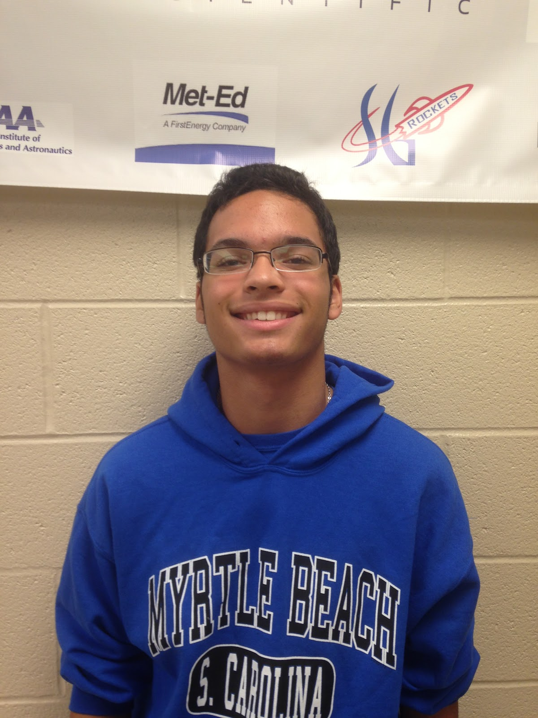
Tre Colbert 15 Sophomore: Chief of Introduction and Table of Contents
I have always found interest in engineering throughout my time at Spring Grove. It wasn’t until the end of last year when I found SL. After speaking with my history teacher about potential engineering fields and colleges to go to she mentioned getting involved in SL to find out if I would have interest in aviation. I see SL as a great opportunity to learn about my own interests and to enhance my knowledge in the engineering field. I also see SL as a great resume builder for college. I have very much enjoyed the short amount of time I have spent in the program and hopefully I will learn a lot this year both from my instructors and returning team members so that I can better support the team in the years to come.

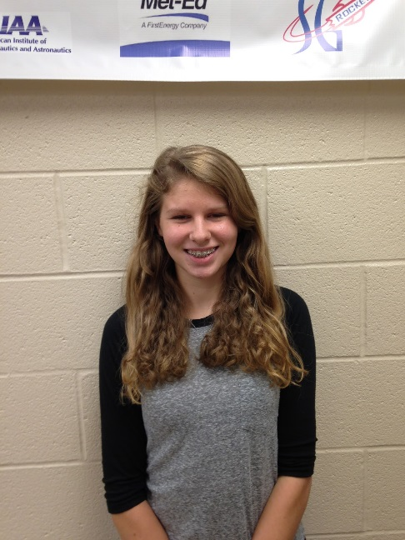
Sarah Staley 15 Freshman: Educational Engagement
I was in the TARC program last year and am excited to be a part of the 2015-2016 SL team. Over the last couple of years I have been to many SL launches for my siblings and I am thrilled to have the chance to be a part of the program this year. I am the vice president of my class and a member of the competition cheerleading squad, orchestra and the German American Partnership Program. I like being around people and working in groups to accomplish our goals. I hope to learn from my teammates and have a great year with the SL team.

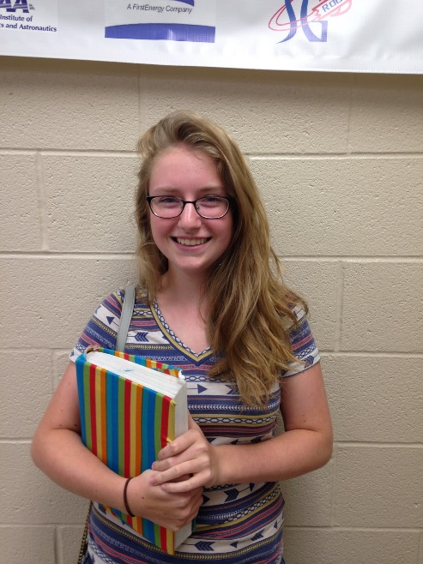
Emily Edsall 15 Sophomore
The reason I joined Student Launch was because of my one friend. He talked me into joining with him. This will be my first year in this club as a sophomore. I hope it will be helpful and interesting. Other extracurricular activities that I am a part of our book club, piano, and I'm the treasurer of our school's language club.

Facilities and Equipment
Description of Facilities/Personnel/Equipment/Supplies
  - Spring Grove High School:
  - Hours: Monday through Friday 7:25 A.M. until 2:30 P.M. and after school upon instructor availability.
    - Room 135:
      - Gravograph LS100 30W laser
      - Structural Stress Analyzer 100
      - Computers with Microsoft Office and Solidworks
    - Room 130
      - AXYZ Automation INnc 2.2kW 18kRPM TypeB 12-2 CNC Router
      - Compound Dewalt miter saw
      - Framarbandsaw
      - 24” Planer
      - Paasche FABSF-6 spray booth
      - Belt sander
      - Drill press
      - Oliver table saw
      - Orbital sander
    - Room 131
      - Lab Volt 5400 CNC Mill
      - Lab Volt Automation 5500-B0 CNC Lathe
      - EMCO Concept Mill
      - General Model 480 Jointer
      - Jet Benchtop drum sander
      - Victor Metal Lathes
      - Tennsmith sheet metal cutter
      - Miller Spot Welder
      - Baldor Grinder/buffer
    - Room 220
      - Computers with Rocksim 9 and Logger Pro
      - Labquests
      - Drill press
      - Belt sander
      - Reciprocating saw
      - Circular saw
      - Cordless drill
    - Room 242
      - Storage and workspace
    - Room 221
      - Fume hoods
      - Laptop cart with 28 IBM Thinkpads
  - Launch site: MDRA Launch field requires an MDRA member for supervision whenever one is free to supervise
  - Materials/Supplies
    - There is an abundance of supplies in Room 220
    - All other needed supplies will be ordered at the appropriate time
- Description of Computer Equipment/WebEx required supplies
  - Conference rooms 50 and 51
    - Laptop computers
    - USB web camera
    - Cisco speakerphone
    - School network connection
WebEx/connectivity Instructor Contact Information:
Instructional Technology Specialist: Mr.Sengia
Email: Sengiaj@sgasd.org
Phone number: (717)-225-4731 ext.7060
3. The Spring Grove SLI Team will implement the Architectural and Transportation Barriers Compliance Board Electronic and Information Technology (EIT) Accessibility Standards (36 CFR Part 1194) Subpart B- Technical Standards 1194.21 (a-l), 1194.22 (a-p), and 1194.26 (a-d).http://ecfr.gpoaccess.gov/cgi/t/text/textidx?c=ecfr&tpl=/ecfrbrowse/Title36/36cfr1194_main_02.tpl

Facilities Available to All Students:
In room 220, Mr. Hastings’ room, we can work and plan most of our project. It has numerous computers with Logger Pro and Rocksim 9. There is also a drill press, belt sander, and multiple Vernier LabQuests. We have original labquests and have a few new LabQuest 2’s. In the room there is also a Craftsman reciprocating saw, a circular saw and cordless drill.
*This room as mentioned above will be our main home for working on the rocket, its construction, and writing of the many papers we must write. Mr. Hastings, as our main mentor, is willing to stay after many late nights to help us work on the project.

Safety
Equipment Safety
Framar Band Saw
Before operating the band saw, remove all jewelry, confine long hair, and remove or roll up long sleeves or any article of clothing that could become caught in the blade or the band saw. Also, obtain an instructor’s permission to use the machine and ensure that safety glasses are covering your eyes. When cutting, make sure adjustment knobs are tight; the upper blade guard should be around one eighth of an inch above the material being cut. Do not force any material through the blade, attempt to cut a radius smaller than the blade will allow, and do not back out of long cuts. Keep fingers on either side of the cut line, never on the line. If necessary, use a push stick or scrap block to guide the material through. Do not allow bystanders to stand to the right of the machine, because if the blade breaks, an injury may occur. Never leave the machine until the blade has come to a complete stop. If an injury should occur during the usage of the band saw, stop the machine, step on the brake to stop the blade quickly, inform an instructor of the injury, and then have the rest of the students in the classroom sit outside in the hallway to avoid being in the way of instructors and medical personnel helping the student.
Router
Before operating the router, remove all jewelry, confine long hair, and remove or roll up long sleeves or any article of clothing that could become caught in the router or router bit. Also, obtain an instructor’s permission to use the machine and ensure that safety glasses are covering your eyes. Ensure that the power switch is in the off position before plugging in the router. Then, check to make sure that the bit is firmly secured in the chuck and that the piece being worked on is firmly secured. Also make sure that the intended path of the router is free of obstructions. Hold the router with both hands and apply constant pressure. Never force the router or bit into the work. When changing bits or making adjustments turn off the router and unplug it from its power source. If an injury should occur during usage of the router, turn off the machine, inform an instructor of the injury, and then have the rest of the students in the classroom sit outside in the hallway to avoid being in the way of instructors and medical personnel helping the student.
Delta Radial Arm Saw
Before operating the saw, remove all jewelry, confine long hair, and remove or roll up long sleeves or any article of clothing that could become caught in the blade. Also, obtain an instructor’s permission to use the radial arm saw and ensure that your eyes are covered by safety glasses. Make all needed adjustments, such as adjusting the blade guard and kickback fingers, while the power is off. Test to see if leaf guards are working properly and that the blade does not extend past the edge of the table. Always firmly hold materials against the fence and pull the blade completely through the material and return blade behind the fence before removing the material and starting another cut. If too much of the table is cut away, then the instructor must be notified so that the table can be replaced. Wait for the blade to stop before leaving the machine. If an should injury occur during usage of the saw, turn off the machine, inform an instructor of the injury, and then have the rest of the students in the classroom sit outside in the hallway to avoid being in the way of instructors and medical personnel helping the student.
Planer-Surface Sander
Before operating the sander, remove all jewelry, confine long hair, and remove or roll up long sleeves or any article of clothing that could become caught in the machine. Also, obtain an instructor’s permission to use the sander and ensure that safety glasses are covering your eyes. Turn on the sawdust collection system. Check all material for loose knots, nails, staples, or any other loose, foreign objects. Never force a material through the planer; after insertion the machine will automatically feed it through. The operator should wait on the other side of the machine to receive the material. Select a proper machine depth and speed for the material being used. Never attempt to plane more than an eighth of an inch of material in one pass. Do not look into the machine at surface level or try to clean debris while the machine is turned on. Always stand to the side, because the possibility of kickback always exists. If injury occurs during usage of the sander, turn off the machine, inform an instructor of the injury, and then have the rest of the students in the classroom sit outside in the hallway to avoid being in the way of instructors and medical personnel helping the student.
Dewalt Compound Miter Saw
Before operating the saw, remove all jewelry, confine long hair, and remove or roll up long sleeves or any article of clothing that could become caught in the blade. Also, obtain an instructor’s permission to use the saw and ensure that safety glasses are covering your eyes. Make all changes to the saw and saw blade while the power is off and the plug is disconnected from its power supply. Hold the material firmly against the fence and the table. Allow the motor to reach its full speed before attempting to cut through the material. Make sure that all guards are functioning properly. If injury occurs during usage of the Miter Saw, turn off the machine, inform an instructor of the injury, and then have the rest of the students in the classroom sit outside in the hallway to avoid being in the way of instructors and medical personnel helping the student.
Jointer
Before operating the jointer, remove all jewelry, confine long hair, and remove or roll up long sleeves or any article of clothing that may become caught in the blade. Also, obtain an instructor’s permission to use the jointer and ensure that safety glasses are covering your eyes. Turn on the sawdust collection system. Make all changes or adjustments to the jointer while the power is off. Use a push stick or scrap block if your hands run the risk of coming within two inches of the blade. Do not attempt to take off more than one eighth of an inch at a time. The minimum length of material that can be cut with the jointer is double the size of the blades. If injury occurs during usage of the jointer, turn off the machine, inform an instructor of the injury, and then have the rest of the students in the classroom sit outside in the hallway to avoid being in the way of instructors and medical personnel helping the student.
Hand Sanders
Before operating the hand sanders, remove all jewelry, confine long hair, and remove or roll up long sleeves or any article of clothing that could become caught in the machine. Also, obtain an instructor’s permission to use the hand sanders and ensure that safety glasses are covering your eyes. Replace the sandpaper while the sander is off and unplugged. Only use sand paper that is in good condition and properly installed. Place the material that you intend on sanding on a flat surface and sand slowly over a large area. Wait for the sander to stop oscillating before placing it on a secure resting surface. Never carry any corded tool by the power cord. If injury occurs during usage of the hand sanders, turn off the machine, inform an instructor of the injury, and then have the rest of the students in the classroom sit outside in the hallway to avoid being in the way of instructors and medical personnel helping the student.
Electric Drills
Before operating the drill, remove all jewelry, confine long hair, and remove or roll up long sleeves or any article of clothing that could become caught in the bit. Also, obtain instructor permission before using the drills and ensure that safety glasses are covering your eyes. Replace the bit while the power is off, installing the bit properly and making sure the chuck is tightened and the chuck key is taken out. Never drill without first marking the hole with an awl. Ensure the material is clamped securely and drill with even pressure. Never carry any corded tool by the power cord. If injury occurs during usage of the electric drills, turn off the drill, inform an instructor of the injury, and then have the rest of the students in the classroom sit outside in the hallway to avoid being in the way of instructors and medical personnel helping the student.
Powermatic Drill Press
Before operating the drill press, remove all jewelry, confine long hair, and remove or roll up long sleeves or any article of clothing that could become caught in the bit or machine. Also, obtain instructor permission and ensure that safety glasses are covering your eyes. Replace the bit while the power is off, installing the bit properly and making sure the chuck is tightened and the chuck key is taken out. Firmly secure the material that you are drilling with vises or clamps. Adjust the table to avoid drilling into it and pick the correct size bit that is properly sharpened. If the drill becomes stuck turn off the machine and inform an instructor. Select the proper speed for the material. If an injury occurs during usage of the drill press, turn off the machine, inform an instructor of the injury, and then have the rest of the students in the classroom sit outside in the hallway to avoid being in the way of instructors and medical personnel helping the student.
CNC Router
Before operating the router, remove all jewelry, confine long hair, and remove or roll up long sleeves or any article of clothing that could become caught in the bit or machine. Also, obtain an instructor’s permission to use the router and ensure that safety glasses are covering your eyes. Turn on the sawdust collection system. Make all adjustments while machine is off. Materials must be firmly secured before the project is run through the router. A person needs to be with the machine during the entire operation. Check to make sure that the spindle rotation, speed, and depth of cut are all correct before starting the machine. Only clean the machine while it is off and make sure that all setup tools are cleared from the table. If an injury occurs during usage, turn off the machine, inform an instructor of the injury, and then have the rest of the students in the classroom sit outside in the hallway to avoid being in the way of instructors and medical personnel helping the student.
Oliver Table Saw
Before operating the table saw, remove all jewelry, confine long hair, and remove or roll up long sleeves or any article of clothing that could become caught in blade. Also, obtain an instructor’s permission to use the table saw and ensure that safety glasses are covering your eyes. Turn on the sawdust collection system. Make all adjustments to the blade or guide while machine is off. Gullets of the blade must clear the top of the material. Never use the miter gauge and the fence at the same time. The miter gauge it for cross cutting and the fence is for ripping. Use extra caution while using a dado cutting head. Always use a push stick when your hand could come close to the blade and have another person at the other end of the table to catch the material that was just cut. Do not leave the table until the blade stops. If an injury occurs during usage of the table saw, turn off the machine, inform an instructor of the injury, and then have the rest of the students in the classroom sit outside in the hallway to avoid being in the way of instructors and medical personnel helping the student.
Powermatic Belt Sander
Before operating the belt sander, remove all jewelry, confine long hair, and remove or roll up long sleeves or any article of clothing that could become caught in machine. Also, obtain an instructor’s permission before using the machine and ensure that safety glasses are covering your eyes. Make all adjustments while the machine is off. Check that there is adequate tension in the belt and that it is not torn before turning on the machine. Keep the material on the table at all times. Keep fingers away from the sand paper. If an injury occurs during the usage of the sander, turn off the machine, inform an instructor of the injury. The instructor will then have any students in the room go out into the hallway. This will ensure that the students do not interfere with the injured person, instructors, or medical personnel that will be helping the student.
Powermatic Disc Sander
Before operating the disc sander, remove all jewelry, confine long hair, and remove or roll up long sleeves or any article of clothing that could become caught in the machine. Also, obtain an instructor’s permission before using the sander and ensure that safety glasses are covering your eyes. Make all adjustments while machine is off. Check that the disc was properly installed and that it is not torn. Keep the material on the table at all times. Keep fingers away from the sand paper. If an injury should occur during usage, turn off the machine, inform an instructor of the injury, and then have the rest of the students in the classroom sit outside in the hallway to avoid being in the way of instructors and medical personnel helping the student.
Powermatic Drum Sander
Before operating the drum sander, remove all jewelry, confine long hair, and remove or roll up long sleeves or any article of clothing that could become caught in the machine. Also, obtain an instructor’s permission before using the sander and ensure that safety glasses are covering your eyes. Make all adjustments while machine is off. Use the proper drum for the radius that is being sanded. Keep the material that you are sanding on the table at all times. Keep fingers away from the sand paper. If an injury occurs during usage, turn off the machine, inform an instructor of the injury, and then have the rest of the students in the classroom sit outside in the hallway to avoid being in the way of instructors and medical personnel helping the student.
Craftsman Reciprocating Saw
Before operating the reciprocating saw, remove all jewelry, confine long hair, and remove or roll up long sleeves or any article of clothing that could become caught in the blade. Also, obtain an instructor’s permission before using the saw and ensure that safety glasses are covering your eyes. Make all changes with the power off and the plug disconnected from its power supply. Firmly secure all material to a workbench or table. Allow the motor to reach its full speed before cutting through the material. Hold the saw with both hands while you are using it. If an injury occurs during usage, turn off the machine, inform an instructor of the injury, and then have the rest of the students in the room sit outside in the hallway to avoid being in the way of instructors and medical personnel helping the student.
Craftsman Circular Saw
Before operating the circular saw, remove all jewelry, confine long hair, and remove or roll up long sleeves or any article of clothing that could become caught in the blade. Also, obtain an instructor’s permission before using the saw and ensure that safety glasses are covering your eyes. Make all changes with the power off and the plug disconnected from its power supply. Firmly secure all material to a workbench or table. Before cutting, ensure that the cut line is not above the table. At least one person must be holding the material being cut off, as long as that piece is large enough for a person to hold it. Allow the motor to reach its full speed before cutting through the material. Hold the saw with both hands while using it. If an injury occurs during usage, turn off the machine, inform an instructor of the injury, and then have the rest of the students in the classroom sit outside in the hallway to avoid being in the way of instructors and medical personnel helping the student.
CNC Lathe (EMCO Concept Mill 55, Lab Volt 5400 CNC Mill, a Lab volt Automation 5500-B0)
Before operating the lathe, remove all jewelry, confine long hair, and remove or roll up long sleeves along with any article of clothing that could become caught in the bit. Also, obtain an instructor’s permission before using the lathe and ensure that safety glasses are covering your eyes. Make all adjustments while machine is off. The material that you intend on cutting must be firmly secured before the project is run through the lathe. A person needs to be with the machine during the entire operation. Check to make sure that the spindle rotation, speed, and depth of cut are all correct before starting the machine. Only clean the machine while it is off .If an injury occurs during the usage of the lathe, turn off the machine, inform an instructor of the injury, and then have the rest of the students in the classroom sit outside in the hallway to avoid being in the way of instructors and medical personnel helping the student.
Victor metal lathes
Before operating the lathes, remove all jewelry, confine long hair, and remove or roll up long sleeves or any article of clothing that could become caught in the work. Also, obtain an instructor’s permission before using the lathe and ensure that safety glasses are covering your eyes. Make all changes with the power off. Center the material so that it will not spin off-center. Firmly secure all of the material to a machine. Use the proper speed for the task at hand. Use the correct, sharpened tools. If an injury occurs during usage, turn off the machine, inform an instructor of the injury, and then have the rest of the students in the classroom sit outside in the hallway to avoid being in the way of instructors and medical personnel helping the student.
Paasche FABSF-6 spray booth
Before using the spray booth, turn on the ventilation system and wear proper protection. Use the correct spray for the material and do not inhale toxic fumes. If an injury occurs during usage, inform an instructor of the injury, and then have the rest of the students in the classroom sit outside in the hallway to avoid being in the way of instructors and medical personnel helping the student.
Miller Spot Welder
Before operating the welder, put on proper clothing, welding mask, gloves, and apron. Obtain an instructor’s permission before using the welder. Do not look at the welding torch unless you are wearing a welding mask. Ensure that the proper solder is being used and that the materials are secured. If an injury occurs during usage, turn off the machine, inform an instructor of the injury, and then have the rest of the students in the classroom sit outside in the hallway to avoid being in the way of instructors and medical personnel helping the student.
Baldor grinder/buffers
Before using the grinder and buffers, put on safety glasses, check that the spark shield is intact, and obtain an instructor’s permission to use it. Keep hands away from the spinning wheel. Adjust the tool rest to the proper height and always use it. If an injury occurs during its usage, turn off the machine, inform an instructor of the injury, and then have the rest of the students in the classroom sit outside the hallway to avoid being in the way of instructors and medical personnel helping the student.
Tennsmith Sheet metal cutter
Before operating the sheet metal cutter, remove all jewelry, confine long hair, and remove or roll up long sleeves or any article of clothing that could become caught in the cutter. Also, obtain an instructor’s permission before using the cutter and ensure that safety glasses are covering your eyes. Do not attempt to cut any material thicker than what the machine is rated for. Make sure that the material and blade are free from debris. If an injury occurs during usage, inform instructor of the injury, and then have the rest of the students in the classroom sit outside in the hallway to avoid being in the way of instructors and medical personnel helping the student.
Gravograph LS100 30 watt laser/engraver/cutter
Before operating the laser, ensure that the laser is focused, the vent fan is on, and the right speed and power are selected for the material you intended on cutting or engraving. Obtain an instructor’s permission before using the laser. Never look directly into the laser. Stay at the laser throughout the entire process. If the machine cuts an area that you didn’t want cut or malfunctions, turn off the machine and alert an instructor immediately. If an injury occurs during usage of the laser, turn off the machine, inform an instructor of the injury, and then have the rest of the students in the classroom sit outside in the hallway to avoid being in the way of instructors and medical personnel helping the student.
1. Safety Plan:
Before any work is done on the rocket, a second mandatory safety meeting will take place to re-inform students of the NAR safety code. When handling potentially hazardous materials, students will be required to read the Materials Safety Data Sheet (MSDS) on the hazardous material. This will be done before they can work with the material. Team members are to handle the material according to the Materials Safety Data Sheet, including, but not limited to, the handling and storage of the material.
The SL rocket will be constructed in the Spring Grove Area High School. Students will have quick access to the following safety materials: Sellstrom SM Z87+FF Safety Goggles, Splash Aprons, Emergency Eye Wash Stations, Emergency Body Wash Stations, Cantflame Fire Blankets, BFPE type ABC Dry Chemical Fire Extinguishers regularly serviced by Dale E. Ness Inc., and Simplex Fire Alarms. In all rooms where rockets will be assembled and prepared, there are fire detection and suppression systems present. There are also sprinklers in all rooms. We also plan on using nitrile gloves and respirators as the MSDS sheets suggest. These will be used for the handling of potentially hazardous materials.
We have appointed a construction safety officer who is required to certify that all materials and building procedures are in conformance with the NAR High Power Rocketry Safety codes. This construction safety officer has also been appointed as our range safety officer. He will also certify that the launch facility, rocket engine components, and environmental conditions are within safety regulation requirements. Our Safety Officer will be Mr. Hastings. Mr. Hastings will be responsible for the safety and handling of the rocket motors. He is also responsible for the safety of all of the Spring Grove SL participants while he is handling a motor. In addition, he will oversee the construction of the project and will ensure that the Safety Plan is being followed throughout the entire project. Mr. Hastings is NAR Level 2 certified. Therefore, he will also be responsible for the ordering and storage of our rocket motors. Our student safety officer will be Josh Staley. He will oversee and make sure there is an emphasis on safety during construction, assembly, and launching of the rocket.
We will incorporate safety as an integral part of the design. The rocket will also be safely inspected and checked throughout the construction. The student safety officer will emphasize safety throughout the entire construction. In addition to the safety plan, we will be following the NAR High Power Safety Code guidelines as outlined below:
*Probability is rated on a scale of 1 to 10, where 1 represents a low probability that the risk will present a problem and a 10 represents a very high probability that the risk will present a problem. Risks that are rated at ten or close to ten will be dealt with as soon as possible and handled according to the mitigation and/ the best way to handle the problem.

Risks | Probability of Risk *(1-10) | Impact on Project Progress | Mitigations
We may fail to get valuable data from the rocket. | 2 | We will need to redesign, rebuild, or reload the payload. This would delay the progress of construction. | The team shall ensure that the payload is properly handled and deal with any design flaws.
The rocket parachute does not deploy and rocket returns unsafely to the ground. | 3 | We lose a rocket and must build another one, losing work time and time to launch. | The team will carefully insert the parachute and make sure there is enough heat shields the ground material to prevent flame up.
Injury could occur while using coping saw. | 2 | A leave of absence of a team member could occur due to minor or severe injury and possibly delay the rocket-building progress. | The team will be aware of limbs and fingers when using this tool.
Injury could occur during Exacto knife usage. | 5 | A small injury could occur, possibly delaying the rocket-building progress. | The team will carry the knife in cautious matter, cut away from oneself, and be aware fingers when using this tool.
Accidental combustion of rocket materials | 3 | In addition, possible injury and a delay of rocket-building progress could occur. | The team will keep 25 feet away from electrical outlets, open flame, and the indoor magazine.
Allergic reactions to chemicals involved in rocket production | 2 | Minor or severe chemical burns of team members and possible delay of rocket progress could occur. | The team will make all students aware of each other’s allergies and stay away from possible allergens.
Electrocution during electrical outlet usage | 1 | Minor or severe injury could occur. | The team will only use electrical outlets if hands are dry and static free. The team will keep fingers away from prongs.
Adhesion to materials or self | 4 | Minor injury and very minor delay of rocket progress could occur. | The team will exercise proper caution when  handling adhesive material and will not use too much of the material.
Injury during laser engraver usage | 2 | Possible combustion of rocket materials could lead to reordering of materials and delay progress. | The team will make sure the laser is on the proper power, speed, and focus settings, and ensure that the exhaust fan is on.
Injury during drill press usage | 2 | Severe injury and delay of progress could occur. | The team will keep clothing, hair, and body parts away from the drill bit and use safety glasses.
Tripping and falling hazards | 3 | Minor or severe injury, delay of rocket progress could occur. | The team will make sure the walking path is clear and keep clutter off of floor.
Abrasions and bruises caused by belt sander | 2 | Minor injury and delay of progress. | The team will keep hands and clothing away from the sandpaper.
Burning caused by soldering iron usage | 2 | Minor injury and delay of progress. | The team will use soldering iron in a proper manner and use safety gear.
Premature ignition of rocket motors | 2 | Possible minor or severe injury, the need to reorder rocket motors, and delay of rocket progress. | Ensure that only the proper level certified personal handle the rocket motors and installations as well as reloads.
Team estrangement because of lack of cooperation | 1 | Delay of rocket progress. | The team will talk calmly and will not fight with one another. The team will respect each other and themselves.
Going over-budget | 5 | Delay of rocket progress due to the need for more time to fundraise | The team will carefully use all materials, order only the parts needed, keep track of materials, and use the budget wisely. The team will be diligent in fundraising endeavors.
Misuse or mishandling of hazardous materials | 2 | Minor or severe injury, leave of absence for team member affected, and delay of progress | The team will follow all safety code regulations, laws, and instructions.
Unforeseen rocket design complications | 4 | Delay of rocket design and rocket building progress | The team will design a stable rocket based on the locations of the center of pressure and center of gravity. The team will also have a NAR representative check rocket design.
Unforeseen payload design complications | 3 | Delay of payload design and production. | The team will design a payload that will be effective for the size body tube that is used and double-check that the components of the payload are properly made.
Complications during transportation of participants and materials to SL or practice launch sites | 3 | Delay of rocket progress due to rocket repairs or cancellation of practice flights because of extensive damage. | The team will make sure that the launch date is known in advance and that all specifications are planned out well in advance. The team will pack the rocket well and make sure it is secure during transportation.
Accidental partial or complete destruction of building site | 2 | Damage to work environment, additional expenditures for repairs, possible progress delay. | The team will ensure that safety guidelines from NAR and the MSDS are being followed.
Team communication failure | 3 | Rocket/payload may be built incorrectly or too many of one part may be made, causing a slight to major delay of progress or loss of material. | Every team member will have access to other members’ email addresses and have the ability to talk during the school day.
Shortage of rocket building materials | 2 | Major delay due to the need to order new material and wait for it to ship. | The team will double- check all materials before ordering and enforce a checklist while parts are being used.
Commitment complications among team members | 2 | Loss of time or team member if the complication is too great. | The team will make sure all team members make this their first priority and plan accordingly.
Inhalation of dangerous fumes | 2 | Minor to severe injury, time lost taking student to ER, delay of progress. | The team will wear proper safety gear, exercise proper use of fume hoods, and be aware of surroundings.
Accidental ingestion of rocket materials | 1 | Minor to severe injury, delay of progress, possible loss of material. | Only experienced students should work with dangerous materials under proper supervision.
Motor ignition delay | 3 | Launch delay, loss of motor if it does not ignite, minor to severe injury if motor ignites while personnel are approaching rocket. | The team will only use commercially available and Range Safety Officer-approved igniters.
Rocket catches fire on the launch pad | 2 | Possible loss of rocket, minor to severe injuries if fire is not properly extinguished. | The team will bring a fire extinguisher suitable for the needs of the fire and according to the MSDS of the motors being used.
Cancellation of launch due to poor conditions | 4 | Delay of testing. | The team will plan multiple days to launch, be flexible in scheduling practice launches, and practice patience.
Motor ignition failure | 3 | Delay of launch testing and rocket progress. | The team will ensure that commercially available igniters and motors are used and follow the NAR High Power Safety Code, which outlines what to do during motor ignition failure.

2. Procedures for NAR/TRA Personnel to Perform:
Brian Hastings is our Level II NAR mentor as well as our safety officer. He will be certifying that the rocket motors that we are using are certified and safe for launch. He will also be ensuring that the engine reload kits are certified and safe for us to use. Mr. Hastings will also be overseeing the construction of the rocket to ensure that the rocket will only be constructed out of lightweight materials such as paper, wood, rubber, plastic, fiberglass, or, if necessary, ductile metal. He will visit occasionally to inform team members about better construction methods and how to build safely.
Mr. Hastings will verify that the rocket engines and engine reload kits are not broken upon delivery. He will also store the engines and reload kits in a locked Type 4 magazine that meets the requirements of NFPA 1127. He will verify that no sources of fire or heat are within 15 feet of the locker and 25 feet of the rocket motors when they are being used. Mr. Hastings will keep an inventory of the engines and reload kits and an adult supervisor will also ensure the completion of the above steps by the safety officer.
Mr. Hastings will be responsible for controlling the inventory of all engines and rocket motor reload kits. When ready for use, he will also update the inventory of the rocket motors and reload kits to ensure that there are no missing supplies. Engines and reload kits that are not used for flight, but have been checked out for use, will be returned to Mr. Hastings and accounted for in the inventory. Engines and reload kits will be documented with the launch location for that particular motor or reload kit, the date and time it was used in a flight, and the number of the flight. Mr. Hastings will also be ensuring that safety equipment for hazardous materials and handling procedures for hazardous materials are being followed based on the Materials Safety Data Sheets for those materials.
3. Plan for Briefing Students:
Students will be required to participate in an introductory meeting, including reading of the NAR High Power Rocketry Safety Code to all members of the team. Team members shall also be required to attend more meetings covering the safety codes of the NFPA and FFA. During the meetings, NAR High Power Rocketry Safety Code shall be reviewed again. Examples from past experience will be used to put the discussions in perspective. Materials will be shown to all team members and they will be told of the hazards of the materials before they are able to use them.
Meetings will be held prior to launches as well. In these meetings, safety codes will be reviewed, team members will be made aware of the hazardous equipment, and team members will be informed of how to avoid other accidents. Team members will be informed on what safety equipment to use while using hazardous materials.
4. Methods for Including Necessary Caution Statements:
In order to ensure that cautionary statements are included in plans, procedures, and other working documents, we plan to post warning signs on the entrances of the room in which the indoor magazine will be placed. Cautionary statements will be placed on the entrance of room 220 to ensure that participants are aware that hazardous materials are being stored in the vicinity as well. To ensure hazardous adhesives and accelerants are handled with care, warnings will be posted on the door of the cabinet where they are stored to notify users of the risks involved with these materials. We plan on posting the Materials Safety Data Sheet for the motors being used outside of the room in which it will be stored for team members to read before entering the room. In the planned documents we also plan to include detailed plans of our safety plan and any other plans to keep everyone safe such as securing the launch site and reading all postings' on machines and launch fields. During construction and assembly of rocket team members will be required to use Personal Protective Equipment. Team members will be required to wear Sellstrom SM Z87+FF Safety Goggles during construction. The will also be informed at safety meetings on how to use emergency eyewash and ABC Dry Chemical Fire Extinguishers. When handling hazardous materials team members will use nitrile gloves.
5. Plan for Complying with Laws:
In order to comply with federal, state, and local laws regarding unmanned rocket launches and motor handling, the Spring Grove SL team shall launch its rocket so that it stays in a suborbital trajectory. The team shall also launch the rocket so that it does not cross into the territory of a foreign country, and the rocket shall be unmanned. The rocket shall be launched in a manner that does not create a hazard for any persons, property, or other aircraft. The team rocket shall also be subject to any additional operating limitations necessary to ensure that air traffic is not adversely affected, and to ensure that public safety is not jeopardized.
To ensure further compliance with FAA regulations, the team shall also avoid launching the rocket at any altitude where clouds or other obscuring phenomena of more than five-tenths coverage prevail. This shall include not launching the rocket at any altitude where the horizontal visibility is less than five miles and not launching the rocket into any cloud. The rocket shall not be launched between sunset and sunrise without prior authorization from the FAA and will not be launched within 9.26 kilometers of any airport boundary without prior authorization from the FAA. The team shall not launch the rocket in controlled airspace.
The Class 2 rocket shall not be launched unless the team observes that there are appropriate separation distances between the launch site and any person or property that is not associated with the operations. The separation should not be less than one-quarter the maximum expected altitude or 457 meters (1,500 ft.), unless a person of at least eighteen years old is present and is charged with ensuring the safety of the operation, and has final approval from authority for initiating high-power rocket flight and unless reasonable precautions are provided to report and control a fire caused by rocket activities.
The Spring Grove SL team shall give the FAA and ATC facility nearest to the place of intended operation the following information no less than 24 hours before and no more than three days before beginning the operation:
a) The name and address of the event launch coordinator, whose duties include coordination of the required launch data estimates and coordinating the launch event;
b) Date and time the activity will begin;
c) Radius of the affected area on the ground in nautical miles;
d) Location of the center of the affected area in latitude and longitudinal coordinates;
e) Highest affected altitude;
f) Duration of the activity;
g) Any other pertinent information requested by the ATC facility.
The Spring Grove SL team shall also research state and local laws regarding rocketry in order to ensure compliance with all laws associated with rocketry in the vicinity of the rocket launch site. The team shall also be in compliance with all rules and regulations regarding rocket launch sites, rocket motor storage, and rocket launch safety described in NFPA 1127.

6. Plan for Motor Handling and Storage:
Rocket motors will be purchased through our NAR level II certified representative, Brian Hastings. All motors will be stored within a Type 4 magazine and access will be granted solely to our NAR representative. Mr. Hastings will be responsible for the safe transportation and construction of the rocket motor reloads. Any use of the motor will be under his supervision at all times.
7. Team Agreements: All team members read and signed a copy of the agreement below.
Spring Grove SL Team Agreements:
As a team member:
1. I agree to comply with all applicable local, federal and state laws.

2. I agree to use of airspace laws of Federal Aviation Regulations 14 CFR, Subchapter F, Part 101, and Subpart C.

3. I agree to handle and use low explosives according to the Code of Federal Regulation 27 Part 55: Commerce in Explosives.
25

4. I also agree to follow all fire safety regulations according to NFPA 1127 “Code for High Power Rocket Motors.”

5. I will follow the NAR High Power Rocketry Safety Code.

6. I agree to read the Material Safety Data Sheet and follow all of its instructions. I will be aware of the hazards that are involved with the materials that we are using in our project. This includes, but is not limited to, the rocket motor.

7. I will use safety equipment in accordance to its safety regulations during the construction of the rocket.

8. I will obey all instructions given by the project manager and supervisors.

9. I agree to work with my team members in a constructive manner in order to make a safe environment for all team members to work together.

10. I am committed to working on this team until the completion of our project.

11. As a team member, I promise to show up to 75 percent or more of all meetings and do my work when I am assigned and do my work to the best of your own ability.
As a team:

A. We agree that there will be range safety inspections for each of our rockets before they are flown. Upon inspection, we will comply with the determination of the safety inspection.

B. We agree that The Range Safety Officer has the final say on all rocket safety issues. Therefore, The Range Safety Officer has the right to deny the launch of any of our rockets for safety reasons.

C. We agree that if our team that does not comply with the safety requirements we will not be able to launch our rocket.

I agree to the Spring Grove SL Team Agreements above. I understand that any violation of these rules will result in consequences including getting taken off the team.
Name: ___________________ Signature: _____________________ Date: _____________

Technical Design
1. Proposed Rocket and Payload Design
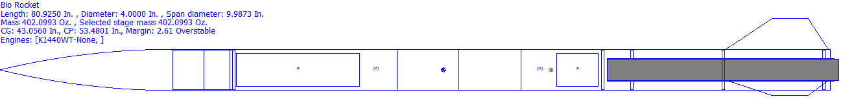
A. Vehicle Dimensions, Material Selection, and Construction Methods
The projected length of the rocket is 82 inches and the projected width of the rocket is 4 inches. The estimated mass of the rocket with motor is 402.1 ounces. The Center of Gravity is located 42.9 inches from the tip of the nosecone and the Center of Pressure is located 53.5 inches. The separation between the CP and CG is 2.63 times the diameter of the rocket, creating a stable design. The proposed material for our body tubes are fiberglass from Public Missiles Limited, as well as ¼in plywood bulkheads, nylon fruity chute parachutes, and fiberglass couplers, also from Public Missiles Limited. We plan to use a self designed Electronics Bay. The fiberglass tubing was selected because of itsrigidity and strength, it is fire retardant, and because of its high impact strength. We will also be using this fiberglass for our fins as well. This we plan to do “through the wall” fins. Our 3 fins will be placed at the bottom of our rocket, each 120 degrees apart. Doing the fins this way will be much stronger than securing fins into a fin can due the fact that it will be fiberglass on fiberglass instead of having fiberglass on plastic. We will have thin slits cut out of the walls of our rocket where the fins will be placed so that we have enough room to place the fins securely in and pour in West System 105 Epoxy Resin and 205 Quick Hardener around the fins to hold them in place. We chose to use West Systems Epoxy because of its greater bond strength and low output of fumes. Our will be a trapezoidal shape with a 10 inch base and a 3.5 inch top. Below is an image of what the design of our fins will be.
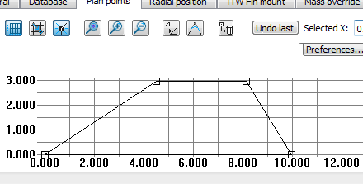
As you can see above our 10 inch base will go through the wall of our rocket and be secure to the fiberglass body tube. For our Electronics bay we plan to have it in the middle of the rocket. We propose that it will also be made out of fiberglass body tubing but it will work almost like a coupler tube. It will be about 3.9 inches in diameter so that it fits inside of our rocket. We plan for it to be 12 inches long. We will have a 2 inch piece of fiberglass tubing in the middle of the Electronics Bay that will slide on the outside. This piece will be epoxied in place to ensure that it is secure because we will have our key switches placed through this piece of fiberglass. This piece also ensures that when the rocket is assembled with the Electronics Bay inside, the tube will be flush all the way up and down. Our Electronics Bay will fit into our the back half of our rocket like a coupler tube but will be held into the front half of our rocket with plastic pop rivets to ensure that the main parachute will eject out of the nose cone and not split at the Electronics Bay from both sides. As for the altimeter, we plan on using a PerfectFliteStratologger altimeter. It is also affordable for this project. This altimeter can handle up to two pyrotechnic outputs, measures acceleration and also has barometric sensors. Inside of the Electronics Bay there will be two of these altimeters' on which one will be our main altimeter and the other on will be our redundant altimeter. If the first charges fail to go off for some reason, the second altimeter will be delayed up to 4 seconds after the first so that we make sure the parachutes will still be deployed.

B. Altitude
The Cesaroni K1440 White Thunder should deliver 2368 Newton-seconds of impulse. With this motor, our calculated point of apogee was planned to be 5,406 feet in perfect conditions. With our weight this should be the motor of choice for us as we planned in the design on a decrease in weight of the rocket by 15%, due to overestimating masses to be heavier than what we need. So with non-ideal conditions and some mass being taken off of final design our height should be right around a mile and right where we want it to be. We got these reading using the Rocksim program and running test simulation.

C. Parachute Design/Recovery System 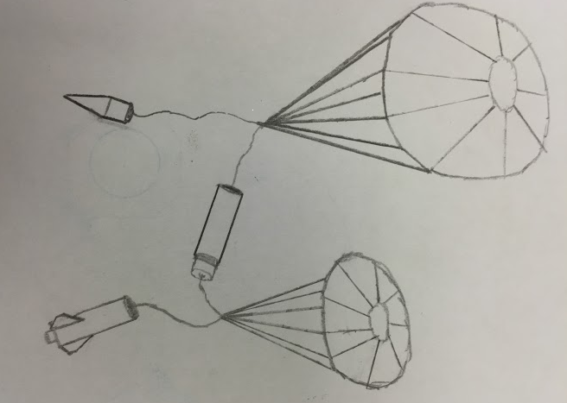
The design concept for recovery of the rocket contains two parachutes. In our Electronics Bay altimeters will send a signals to the charges that will eject the drogue chute at apogee and the main chute at 700 ft. Our first charge at apogee will eject the back half away from the Electronics Bay pulling out and deploying our drogue chute. At 700ft the altimeters send another signal to the charges which will eject our main chute out of our rocket at the nose cone. The main parachute will slow the descent rate to a projected descent speed of 17.6 ft/s. The nosecone and payload will be hanging from the main parachute, while the body hangs from the drogue parachute. For our design we propose on our drogue chute being a 24 inch diameter parachute by Fruity Chutes. We then plan to use for our main chute, a 72 inch diameter parachute also by Fruity Chutes.
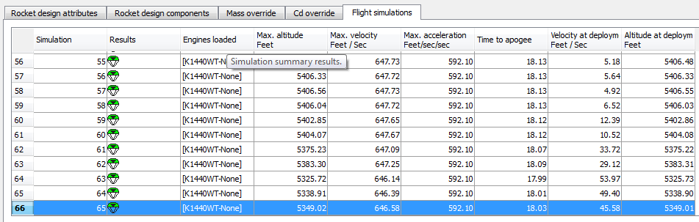
According to simulations on Rocksim, the recovery system, even up to speeds at the maximum 25 miles per hour, should allow the rocket to be within a range at landing of three-eighths of a mile, with an average at less than a quarter of a mile.

D. Motor Selection
The proposed motor for the rocket is a K1440 White Thunder from Cesaroni Technology. The casing is a 54 mm Cesaroni casing. The total impulse of the K1440 White Thunder is projected to be 2368 Newton-seconds. The average thrust is expected to be 1440 Newtons. We selected this motor because we will be testing how the planarian will react to the immense force that they will be subjected to. This motor will provide us with almost 42 G’s of force.

E. Payload Design
Our plan for our payload is to assemble it right into our nose cone. We will take a bulkhead and run two pieces of all thread symmetrically through it on the two halves of the bulkhead. We plan to thread nuts onto the all thread on both sides of the bulkhead. We will only leave a small length of all thread sticking out on the one side of the bulkhead due to the fact that it will be up in our nose cone and it cannot stick far up into it. We then plan to epoxy both of the nuts to the all thread and to the bulkhead to ensure that they will not move around and come loose. Once the epoxy dries and it has been assembled into one piece we will then push the bulkhead into the nose cone until it is in far enough that it is snug. We have to be sure that we push the side of the bulkhead with the shorter length of all thread up into the nose cone to ensure that we do not put a hole in it with the longer ends of all thread. After the bulkhead is pushed into the nose cone we will ensure that there are no gaps between the bulkhead and the nose cone, and we will then pour epoxy on and around the bulkhead to secure it to the nose cone. We will make extra-sure that it is secure because we will not want it to move around in flight. After that piece is secured in the nose cone we will spray expanding foam in it so that it will fill the space to the end of the nose cone. After the foam has dried and hardened we will drill 4 similar sized holes out of the foam so that we will be able to fit our test tubes that will be holding our planaria, into the foam tightly. We will then take another bulkhead and drill holes in it to match up with the all thread. We will also have foam on this bulkhead because it will be acting as a lid for our payload. This bulkhead will be held tight into the nose cone by threading nuts onto the all thread. These nuts will not be epoxied on so that we can access our payload. We will also have a U-bolt secured to this bulkhead so that we can attach a quick link and shock cord to it as well. This U-bolt will be threaded onto the other side to secure it to the bulkhead and the U-bolt will then be epoxied as well to ensure that it will not move. Our payload is designed to fit completely into the nose cone and will be ejected with the main chute at 700 feet.

F. Vehicle Requirements
The Spring Grove Area High School Rocket design for the launch vehicle is designed and intended to reach an altitude of 5,280 feet above ground level and not exceed that limit. During the flight, the vehicle is designed and made to remain under mach 1 for the entire flight going up and returning safely back to Earth. This rocket is designed to contain a recovery system and proper components to make the rocket recoverable and reusable. The rocket is also designed to only contain four independent sections all tethered together which is exactly the legal limit. The launch vehicle shall be constructed before reaching a launch site, so that the rocket is capable of being prepared for flight within two hours from the time the FAA flight waiver opens. The rocket is going to contain the proper components needed to keep the rocket in launch-ready configuration for one hour without losing any functionality of any onboard components that are critical to the safety and success of the launch. The launch vehicle shall also contain components which would make it compatible with either an eight foot 1010 or a 1515 rail. The vehicle will also be capable of being launched with a standard 12 volt DC current firing system. It won’t need external circuitry or special ground support equipment to initiate its launch. The vehicle will make use of a commercially available solid fuel motor propulsion system which uses an ammonium perchlorate composite propellant approved by the NAR, TRA, and the CAR. The vehicle shall contain no more ballast than 10% of the unballasted vehicle mass. The final rocket design will be flown and recovered in full scale prior to the FRR. The successful flight of the full-scale rocket shall be documented on the flight certification form by a Level 2 or 3 NAR/TRA observer, and then documented in the FRR. After successful completion of the full-scale flight, the rocket and its components will not be altered without the concurrence of the NASA Range Safety Officer (RSO). All of our launch vehicles won’t, in any way employ forward canards, forward firing motors, titanium sponges, hybrid motors, or a cluster of motors. The launch vehicle of Spring Grove Area High School has been designed to deploy two separate recovery systems. The first of those two recovery systems is designed to deploy at apogee and consists of a small, drogue parachute. The secondary recovery system, that deploys at a much lower altitude consist of a larger, main chute. This deployment is necessary to reduce the speed of the falling rocket to a safer landing speed. All sections of the vehicle shall have a kinetic energy less than 75 foot pounds of force. The vehicle has also been designed to land within 2500feet of the launch pad, assuming a 15 miles per hour wind, ensuring the safety of those outside of the 2500foot radius of the launch pad. The recovery system circuits have also been designed to be completely separate from the payload’s electrical circuits. The recovery system of the rocket has also been designed to include commercially available altimeters. The altimeter contained within the recovery system has also been designed by the manufacture to be armed from the outside of the rocket airframe with an arming switch. The altimeter shall have a power supply reserved for the use of the altimeter only. The arming switch for the altimeter will also be capable of being locked in the ON position for the entire duration of the launch. The arming switch for the altimeter must be less than six feet above the base of the rocket. The main parachute compartment and the drogue parachute compartment shall also contain removable shear pins. During flight a functional electronic transmitting device is intended to be placed inside the rocket. It will be used to track all of the components of the rocket. The recovery system electronics have also been incorporated into the rocket design in a way that no other onboard electronic devices adversely affect the recovery system. The recovery system will use low-current, commercially available electric matches to ignite all onboard ejection charges. The electronic ignition system for ejection charges won’t use a flashbulb. In addition, a rear ejection parachute design will not be used.

G. Technical Challenges and Solutions

Challenge | Solution

Creating a rocket that won’t go over 5280 feet. | Design the rocket to fly one mile high or slightly over under perfect conditions. This is accounted for due to the highly probable case that the rocket will weigh 25 percent more than calculated values. Therefore in experimental launches you will have factors, such as air resistance, that will cause drag.
Designing a rocket that can house a payload and chutes that won’t get stuck or tangled during deployment | Design the rocket so that the ejection charges effectively deploy the parachutes and also the payload. Place them in the correct order, or place, in the rocket so that they are successfully deployed.
Designing a protection system for the mass weight. | We will perform many stress tests on the case we are using inside the rocket and perfect the design. The team will also make sure to pack the weight correctly so that it has no tendency to fall off during flight.
Designing an external access to switch connected to the altimeter to ignite the ejection charges | Consult a Level 2 or Level 3 NAR/TRA representative on the procedure needed for the particular ejection system that was chosen. We should have safe access to the switch on the altimeter that ignites the ejection charges. It shouldn’t affect the recovery system or the flight of the rocket.

Educational Engagement
In order to spread awareness of all science programs at Spring Grove, we first plan to hold presentations to both our intermediate and middle schools from grades 1 to 8 to inform them of our project, the basics of a rocketry, and how to get involved in the rocketry teams when they reach the high school. We will spend that time giving the students a basic feel of what we are and what they could look forward to in the future. This includes all of the teams and events that we have for science like. Team America Rocketry Challenge and The Student Launch Program. If we present to both schools, over 1,000 children would be involved.
To obtain feedback, we will give small surveys to all children who were involved in our presentations. These surveys will ask how was the presentation, how interested the student is in joining a science club, and if they are interested in joining our rocketry workshop or a tarc team if we can get one together for the middle school
Below is an example of a survey which will be given to students after the presentation on the SL Program. From this survey, we can take the data and look over it to find what we can improve on in our presentation, and also so that we can reach out and contact those students who are interested in the program:
Student Launch Project Survey Form
Grade Level of Student- .
Rate 1-5 with 1 the worst and 5 the best.
Are you interested to learn more? .
Did you learn anything new? .
Are you interested in joining the TARC or SLP team in the future? _________
Do you know what SLP team is all about? _________
Did you understand it all? _________
Did the presenters get off topic? ________
Comments:
After last year’s rocket workshop which we had for the middle schoolers we would like to do this again. We would be using the same kits that we did last year. The rocket kits include body tubes, nose cones, and 2 oz. bottles of super glue, bulkheads, motor centering rings, wings, air resistance tubes, sandpaper, motors, ruler, shock cord, twine, solar igniters, bags, and scissors. Every team member of the Student Launch program would lead a small group, where the member will guide the children through the basics of rocket-building. The groups would then launch their small rockets and see if they want to be a part of one of our programs in the future.
Another possibility is to make a Team America Rocketry Challenge group for the middle school. This will allow interested students who are of younger age to work and learn in a safe working environment and express their interests in STEM at a young age. T
Along with this we will contact local television stations and newspapers. They would then make short segments on our project, further spreading awareness of our rocketry programs. Along with this we plan to go to home football games to set up a table and spread awareness about our project. We will also make our website more known and accessible to others so that if they want the can have a more in depth look at our group and what we do. Through this way and many others’, we should be able to spread our word to a younger generation and bring STEM to the forefront in our local community.

Project Plan:
1. Timeline
August 2015
- August 7, 2015: Request for Proposal (RFP) goes out to all terms
September 2015
- September 11, 2015: Electronic copy of completed proposal due to project office by 5pm
October 2015
- October 2, 2015: Awarded proposals announced
- October 7, 2015: Kickoff and PDR Q&A
- October 23, 2015: Team web presence established
November 2015
- November 6, 2015: Preliminary Design Review (PDR) reports, presentation slides, and flysheet posted on the team website
- November 9-20, 2015: PDR video teleconferences
December 2015
- December 14, 2015: CDR Q&A
January 2016
- January 15, 2016: Critical design review (CDR) reports, presentation slides, and flysheet posted on the team website
- January 19-29, 2016: CDR video teleconferences
February 2016
- February 3, 2016: FRR Q&A
March 2016
- March 14, 2016: Flight Readiness Review (FRR) reports, presentation slides, and flysheet posted to team website.
- March 17-30, 2016: FRR video teleconferences
April 2016
- April 13, 2016: Teams travel to Huntsville, AL; Launch Readiness Reviews (LRR)
- April 14, 2016: LRR’s and safety briefing
- April 15, 2016: Rocket Fair and Tours of MSFC
- April 16, 2016: Banquet; launch day
- April 17, 2016: Backup launch day
- April 29, 2016: Post-Launch Assessment Review (PLAR) posted on the team website
May 2016
- May 11, 2016: Winning team announced
Team Schedule:
As far as get-together’s go, there are two types: meetings and sessions. The meetings will be discussions conducted by the Team Captain and Co-Captain with the entire, including supervision and comments from them. Sessions will only be for team members to allow them to work without advisor help as a team, though an advisor will supervise them. The schedule will include general and formal meetings, briefing, group sessions, bonding sessions, work sessions, and construction sessions. The dates for these are variable to help better accommodate everyone.
Meetings:
At general meetings, tasks will be assigned and the information of when they need to be completed and turned in. These meetings will be informal and quite short, they will be held prior to the work that is going to be done that day.
The more formal meetings will have a considerable and strict agenda to discuss everything that needs to be done. This will include the progress on certain tasks or problems that have come up throughout the course of the week. Team members and advisors can share their thoughts and discuss them as a team. Team members and advisors can also ask any general questions about the project and/or concerns and can discuss them during these more formal meetings.
Briefings will be informative meetings consisting of a collective report of all work that has been completed and progress on any unfinished tasks. These will be used to inform the team of any changes to the project’s budget, schedule, fundraising, and other changes rather than focusing on what needs to be done.
Sessions:
Sessions will be somewhat of a counseling type of meeting. These will be used to address personal problems and challenges that have come up during the completion of the project. Team members may share personal problems that are outside of the project that are affecting their ability to work well, or explain problems that are preventing them from attending meetings. Other team members can then help in completing their part of the project. Since these are only held with team members, they can discuss how they feel about something else another team member has done, or if something another has done that has upset them in some way in order to best resolve the issue at hand. The sessions will allow the team members to get help in solving personal affairs and dealing with problems within or outside of the project to relieve as much stress as possible. These will help the team understand what is going on with other team members and grow together and help each other. The sessions will be more serious than the others, and are largely going to influence the project as we need everyone to be working at their best cooperatively. Not having this will make the project more stressful not only for those directly having problems, but for the entire team as well.
Part of our effort to make our team grow together and cooperate well, special bonding sessions will be held to improve the bond between team members and advisors. These are designated to help build relationships outside of the project. We will do various activities such as watching movies about science in general as well as more specifically aerospace, and other group favorite movies that we can watch together. As stated earlier, we need to have an open and friendly environment and atmosphere within our teams and these sessions and/or activities are crucial to that kind of team development and maintaining a pleasurable experience for all involved.
Work sessions will be used for working on any and all of the reports needed throughout the project. This will present the opportunity for team members to ask others questions about their part and allows for clarification if need be. This will also be used as a progress check to see what needs to be done and see what has been completed. It will give the chance for the two teams to work together and assist as needed within the time being.
Construction sessions will be used later in the project to actually build the tangible rocket itself. Team members will be paired to work on building specific parts of the rocket or payload. This prevents mistakes and accidents from happening and builds progress within itself. The partners are in case an accident does happen, so that the other partner will be there ready to help if needed. Construction will have adult supervision, so partners can inform them immediately if something requires attention or assistance. Both team members must read and abide by all safety rules regarding the operation of tools, for both their safety and their partner’s.
Meeting Times, Session Times, and Proposed Schedule:
Meetings and sessions will be held on several different dates; general meetings will be held every day when the team is capable of meeting together, typically before work sessions and before/after school hours. Formal meetings will be mandatory meetings that will be ideally held once a week from about 3:00pm to 5:00pm. Briefings will also be mandatory, as they are ideally held every Friday from 3:30pm to 4:30pm. Group sessions will be held every other week on the day that is more convenient for the team at the time. Work sessions will be held during any of the available times after school, allowing for convenience for each team member. Construction sessions, once that point in the project has been reached, will be held once or twice a week with Friday being our official construction day. Extra days will be assigned as needed later on in the project to assure that we stay on schedule. Partners must be present during the construction sessions for a team member to be able to do any work on their designated task. These construction sessions will also be under close supervision by an adult so in case any of the aforementioned issues arise.
2. Budget:
Item: | Cost (In Dollars):
Travel to Huntsville | 6000.00
Food for All Trips: | 2354.00
Practice Trips to Maryland | 840.00
Lodging in Huntsville | 3600.00
Nose Cone | 19.95
Body Tubes | 399.80
Rocket Mount | 4.99
Fast-Hardener | 43.94
Resin | 84.96
Shock Cords | 47.80
Large Parachute | 188.00
Small Parachute | 113.00
Centering Rings | 55.88
Bulkheads | 70.54
Motor Casing | 149.95
Reload | 531.80
Reload | 265.90
Couplers | 74.00
Motor Mount Tube | 9.95
Engine Retainers | 72.76
U-Bolts | 15.84
Quick-Links | 14.88
Altimeters | 1119.03
Batteries for E-BAY | 25.46
Materials for Fins | 70.38
Wires | 30.78
All-Threads | 6.40
Key-Switches | 106.68
Subscale Rocket | 500.00
3D Printer Filament | 21.22
Camera | 99.99
Battery Holder | 5.6
Total: | 16,943.48

3. Funding Plan:
In order to receive the necessary funds in order to successfully complete this project our team intends to cover the costs through a combination of fundraisers, donations and sponsors/grants all of which will be completed and then sent to our financial advisor for approval. Our club will be taking part in fundraisers throughout the year to help finance our endeavor. Current fundraisers that will be taking part includes “Nuts About Granola” (information is located at (www.nutsaboutgranola.com), selling cotton candy at local sporting events, Bonus Books (information is located at www.bonusbook.com), and we are currently brainstorming other options to continue to fundraise that are not yet official. Currently we are talking to TE Connectivity who was one of our largest sponsors last year and they have promised to support us this year as well. There are also several previous sponsors who may be interested in our clubs are currently accepting all donations and bring donation jars to all the events that we are planning to take part in.
4. Community Support:
To publicize our project, our team will be contacting local television stations like FOX43 of the FOX Corporation and WGAL 8 in the Susquehanna Valley like we have done in previous years as well as contacting local radio stations like 107.7 and 105.7. Lastly we will contact local newspapers to spread the word of the Spring Grove Rockets. We will be sending each of these kinds of organizations information about us and asking if they were willing to spread awareness about our club. We will also be using our own SL website to notify the public about the project and to post updates. We plan on making presentations to both our middle school and intermediate school about our project and the clubs offered at our high school to help get the kids more into and aware of the great possibilities that SLI provides. We also intend to create posters to put around our school and local businesses to promote and encourage sponsorship and donations.
5. Sustainability Plan:
We intend to keep our SL club together now and into the future through a combination of many plans and elements. We intend to maintain all of our current relationships by send them regular reports, maintain an active dialogue with them and taking their feedback into account. Our current relationships are with several certified NAR members, Advanced Application Design and the Engineering Society of York. Now in keeping a steady stream of new members coming into the club we will primarily recruit new members from our TARC teams who have had past experience in rocketry but we are willing to accept anyone who wants to join and is willing to put in the work. We will be using a combination of announcements, posters, and our website to get the word to potential club members. We intend to engage the students of Spring Grove Area School District in our club and mission through a series of assemblies and workshops. Lastly we intend to keep a steady stream of funding coming in through fundraisers, donations and sponsors/ grants. This will all ensure that our club is maintained well into the future. We also plan to:
- Avoid safety hazards is to have team members and supervisors read the all operation manuals for the tools and products that will be handled during the completion of our project before proceeding with any of such devices or products, while following the enclosed safety plan.
- Address if a team member is comfortable with using a tool at any time or not. ∙ Raise enough funds for our project we will be holding public outreach programs for funding and support we will be contacting local businesses for grants such as our local power company’s (MetEd’s)
- Stay on budget, we will keep track of all funds being used and track whether the prices of materials are within the projected coast by researching for the best pricing of the materials. If going over budget is inevitable, due to rising prices of materials, we will raise more funds from companies using our progress on the project to incite sponsorship from more companies and businesses.
- In order to make it to Huntsville, we want to work with people, local businesses, and corporate sponsors in and around the Spring Grove area. We plan on spreading awareness of our rocketry programs at Spring Grove to every adult and student in the area, to accomplish this we would like to create hands-on learning experiences for kids in our community to explore and learn more about the rocketry field.
- We will also be holding public outreach and funding programs at school and local events to help with awareness of our project to get the attention of adults of our community.
- We hope to have small groups work together and build small scale rockets, each group will have an SL member directing the group to help teach the students to build the small rocket. If feasible, we may launch the said rockets (if they are deemed safe to fly). We want to provide fun hands on experience for our students so more students will be interested in joining TARC and potentially even SL in the future.
- In order to spread public awareness, we are planning to contact television stations, such as FOX and our local news channels, to see if they are interested in making a short segment on the SL program of Spring Grove High School. We will also contact local radio stations such as 107.7 and 105.7 to see if they are interested in speaking on behalf of our program here at Spring Grove.

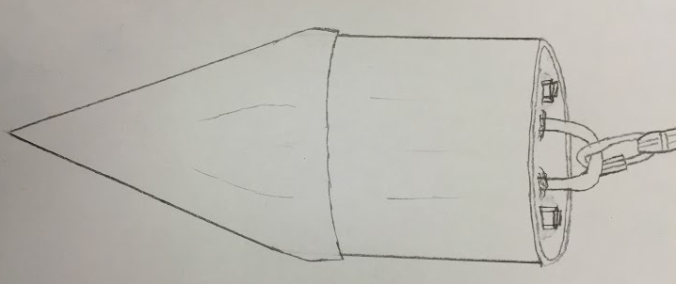
.
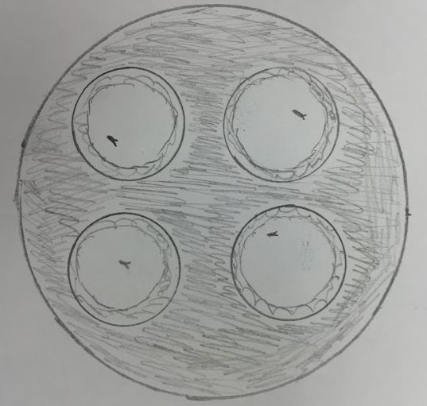

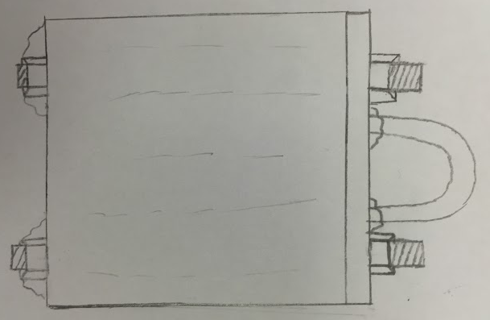

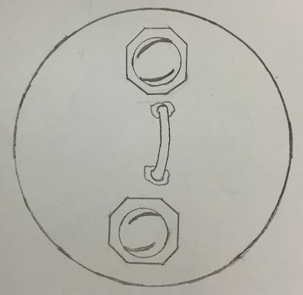

Seen above are many images of different perspectives of how our payload is proposed to look. The image in the top left is how payload will look from a top view, without the lid on. The image in the bottom left is how the payload will look from a top view, with the lid on. The image in the middle is how the payload will look from a side view with the lid on. And the image on the right is how the payload will look in the nose cone, with the lid on, and the shock cord attached. Before we put the planaria in the rocket we will be doing ground test. The ground test will help us to determine if we need to make temperature modifications. Planaria can survive in temperatures from 20-23 degrees celsius and if left in direct sunlight they will die. After ground test we will be able to see if we need to add anything into our payload other than just the insulation to make it warmer or cooler. The setup for the ground test will look like the payload design for the rocket but we will just have our payload in a piece of fiberglass tubing to make it as similar as possible to how it would be in the rocket. If these tests go well we will be launching them in our rocket and tracking their regrowth until they are fully grown again and comparing them to our control group.

F. Vehicle Requirements
The Spring Grove Area High School Rocket design for the launch vehicle is designed and intended to reach an altitude of 5,280 feet above ground level and not exceed that limit. During the flight, the vehicle is designed and made to remain under mach 1 for the entire flight going up and returning safely back to Earth. This rocket is designed to contain a recovery system and proper components to make the rocket recoverable and reusable. The rocket is also designed to only contain four independent sections all tethered together which is exactly the legal limit. The launch vehicle shall be constructed before reaching a launch site, so that the rocket is capable of being prepared for flight within two hours from the time the FAA flight waiver opens. The rocket is going to contain the proper components needed to keep the rocket in launch-ready configuration for one hour without losing any functionality of any onboard components that are critical to the safety and success of the launch. The launch vehicle shall also contain components which would make it compatible with either an eight foot 1010 or a 1515 rail. The vehicle will also be capable of being launched with a standard 12 volt DC current firing system. It won’t need external circuitry or special ground support equipment to initiate its launch. The vehicle will make use of a commercially available solid fuel motor propulsion system which uses an ammonium perchlorate composite propellant approved by the NAR, TRA, and the CAR. The vehicle shall contain no more ballast than 10% of the unballasted vehicle mass. The final rocket design will be flown and recovered in full scale prior to the FRR. The successful flight of the full-scale rocket shall be documented on the flight certification form by a Level 2 or 3 NAR/TRA observer, and then documented in the FRR. After successful completion of the full-scale flight, the rocket and its components will not be altered without the concurrence of the NASA Range Safety Officer (RSO). All of our launch vehicles won’t, in any way employ forward canards, forward firing motors, titanium sponges, hybrid motors, or a cluster of motors. The launch vehicle of Spring Grove Area High School has been designed to deploy two separate recovery systems. The first of those two recovery systems is designed to deploy at apogee and consists of a small, drogue parachute. The secondary recovery system, that deploys at a much lower altitude consist of a larger, main chute. This deployment is necessary to reduce the speed of the falling rocket to a safer landing speed. All sections of the vehicle shall have a kinetic energy less than 75 foot pounds of force. The vehicle has also been designed to land within 2500feet of the launch pad, assuming a 15 miles per hour wind, ensuring the safety of those outside of the 2500foot radius of the launch pad. The recovery system circuits have also been designed to be completely separate from the payload’s electrical circuits. The recovery system of the rocket has also been designed to include commercially available altimeters. The altimeter contained within the recovery system has also been designed by the manufacture to be armed from the outside of the rocket airframe with an arming switch. The altimeter shall have a power supply reserved for the use of the altimeter only. The arming switch for the altimeter will also be capable of being locked in the ON position for the entire duration of the launch. The arming switch for the altimeter must be less than six feet above the base of the rocket. The main parachute compartment and the drogue parachute compartment shall also contain removable shear pins. During flight a functional electronic transmitting device is intended to be placed inside the rocket. It will be used to track all of the components of the rocket. The recovery system electronics have also been incorporated into the rocket design in a way that no other onboard electronic devices adversely affect the recovery system. The recovery system will use low-current, commercially available electric matches to ignite all onboard ejection charges. The electronic ignition system for ejection charges won’t use a flashbulb. In addition, a rear ejection parachute design will not be used.

G. Technical Challenges and Solutions

Challenge | Solution

Creating a rocket that won’t go over 5280 feet. | Design the rocket to fly one mile high or slightly over under perfect conditions. This is accounted for due to the highly probable case that the rocket will weigh 25 percent more than calculated values. Therefore in experimental launches you will have factors, such as air resistance, that will cause drag.
Designing a rocket that can house a payload and chutes that won’t get stuck or tangled during deployment | Design the rocket so that the ejection charges effectively deploy the parachutes and also the payload. Place them in the correct order, or place, in the rocket so that they are successfully deployed.
Designing a protection system for the mass weight. | We will perform many stress tests on the case we are using inside the rocket and perfect the design. The team will also make sure to pack the weight correctly so that it has no tendency to fall off during flight.
Designing an external access to switch connected to the altimeter to ignite the ejection charges | Consult a Level 2 or Level 3 NAR/TRA representative on the procedure needed for the particular ejection system that was chosen. We should have safe access to the switch on the altimeter that ignites the ejection charges. It shouldn’t affect the recovery system or the flight of the rocket.

Educational Engagement
In order to spread awareness of all science programs at Spring Grove, we first plan to hold presentations to both our intermediate and middle schools from grades 1 to 8 to inform them of our project, the basics of a rocketry, and how to get involved in the rocketry teams when they reach the high school. We will spend that time giving the students a basic feel of what we are and what they could look forward to in the future. This includes all of the teams and events that we have for science like. Team America Rocketry Challenge and The Student Launch Program. If we present to both schools, over 1,000 children would be involved.
To obtain feedback, we will give small surveys to all children who were involved in our presentations. These surveys will ask how was the presentation, how interested the student is in joining a science club, and if they are interested in joining our rocketry workshop or a tarc team if we can get one together for the middle school
Below is an example of a survey which will be given to students after the presentation on the SL Program. From this survey, we can take the data and look over it to find what we can improve on in our presentation, and also so that we can reach out and contact those students who are interested in the program:
Student Launch Project Survey Form
Grade Level of Student- .
Rate 1-5 with 1 the worst and 5 the best.
Are you interested to learn more? .
Did you learn anything new? .
Are you interested in joining the TARC or SLP team in the future? _________
Do you know what SLP team is all about? _________
Did you understand it all? _________
Did the presenters get off topic? ________
Comments:

After last years rocket workshop which we had for the middle schoolers we would like to do this again. We would be using the same kits that we did last year. The rocket kits include body tubes, nose cones, and 2 oz. bottles of super glue, bulkheads, motor centering rings, wings, air resistance tubes, sandpaper, motors, ruler, shock cord, twine, solar igniters, bags, and scissors. Every team member of the Student Launch program would lead a small group, where the member will guide the children through the basics of rocket-building. The groups would then launch their small rockets and see if they want to be a part of one of our programs in the future.
Another possibility is to make a Team America Rocketry Challenge group for the middle school. This will allow interested students who are of younger age to work and learn in a safe working environment and express their interests in STEM at a young age. T
Along with this we will contact local television stations and newspapers. They would then make short segments on our project, further spreading awareness of our rocketry programs. Along with this we plan to go to home football games to set up a table and spread awareness about our project. We will also make our website more known and accessible to others so that if they want the can have a more in depth look at our group and what we do. Through this way and many others’, we should be able to spread our word to a younger generation and bring STEM to the forefront in our local community.

Project Plan:
1. Timeline
August 2015
- August 7, 2015: Request for Proposal (RFP) goes out to all terms
September 2015
- September 11, 2015: Electronic copy of completed proposal due to project office by 5pm
October 2015
- October 2, 2015: Awarded proposals announced
- October 7, 2015: Kickoff and PDR Q&A
- October 23, 2015: Team web presence established
November 2015
- November 6, 2015: Preliminary Design Review (PDR) reports, presentation slides, and flysheet posted on the team website
- November 9-20, 2015: PDR video teleconferences
December 2015
- December 14, 2015: CDR Q&A
January 2016
- January 15, 2016: Critical design review (CDR) reports, presentation slides, and flysheet posted on the team website
- January 19-29, 2016: CDR video teleconferences
February 2016
- February 3, 2016: FRR Q&A
March 2016
- March 14, 2016: Flight Readiness Review (FRR) reports, presentation slides, and flysheet posted to team website.
- March 17-30, 2016: FRR video teleconferences
April 2016
- April 13, 2016: Teams travel to Huntsville, AL; Launch Readiness Reviews (LRR)
- April 14, 2016: LRR’s and safety briefing
- April 15, 2016: Rocket Fair and Tours of MSFC
- April 16, 2016: Banquet; launch day
- April 17, 2016: Backup launch day
- April 29, 2016: Post-Launch Assessment Review (PLAR) posted on the team website
May 2016
- May 11, 2016: Winning team announced
Team Schedule:
As far as get-together’s go, there are two types: meetings and sessions. The meetings will be discussions conducted by the Team Captain and Co-Captain with the entire, including supervision and comments from them. Sessions will only be for team members to allow them to work without advisor help as a team, though an advisor will supervise them. The schedule will include general and formal meetings, briefing, group sessions, bonding sessions, work sessions, and construction sessions. The dates for these are variable to help better accommodate everyone.
Meetings:
At general meetings, tasks will be assigned and the information of when they need to be completed and turned in. These meetings will be informal and quite short, they will be held prior to the work that is going to be done that day.
The more formal meetings will have a considerable and strict agenda to discuss everything that needs to be done. This will include the progress on certain tasks or problems that have come up throughout the course of the week. Team members and advisors can share their thoughts and discuss them as a team. Team members and advisors can also ask any general questions about the project and/or concerns and can discuss them during these more formal meetings.
Briefings will be informative meetings consisting of a collective report of all work that has been completed and progress on any unfinished tasks. These will be used to inform the team of any changes to the project’s budget, schedule, fundraising, and other changes rather than focusing on what needs to be done.
Sessions:
Sessions will be somewhat of a counseling type of meeting. These will be used to address personal problems and challenges that have come up during the completion of the project. Team members may share personal problems that are outside of the project that are affecting their ability to work well, or explain problems that are preventing them from attending meetings. Other team members can then help in completing their part of the project. Since these are only held with team members, they can discuss how they feel about something else another team member has done, or if something another has done that has upset them in some way in order to best resolve the issue at hand. The sessions will allow the team members to get help in solving personal affairs and dealing with problems within or outside of the project to relieve as much stress as possible. These will help the team understand what is going on with other team members and grow together and help each other. The sessions will be more serious than the others, and are largely going to influence the project as we need everyone to be working at their best cooperatively. Not having this will make the project more stressful not only for those directly having problems, but for the entire team as well.
Part of our effort to make our team grow together and cooperate well, special bonding sessions will be held to improve the bond between team members and advisors. These are designated to help build relationships outside of the project. We will do various activities such as watching movies about science in general as well as more specifically aerospace, and other group favorite movies that we can watch together. As stated earlier, we need to have an open and friendly environment and atmosphere within our teams and these sessions and/or activities are crucial to that kind of team development and maintaining a pleasurable experience for all involved.
Work sessions will be used for working on any and all of the reports needed throughout the project. This will present the opportunity for team members to ask others questions about their part and allows for clarification if need be. This will also be used as a progress check to see what needs to be done and see what has been completed. It will give the chance for the two teams to work together and assist as needed within the time being.
Construction sessions will be used later in the project to actually build the tangible rocket itself. Team members will be paired to work on building specific parts of the rocket or payload. This prevents mistakes and accidents from happening and builds progress within itself. The partners are in case an accident does happen, so that the other partner will be there ready to help if needed. Construction will have adult supervision, so partners can inform them immediately if something requires attention or assistance. Both team members must read and abide by all safety rules regarding the operation of tools, for both their safety and their partner’s.
Meeting Times, Session Times, and Proposed Schedule:
Meetings and sessions will be held on several different dates; general meetings will be held every day when the team is capable of meeting together, typically before work sessions and before/after school hours. Formal meetings will be mandatory meetings that will be ideally held once a week from about 3:00pm to 5:00pm. Briefings will also be mandatory, as they are ideally held every Friday from 3:30pm to 4:30pm. Group sessions will be held every other week on the day that is more convenient for the team at the time. Work sessions will be held during any of the available times after school, allowing for convenience for each team member. Construction sessions, once that point in the project has been reached, will be held once or twice a week with Friday being our official construction day. Extra days will be assigned as needed later on in the project to assure that we stay on schedule. Partners must be present during the construction sessions for a team member to be able to do any work on their designated task. These construction sessions will also be under close supervision by an adult so in case any of the aforementioned issues arise.
2. Budget:
Item: | Cost (In Dollars):
Travel to Huntsville | 6000.00
Food for All Trips: | 2354.00
Practice Trips to Maryland | 840.00
Lodging in Huntsville | 3600.00
Nose Cone | 19.95
Body Tubes | 399.80
Rocket Mount | 4.99
Fast-Hardener | 43.94
Resin | 84.96
Shock Cords | 47.80
Large Parachute | 188.00
Small Parachute | 113.00
Centering Rings | 55.88
Bulkheads | 70.54
Motor Casing | 149.95
Reload | 531.80
Reload | 265.90
Couplers | 74.00
Motor Mount Tube | 9.95
Engine Retainers | 72.76
U-Bolts | 15.84
Quick-Links | 14.88
Altimeters | 1119.03
Batteries for E-BAY | 25.46
Materials for Fins | 70.38
Wires | 30.78
All-Threads | 6.40
Key-Switches | 106.68
Subscale Rocket | 500.00
3D Printer Filament | 21.22
Camera | 99.99
Battery Holder | 5.6
Total: | 16,943.48

3. Funding Plan:
In order to receive the necessary funds in order to successfully complete this project our team intends to cover the costs through a combination of fundraisers, donations and sponsors/grants all of which will be completed and then sent to our financial advisor for approval. Our club will be taking part in fundraisers throughout the year to help finance our endeavor. Current fundraisers that will be taking part includes “Nuts About Granola” (information is located at (www.nutsaboutgranola.com), selling cotton candy at local sporting events, Bonus Books (information is located at www.bonusbook.com), and we are currently brainstorming other options to continue to fundraise that are not yet official. Currently we are talking to TE Connectivity who was one of our largest sponsors last year and they have promised to support us this year as well. There are also several previous sponsors who may be interested inOur clubs are currently accepting all donations and bring donation jars to all the events that we are planning to take part in.
4. Community Support:
To publicize our project, our team will be contacting local television stations like FOX43 of the FOX Corporation and WGAL 8 in the Susquehanna Valley like we have done in previous years as well as contacting local radio stations like 107.7 and 105.7. Lastly we will contact local newspapers to spread the word of the Spring Grove Rockets. We will be sending each of these kinds of organizations information about us and asking if they were willing to spread awareness about our club. We will also be using our own SL website to notify the public about the project and to post updates. We plan on making presentations to both our middle school and intermediate school about our project and the clubs offered at our high school to help get the kids more into and aware of the great possibilities that SLI provides. We also intend to create posters to put around our school and local businesses to promote and encourage sponsorship and donations.
5. Sustainability Plan:
We intend to keep our SL club together now and into the future through a combination of many plans and elements. We intend to maintain all of our current relationships by send them regular reports, maintain an active dialogue with them and taking their feedback into account. Our current relationships are with several certified NAR members, Advanced Application Design and the Engineering Society of York. Now in keeping a steady stream of new members coming into the club we will primarily recruit new members from our TARC teams who have had past experience in rocketry but we are willing to accept anyone who wants to join and is willing to put in the work. We will be using a combination of announcements, posters, and our website to get the word to potential club members. We intend to engage the students of Spring Grove Area School District in our club and mission through a series of assemblies and workshops. Lastly we intend to keep a steady stream of funding coming in through fundraisers, donations and sponsors/ grants. This will all ensure that our club is maintained well into the future. We also plan to:
- Avoid safety hazards is to have team members and supervisors read the all operation manuals for the tools and products that will be handled during the completion of our project before proceeding with any of such devices or products, while following the enclosed safety plan.
- Address if a team member is comfortable with using a tool at any time or not. ∙ Raise enough funds for our project we will be holding public outreach programs for funding and support we will be contacting local businesses for grants such as our local power company’s (MetEd’s)
- Stay on budget, we will keep track of all funds being used and track whether the prices of materials are within the projected coast by researching for the best pricing of the materials. If going over budget is inevitable, due to rising prices of materials, we will raise more funds from companies using our progress on the project to incite sponsorship from more companies and businesses.
- In order to make it to Huntsville, we want to work with people, local businesses, and corporate sponsors in and around the Spring Grove area. We plan on spreading awareness of our rocketry programs at Spring Grove to every adult and student in the area, to accomplish this we would like to create hands-on learning experiences for kids in our community to explore and learn more about the rocketry field.
- We will also be holding public outreach and funding programs at school and local events to help with awareness of our project to get the attention of adults of our community.
- We hope to have small groups work together and build small scale rockets, each group will have an SL member directing the group to help teach the students to build the small rocket. If feasible, we may launch the said rockets (if they are deemed safe to fly). We want to provide fun hands on experience for our students so more students will be interested in joining TARC and potentially even SL in the future.
- In order to spread public awareness, we are planning to contact television stations, such as FOX and our local news channels, to see if they are interested in making a short segment on the SL program of Spring Grove High School. We will also contact local radio stations such as 107.7 and 105.7 to see if they are interested in speaking on behalf of our program here at Spring Grove.

.

Seen above are many images of different perspectives of how our payload is proposed to look. The image in the top left is how payload will look from a top view, without the lid on. The image in the bottom left is how the payload will look from a top view, with the lid on. The image in the middle is how the payload will look from a side view with the lid on. And the image on the right is how the payload will look in the nose cone, with the lid on, and the shock cord attached. Before we put the planarians in the rocket we will be doing ground test. The ground test will help us to determine if we need to make temperature modifications. Planarians can survive in temperatures from 20-23 degrees Celsius and if left in direct sunlight they will die. After ground test we will be able to see if we need to add anything into our payload other than just the insulation to make it warmer or cooler. The setup for the ground test will look like the payload design for the rocket but we will just have our payload in a piece of fiberglass tubing to make it as similar as possible to how it would be in the rocket. If these tests go well we will be launching them in our rocket and tracking their regrowth until they are fully grown again and comparing them to our control group.

F. Vehicle Requirements
The Spring Grove Area High School Rocket design for the launch vehicle is designed and intended to reach an altitude of 5,280 feet above ground level and not exceed that limit. During the flight, the vehicle is designed and made to remain under Mach 1 for the entire flight going up and returning safely back to Earth. This rocket is designed to contain a recovery system and proper components to make the rocket recoverable and reusable. The rocket is also designed to only contain four independent sections all tethered together which is exactly the legal limit. The launch vehicle shall be constructed before reaching a launch site, so that the rocket is capable of being prepared for flight within two hours from the time the FAA flight waiver opens. The rocket is going to contain the proper components needed to keep the rocket in launch-ready configuration for one hour without losing any functionality of any onboard components that are critical to the safety and success of the launch. The launch vehicle shall also contain components which would make it compatible with either an eight foot 1010 or a 1515 rail. The vehicle will also be capable of being launched with a standard 12 volt DC current firing system. It won’t need external circuitry or special ground support equipment to initiate its launch. The vehicle will make use of a commercially available solid fuel motor propulsion system which uses an ammonium perchlorate composite propellant approved by the NAR, TRA, and the CAR. The vehicle shall contain no more ballast than 10% of the ballasted vehicle mass. The final rocket design will be flown and recovered in full scale prior to the FRR. The successful flight of the full-scale rocket shall be documented on the flight certification form by a Level 2 or 3 NAR/TRA observer, and then documented in the FRR. After successful completion of the full-scale flight, the rocket and its components will not be altered without the concurrence of the NASA Range Safety Officer (RSO). All of our launch vehicles won’t, in any way employ forward canards, forward firing motors, titanium sponges, hybrid motors, or a cluster of motors. The launch vehicle of Spring Grove Area High School has been designed to deploy two separate recovery systems. The first of those two recovery systems is designed to deploy at apogee and consists of a small, drogue parachute. The secondary recovery system, that deploys at a much lower altitude consist of a larger, main chute. This deployment is necessary to reduce the speed of the falling rocket to a safer landing speed. All sections of the vehicle shall have a kinetic energy less than 75 foot pounds of force. The vehicle has also been designed to land within 2500feet of the launch pad, assuming a 15 miles per hour wind, ensuring the safety of those outside of the 2500foot radius of the launch pad. The recovery system circuits have also been designed to be completely separate from the payload’s electrical circuits. The recovery system of the rocket has also been designed to include commercially available altimeters. The altimeter contained within the recovery system has also been designed by the manufacture to be armed from the outside of the rocket airframe with an arming switch. The altimeter shall have a power supply reserved for the use of the altimeter only. The arming switch for the altimeter will also be capable of being locked in the ON position for the entire duration of the launch. The arming switch for the altimeter must be less than six feet above the base of the rocket. The main parachute compartment and the drogue parachute compartment shall also contain removable shear pins. During flight a functional electronic transmitting device is intended to be placed inside the rocket. It will be used to track all of the components of the rocket. The recovery system electronics have also been incorporated into the rocket design in a way that no other onboard electronic devices adversely affect the recovery system. The recovery system will use low-current, commercially available electric matches to ignite all onboard ejection charges. The electronic ignition system for ejection charges won’t use a flashbulb. In addition, a rear ejection parachute design will not be used.

G. Technical Challenges and Solutions

Challenge | Solution

Creating a rocket that won’t go over 5280 feet. | Design the rocket to fly one mile high or slightly over under perfect conditions. This is accounted for due to the highly probable case that the rocket will weigh 25 percent more than calculated values. Therefore in experimental launches you will have factors, such as air resistance, that will cause drag.
Designing a rocket that can house a payload and chutes that won’t get stuck or tangled during deployment | Design the rocket so that the ejection charges effectively deploy the parachutes and also the payload. Place them in the correct order, or place, in the rocket so that they are successfully deployed.
Designing a protection system for the mass weight. | We will perform many stress tests on the case we are using inside the rocket and perfect the design. The team will also make sure to pack the weight correctly so that it has no tendency to fall off during flight.
Designing an external access to switch connected to the altimeter to ignite the ejection charges | Consult a Level 2 or Level 3 NAR/TRA representative on the procedure needed for the particular ejection system that was chosen. We should have safe access to the switch on the altimeter that ignites the ejection charges. It shouldn’t affect the recovery system or the flight of the rocket.

Educational Engagement
In order to spread awareness of all science programs at Spring Grove, we first plan to hold presentations to both our intermediate and middle schools from grades 1 to 8 to inform them of our project, the basics of a rocketry, and how to get involved in the rocketry teams when they reach the high school. We will spend that time giving the students a basic feel of what we are and what they could look forward to in the future. This includes all of the teams and events that we have for science like. Team America Rocketry Challenge and The Student Launch Program. If we present to both schools, over 1,000 children would be involved.
To obtain feedback, we will give small surveys to all children who were involved in our presentations. These surveys will ask how was the presentation, how interested the student is in joining a science club, and if they are interested in joining our rocketry workshop or a tarc team if we can get one together for the middle school
Below is an example of a survey which will be given to students after the presentation on the SL Program. From this survey, we can take the data and look over it to find what we can improve on in our presentation, and also so that we can reach out and contact those students who are interested in the program:
Student Launch Project Survey Form
Grade Level of Student- .
Rate 1-5 with 1 the worst and 5 the best.
Are you interested to learn more? .
Did you learn anything new? .
Are you interested in joining the TARC or SLP team in the future? _________
Do you know what SLP team is all about? _________
Did you understand it all? _________
Did the presenters get off topic? ________
Comments:

After last year’s rocket workshop which we had for the middle schoolers we would like to do this again. We would be using the same kits that we did last year. The rocket kits include body tubes, nose cones, and 2 oz. bottles of super glue, bulkheads, motor centering rings, wings, air resistance tubes, sandpaper, motors, ruler, shock cord, twine, solar igniters, bags, and scissors. Every team member of the Student Launch program would lead a small group, where the member will guide the children through the basics of rocket-building. The groups would then launch their small rockets and see if they want to be a part of one of our programs in the future.
Another possibility is to make a Team America Rocketry Challenge group for the middle school. This will allow interested students who are of younger age to work and learn in a safe working environment and express their interests in STEM at a young age. T
Along with this we will contact local television stations and newspapers. They would then make short segments on our project, further spreading awareness of our rocketry programs. Along with this we plan to go to home football games to set up a table and spread awareness about our project. We will also make our website more known and accessible to others so that if they want the can have a more in depth look at our group and what we do. Through this way and many others’, we should be able to spread our word to a younger generation and bring STEM to the forefront in our local community.

Project Plan:
1. Timeline
August 2015
- August 7, 2015: Request for Proposal (RFP) goes out to all terms
September 2015
- September 11, 2015: Electronic copy of completed proposal due to project office by 5pm
October 2015
- October 2, 2015: Awarded proposals announced
- October 7, 2015: Kickoff and PDR Q&A
- October 23, 2015: Team web presence established
November 2015
- November 6, 2015: Preliminary Design Review (PDR) reports, presentation slides, and flysheet posted on the team website
- November 9-20, 2015: PDR video teleconferences
December 2015
- December 14, 2015: CDR Q&A
January 2016
- January 15, 2016: Critical design review (CDR) reports, presentation slides, and flysheet posted on the team website
- January 19-29, 2016: CDR video teleconferences
February 2016
- February 3, 2016: FRR Q&A
March 2016
- March 14, 2016: Flight Readiness Review (FRR) reports, presentation slides, and flysheet posted to team website.
- March 17-30, 2016: FRR video teleconferences
April 2016
- April 13, 2016: Teams travel to Huntsville, AL; Launch Readiness Reviews (LRR)
- April 14, 2016: LRR’s and safety briefing
- April 15, 2016: Rocket Fair and Tours of MSFC
- April 16, 2016: Banquet; launch day
- April 17, 2016: Backup launch day
- April 29, 2016: Post-Launch Assessment Review (PLAR) posted on the team website
May 2016
- May 11, 2016: Winning team announced
Team Schedule:
As far as get-together’s go, there are two types: meetings and sessions. The meetings will be discussions conducted by the Team Captain and Co-Captain with the entire, including supervision and comments from them. Sessions will only be for team members to allow them to work without advisor help as a team, though an advisor will supervise them. The schedule will include general and formal meetings, briefing, group sessions, bonding sessions, work sessions, and construction sessions. The dates for these are variable to help better accommodate everyone.
Meetings:
At general meetings, tasks will be assigned and the information of when they need to be completed and turned in. These meetings will be informal and quite short, they will be held prior to the work that is going to be done that day.
The more formal meetings will have a considerable and strict agenda to discuss everything that needs to be done. This will include the progress on certain tasks or problems that have come up throughout the course of the week. Team members and advisors can share their thoughts and discuss them as a team. Team members and advisors can also ask any general questions about the project and/or concerns and can discuss them during these more formal meetings.
Briefings will be informative meetings consisting of a collective report of all work that has been completed and progress on any unfinished tasks. These will be used to inform the team of any changes to the project’s budget, schedule, fundraising, and other changes rather than focusing on what needs to be done.
Sessions:
Sessions will be somewhat of a counseling type of meeting. These will be used to address personal problems and challenges that have come up during the completion of the project. Team members may share personal problems that are outside of the project that are affecting their ability to work well, or explain problems that are preventing them from attending meetings. Other team members can then help in completing their part of the project. Since these are only held with team members, they can discuss how they feel about something else another team member has done, or if something another has done that has upset them in some way in order to best resolve the issue at hand. The sessions will allow the team members to get help in solving personal affairs and dealing with problems within or outside of the project to relieve as much stress as possible. These will help the team understand what is going on with other team members and grow together and help each other. The sessions will be more serious than the others, and are largely going to influence the project as we need everyone to be working at their best cooperatively. Not having this will make the project more stressful not only for those directly having problems, but for the entire team as well.
Part of our effort to make our team grow together and cooperate well, special bonding sessions will be held to improve the bond between team members and advisors. These are designated to help build relationships outside of the project. We will do various activities such as watching movies about science in general as well as more specifically aerospace, and other group favorite movies that we can watch together. As stated earlier, we need to have an open and friendly environment and atmosphere within our teams and these sessions and/or activities are crucial to that kind of team development and maintaining a pleasurable experience for all involved.
Work sessions will be used for working on any and all of the reports needed throughout the project. This will present the opportunity for team members to ask others questions about their part and allows for clarification if need be. This will also be used as a progress check to see what needs to be done and see what has been completed. It will give the chance for the two teams to work together and assist as needed within the time being.
Construction sessions will be used later in the project to actually build the tangible rocket itself. Team members will be paired to work on building specific parts of the rocket or payload. This prevents mistakes and accidents from happening and builds progress within itself. The partners are in case an accident does happen, so that the other partner will be there ready to help if needed. Construction will have adult supervision, so partners can inform them immediately if something requires attention or assistance. Both team members must read and abide by all safety rules regarding the operation of tools, for both their safety and their partner’s.
Meeting Times, Session Times, and Proposed Schedule:
Meetings and sessions will be held on several different dates; general meetings will be held every day when the team is capable of meeting together, typically before work sessions and before/after school hours. Formal meetings will be mandatory meetings that will be ideally held once a week from about 3:00pm to 5:00pm. Briefings will also be mandatory, as they are ideally held every Friday from 3:30pm to 4:30pm. Group sessions will be held every other week on the day that is more convenient for the team at the time. Work sessions will be held during any of the available times after school, allowing for convenience for each team member. Construction sessions, once that point in the project has been reached, will be held once or twice a week with Friday being our official construction day. Extra days will be assigned as needed later on in the project to assure that we stay on schedule. Partners must be present during the construction sessions for a team member to be able to do any work on their designated task. These construction sessions will also be under close supervision by an adult so in case any of the aforementioned issues arise.
2. Budget:
Item: | Cost (In Dollars):
Travel to Huntsville | 6000.00
Food for All Trips: | 2354.00
Practice Trips to Maryland | 840.00
Lodging in Huntsville | 3600.00
Nose Cone | 19.95
Body Tubes | 399.80
Rocket Mount | 4.99
Fast-Hardener | 43.94
Resin | 84.96
Shock Cords | 47.80
Large Parachute | 188.00
Small Parachute | 113.00
Centering Rings | 55.88
Bulkheads | 70.54
Motor Casing | 149.95
Reload | 531.80
Reload | 265.90
Couplers | 74.00
Motor Mount Tube | 9.95
Engine Retainers | 72.76
U-Bolts | 15.84
Quick-Links | 14.88
Altimeters | 1119.03
Batteries for E-BAY | 25.46
Materials for Fins | 70.38
Wires | 30.78
All-Threads | 6.40
Key-Switches | 106.68
Subscale Rocket | 500.00
3D Printer Filament | 21.22
Camera | 99.99
Battery Holder | 5.6
Total: | 16,943.48

3. Funding Plan:
In order to receive the necessary funds in order to successfully complete this project our team intends to cover the costs through a combination of fundraisers, donations and sponsors/grants all of which will be completed and then sent to our financial advisor for approval. Our club will be taking part in fundraisers throughout the year to help finance our endeavor. Current fundraisers that will be taking part includes “Nuts About Granola” (information is located at (www.nutsaboutgranola.com), selling cotton candy at local sporting events, Bonus Books (information is located at www.bonusbook.com), and we are currently brainstorming other options to continue to fundraise that are not yet official. Currently we are talking to TE Connectivity who was one of our largest sponsors last year and they have promised to support us this year as well. There are also several previous sponsors who may be interested in Our clubs are currently accepting all donations and bring donation jars to all the events that we are planning to take part in.
4. Community Support:
To publicize our project, our team will be contacting local television stations like FOX43 of the FOX Corporation and WGAL 8 in the Susquehanna Valley like we have done in previous years as well as contacting local radio stations like 107.7 and 105.7. Lastly we will contact local newspapers to spread the word of the Spring Grove Rockets. We will be sending each of these kinds of organizations information about us and asking if they were willing to spread awareness about our club. We will also be using our own SL website to notify the public about the project and to post updates. We plan on making presentations to both our middle school and intermediate school about our project and the clubs offered at our high school to help get the kids more into and aware of the great possibilities that SLI provides. We also intend to create posters to put around our school and local businesses to promote and encourage sponsorship and donations.
5. Sustainability Plan:
We intend to keep our SL club together now and into the future through a combination of many plans and elements. We intend to maintain all of our current relationships by send them regular reports, maintain an active dialogue with them and taking their feedback into account. Our current relationships are with several certified NAR members, Advanced Application Design and the Engineering Society of York. Now in keeping a steady stream of new members coming into the club we will primarily recruit new members from our TARC teams who have had past experience in rocketry but we are willing to accept anyone who wants to join and is willing to put in the work. We will be using a combination of announcements, posters, and our website to get the word to potential club members. We intend to engage the students of Spring Grove Area School District in our club and mission through a series of assemblies and workshops. Lastly we intend to keep a steady stream of funding coming in through fundraisers, donations and sponsors/ grants. This will all ensure that our club is maintained well into the future. We also plan to:
- Avoid safety hazards is to have team members and supervisors read the all operation manuals for the tools and products that will be handled during the completion of our project before proceeding with any of such devices or products, while following the enclosed safety plan.
- Address if a team member is comfortable with using a tool at any time or not. ∙ Raise enough funds for our project we will be holding public outreach programs for funding and support we will be contacting local businesses for grants such as our local power company’s (MetEd’s)
- Stay on budget, we will keep track of all funds being used and track whether the prices of materials are within the projected coast by researching for the best pricing of the materials. If going over budget is inevitable, due to rising prices of materials, we will raise more funds from companies using our progress on the project to incite sponsorship from more companies and businesses.
- In order to make it to Huntsville, we want to work with people, local businesses, and corporate sponsors in and around the Spring Grove area. We plan on spreading awareness of our rocketry programs at Spring Grove to every adult and student in the area, to accomplish this we would like to create hands-on learning experiences for kids in our community to explore and learn more about the rocketry field.
- We will also be holding public outreach and funding programs at school and local events to help with awareness of our project to get the attention of adults of our community.
- We hope to have small groups work together and build small scale rockets, each group will have an SL member directing the group to help teach the students to build the small rocket. If feasible, we may launch the said rockets (if they are deemed safe to fly). We want to provide fun hands on experience for our students so more students will be interested in joining TARC and potentially even SL in the future.
- In order to spread public awareness, we are planning to contact television stations, such as FOX and our local news channels, to see if they are interested in making a short segment on the SL program of Spring Grove High School. We will also contact local radio stations such as 107.7 and 105.7 to see if they are interested in speaking on behalf of our program here at Spring Grove.

