Spring grove area high school nasa SLI team tesla
springgroverocketry.weebly.com

background
As one of only 12 high schools in the United States, Team Tesla (named after Nikola Tesla) of Spring Grove Area High School has a unique, once-of-a-lifetime opportunity to work closely with NASA and compete in its Student Launch Initiative challenge. This opportunity isn’t all fun and games, however, because it involves significant dedication, lots of hard work, and a great deal of time to meet our goals toward the final launch in Huntsville, Alabama. Nonetheless, we are still able to have fun and enjoy ourselves while collaborating as a team to complete everything on time. Another important aspect of Team Tesla is our ability to financially support this project. Our team must cover all costs through a combination of fundraisers, donations, and sponsors/grants to meet our goal of $26,000. We rely on outside donations to ensure that we have enough funds to continue our project, as well as media coverage to highlight our project to the general public and intrigue them to follow our progress. We have been able to complete many successful test launches in preparation for the final launch in April and plan on having one additional launch before attending the final event in Alabama. If all goes well, we should be able to meet our goal of 1 mile and bring home yet another award for Spring Grove!

Adult Educators
- Brian Hastings (hastingb@sgasd.org)
  - Physics teacher, Rocket Scientist Club Coach, and Team Tesla NAR Mentor
- Renee Bosak (bosakr@sgasd.org)
  - Biology teacher, Rocket Scientist Club Coach, and Team Darwin NAR Mentor

team members
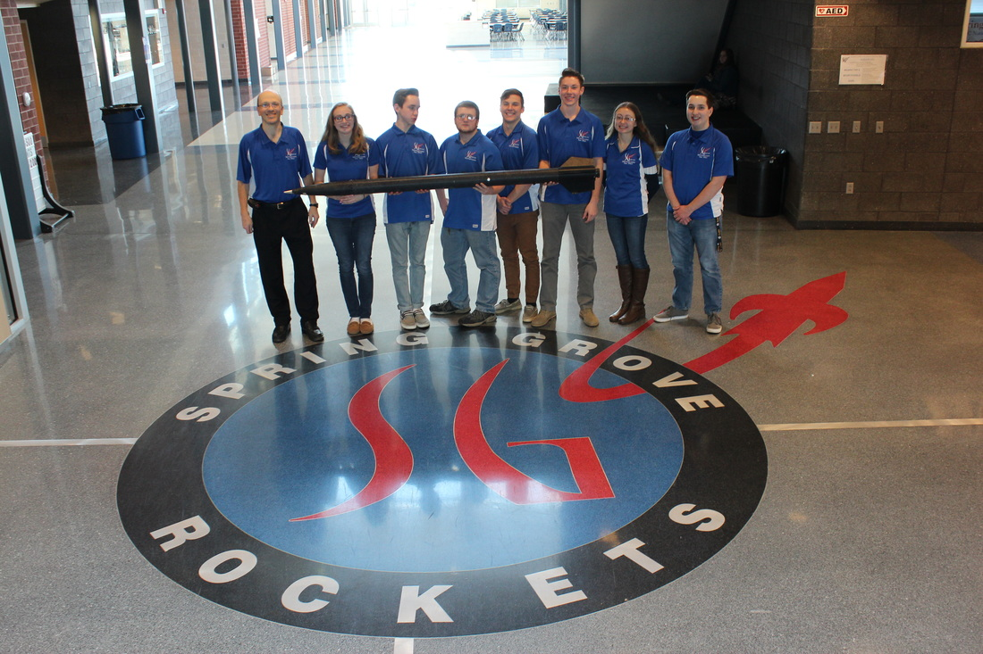
- David Williams, Senior
  - Team Co-Captain, Student Safety Officer, Payload Specialist
- Gavin Black, Senior
  - Team Co-Captain, Electronic Bay Specialist
- Kory Trout, Senior
  - Launch Vehicle Specialist
- Josh Snyder, Sophomore
  - Safety and Mass Reduction Specialist
- Zeb Hollinger, Junior
  - Safety and Mass Reduction Specialist
- Katie Garner, Senior
  - Budget and Funding Plan
- Rebekah Silar, Senior
  - Educational Engagement

our goal
Our goal as Team Tesla is to successfully design, build, and launch a rocket that will achieve an altitude of one mile (5280 ft.), utilize a physics-based scientific payload, and return safely to the ground. In addition to this, Team Tesla will work as a team to comprise and present written and oral presentations to NASA throughout the year to show the team’s work and progress on our project.

payload summary
The payload for Spring Grove's Team Tesla is designed to test the rate at which airflow through a turbine will generate current on the ascent of the launch vehicle. Data will be recorded to analyze the usefulness of this payload.

rocket summary
- Total Length: 7 feet, 1 inch
- Total Weight: 20.61 pounds
- Diameter: 4 inches
- Motor Choice: K740 C-Star
- Airframe Material: Fiberglass
- Fin Material: Ultem 3D filament (designed by team captain David and printed by our sponsor
TE Connectivity)
- Recovery System: Two PerfectFlite StratoLogger CFs igniting 2.0 grain charges
- Electronics Bay: Includes 2 key switches for redundancy
- Payload: Generates electricity on ascent
- Parachutes:
  - 24 inch drogue
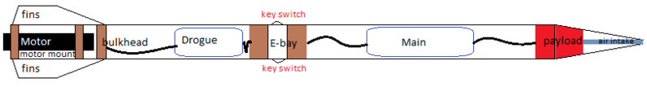
  - 72 inch main

mission performance predictions
In order for this project to be successful the following conditions must be met:
- The rocket must successfully launch and deploy both parachutes.
- The rocket must be within 10% of our target altitude of 1 mile or 5280 feet.
- We must be able to use the data collected during the flight to draw a meaningful conclusion to our experiment.
- Lastly, no onboard systems or parts may break or malfunction during the course of the launch.

project plan
- The proposed budget for the project is approximately $26,000.
- Local companies and universities have been solicited for donations and grants written to help fund the project.

sponsors
- TE Connectivity
- AquaPhoenix Scientific
- Engineering Society of York
- Spring Grove Education Fund
- Hain Pure Protein Corporation
- Hanover Foods
- Hanover Elks
- Hanover Rotary Club
- York County Community Foundation
- First Energy

educational engagement
- The team held an assembly with 7th graders on March 15, 2016 with the goal to spark an interest in those students to become involved in the future.
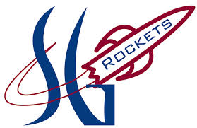
- The team will hold a rocket-building workshop at the high school in late April for those 7th graders to present those interested in rocketry a hands-on experience.

